LOSTOCK GRALAM CHURCH OF ENGLAND PRIMARY SCHOOL
Children are at the heart of everything we do and Christ is the light that guides us. John 8:12

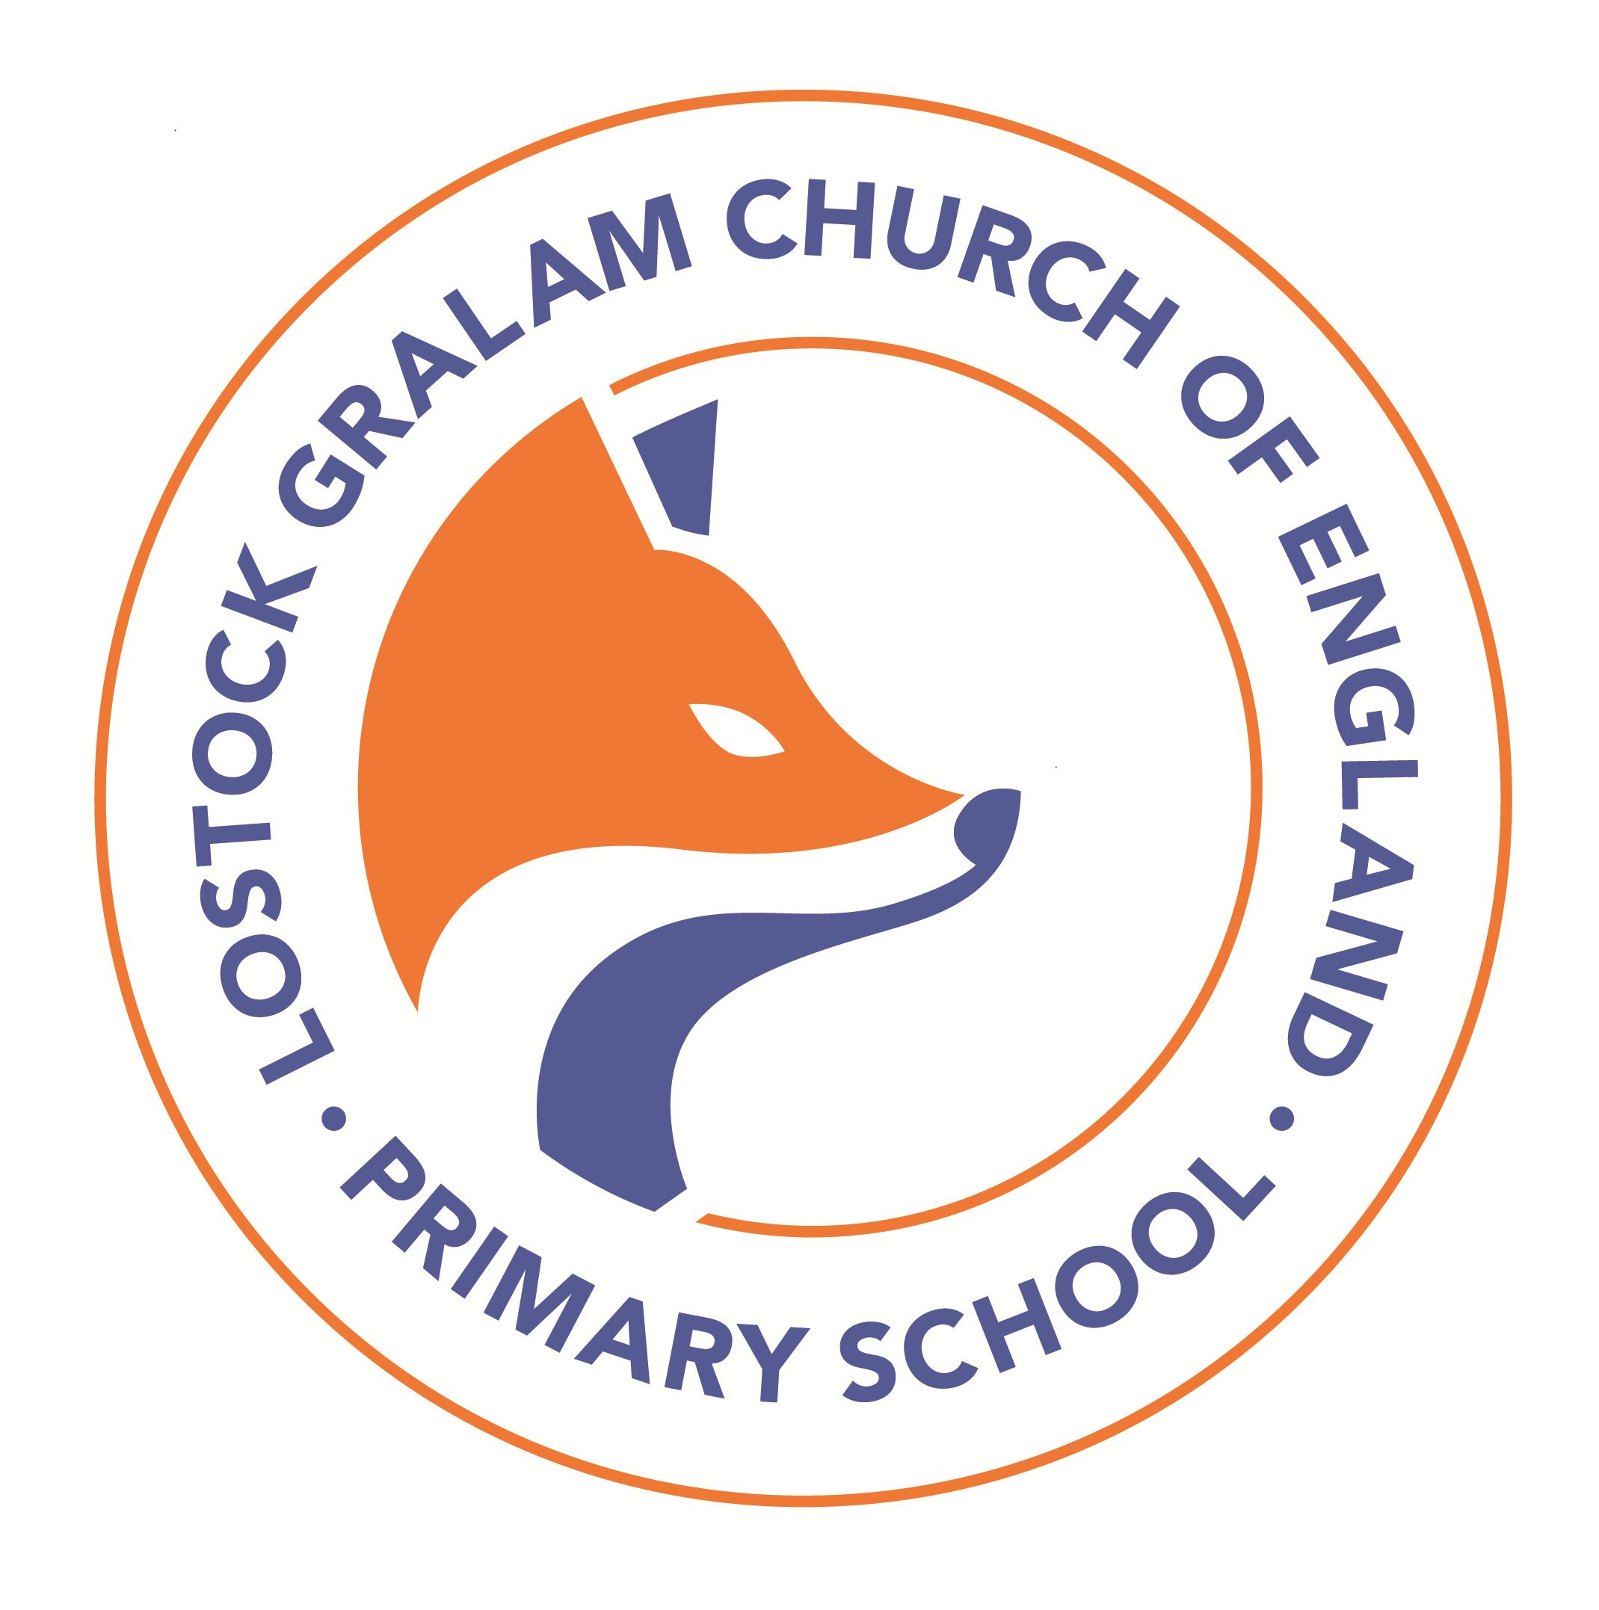

TERM DATES September 2023/August 2024

 | Date of Closing | Date of Re-Opening
Summer 2023 | Thursday 20th July | Tuesday 5th September
Autumn Half-Term 2023 | Friday 20th October | Monday 30th October
Christmas 2023/2024 | Friday 15th December | Tuesday 2nd January
Spring Half-Term 2024 | Friday 16th February | Monday 26th February
Spring Break 2024 | Wednesday 27th March | Monday 15th April
May Day Weekend 2024 | Friday 3rd May | Tuesday 7th May
Summer Half-Term 2024 | Friday 24th May | Monday 3rd June
Summer break 2024 | Friday 19th July | Monday 2nd September

INSET DAYS (Teacher Training) – 5 in total for 2023/24

Monday 4th September 2023
Thursday 28th March 2024
Monday 22nd July 2024
Tuesday 23rd July 2024
Wednesday 24 July 2024

