Getting Ready for School
It is nearly time to start school!
Here are a few things that you can practise at home to help you to get ready.

Getting Ready for School

Self-Care and Independence  I know when to wash my hands.  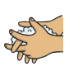  I can wipe my nose.  I can ask for help if I do not feel well.  I am happy to tidy my belongings and look after my things. | Playing with others  I can join in games and activities with other people.  I can share and take turns.
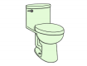  Going to the toilet  I can go to the toilet on my own, wipe myself properly and flush.  I can wash and dry my hands without any help. | Eating and Drinking  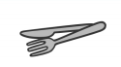  I can use a spoon, knife and fork.  I can open my lunch box as well as wrappers and packaging.  I can drink from a water bottle, carton or open cup.
Getting dressed and undressed on my own  I can put my own socks and shoes on.  I can put my coat on and use a zip.  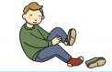  I am learning to dress/undress – this will help me change for PE.  I can begin to button and unbutton my clothes. | Speaking and Listening  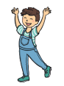  I can talk about my ideas, needs and feelings.  I can ask a grown-up for help.  I can follow simple instructions  I can wait my turn to talk.
Numbers  I can count a small number of items.  I like singing number rhymes or songs.  I am learning to say numbers to ten.  I can recognise some numbers. | Reading and Writing  I can follow simple instructions.  I can recognise/read my name.  I am practising holding a pencil to draw.  I am learning to write my name.  I enjoy listening to stories and rhymes
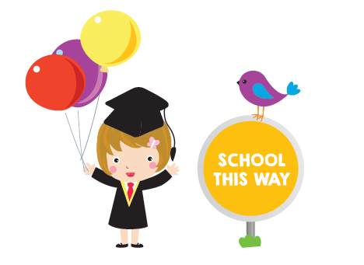
What are you looking forward to the most?
Is there anything you are unsure of?

*Please remember these are just
ideas to help. Every child starts school
with different abilities and each child
develops and progresses at their own
level. Please do not worry if your child
cannot do all of these things!

