Autumn 2021 Worship Planning
Monday – Mrs Powell Picture This News
Tuesday – Mrs Rice Christian Values / No Outsiders
Wednesday – Mrs Downing Open The Book Bible Stories Through Drama (Visiting OTB team)
Thursday – Miss Gillam, Mrs Evans/Miss Beattie Praise Singing
Friday – Mrs Powell Praise Celebrations
The Library has story books, secular and Christian, organised into folders for each Christian Value for you to use as and when.

Date | Theme | Resource
Autumn 1 2021 Christian Values: Friendship and Hope
Please light a candle at the beginning of each worship to remind us that “Christ is the Light that guides us” (our mission statement) and have the Bible open at the Bible verse that is indicated in purple in each worship.
WB 06.09.21  Ethos Children to use the worship cards to open and close worship | “Encourage one another and build each other up.”  1 Thessalonians 5:11  Explore the term ‘Friendship’ allow chn to discuss and collect feedback. Show a friendship bracelet and explain that friends can make things for each other. Ask some chn to plait the strings together during the worship to make a friendship bracelet. In Hindu families, sisters make these bracelets for their brothers as part of the festival Raksha Bandham.  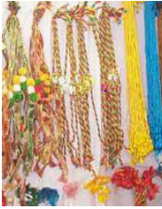  In the Bible there is a book of wise sayings called Proverbs. Which friend do you think this saying is referring to?  “There is a friend who sticks closer than a brother”  Proverbs 18:24  Just like the strands in the friendship bracelet that is being woven by my helpers, Christians believe that Jesus is woven into our lives and will be our closest friend.  Friendship poem:  Finding things to do together  Relying on each other  Impossible on your own  Enjoying being together  Never selfish  Depending on someone else  Sharing hopes and dreams  Happiness and laughter  Including others  Precious  Show the friendship bracelet that the chn have made. The three strings have been plaited together, making it stronger. Plaiting the strands together needs time and effort, just like building a good friendship.  Reflect: Spend a few moments thinking about your friends. What makes them a special friend? How can you show your friends that you care?  Prayer: Dear Lord Jesus. You have shown us through the Bible that you want to be woven into our lives as our friend. Thank you that we can talk to you at any time because you are always close to us.  Amen | Class Bible and candle  Roots and Shoots pg 95 – 99  String to make friendship bracelets  As chn leave worship, allow them to take a piece of string. This could remind them of the value of friendship or of one thing they would like to remember/act on for our worship today. Encourage the chn to use their length of string, join together with two other friends and make a friendship bracelet.
WB 13.09.21  Ethos Children to use the worship cards to open and close worship | “Encourage one another and build each other up.”  1 Thessalonians 5:11  Display the image of three friends at https://www.imaginor.co.uk/roots-fruits-resources/ Password (RaF14img7)  St Paul write these words of wisdom in the Bible  Encourage one another and build each other up. St Paul wanted to teach people that the best way to live in friendship is to encourage one another rather than being critical and negative.  Chn act out the drama of Danny and his friends demonstrating that it takes time to build a friendship but seconds to hurt someone’s feelings.  Reflect: Talk partners. Do you think Danny will find it easier to remember all the positive, encouraging comments that built him up or the negative criticism?  Prayer: What kind of a friend are you?  Leader: Lord Jesus. Thank you for the gift of our friends. At every opportunity help us to…  All: encourage one another and build each other up  Leader: Make us aware when our friends are sad. Help us to …  All: encourage one another and build each other up  Leader: When we are tempted to be negative or criticise our friends. Help us to…  All: encourage one another and build each other up. Amen | Class Bible and candle  Roots and Shoots pg 100-102  Lego tower/ multi-link tower  Few pieces of litter  Book  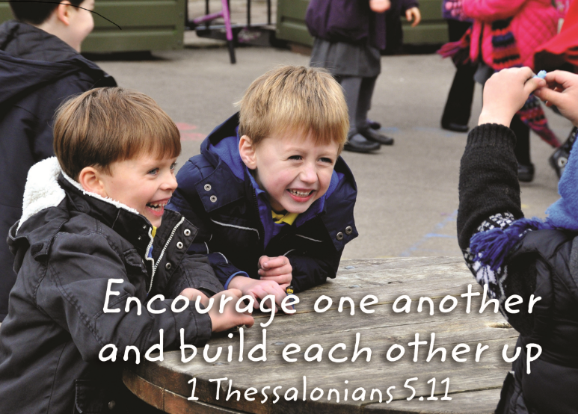
WB 20.09.21  Ethos Children to use the worship cards to open and close worship | “Encourage one another and build each other up.”  1 Thessalonians 5:11  Agents of Hope  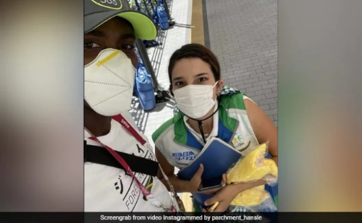  Hansle Parchment is a Jamaican athlete who competed in Olympics in Tokyo this year; he was competing in the 110m men’s hurdles. On the morning of the race he got on the bus that had been provided for athletes to take them from the Olympic village to their stadiums. However, there are many different stadiums and Hansle realised when he got off the bus that he had arrived at an aquatics venue which meant he had taken the wrong bus and was in the wrong place for his race.  People told Hansle he had to get a bus back to the Olympic village and then get the correct bus to his stadium, but he knew if he did that, he would miss his race. Hansle saw some Olympic branded cars outside the stadium but they all said he had to book them in advance and they couldn’t take him. Hansle was desperate for help. He approached a volunteer called Trijana and explained what had happened. The volunteer gave him her own money for a taxi and made sure the driver knew where to go.  Hansle arrived at the correct stadium just in time to warm up and take part in the race. Another athlete Grant Holloway was clear favourite to win the race. Take a look at what happened here https://www.youtube.com/watch?v=PZ_rnP7sx28  Hansle took Gold, but no-one knew that he had almost missed the race. Afterwards he went back to find the volunteer that had helped him and he filmed his thank you, which has gone viral.  - What is a hurdle race?  - How long do you think Hansle has been in training for this race?  - How do you think Hansle got to go to Tokyo for the Olympics?  - How do you think he felt when he realised he had got on the wrong bus?  - What would be the consequences for Hansle if he had missed his race?  - Why did the volunteer pay for his taxi?  - How do you think she feels when he finds her to say thank you?  - Why do you think Hansle filmed his thank you? What does he want to show people?  Reflect: Hope is one of our core Christian Values. Why is this a story of hope? The Olympics is another example of encouraging each other building each other up just as the Bible teaches us.  Prayer: School Prayer | Class Bible and candle  https://www.youtube.com/watch?v=f47Db5O8Zj8  https://www.huffingtonpost.co.uk/entry/olympian-tracks-down-good-samaritan-who-helped-him-win-gold-in-tokyo_uk_6114c6ebe4b07b9118a77a05?fbclid=IwAR2yS6rOEakBIC9Sri94qwMZphWuDT1lJs9ehyRLcTba7NAtxp9jHcHUxAY
WB 27.09.21  Ethos Children to use the worship cards to open and close worship | “Encourage one another and build each other up.”  1 Thessalonians 5:11  Display 5 strips of paper each with the name of each character written on. Hand them out to five children.  Read the story of The Five Friends from the book of Luke.  Reflect: Ask the 5 friends to connect their strips of paper to make a chain using the glue stick.  Discuss how the strips of paper now make a chain as they are linked together. Discuss how the friends were linked together in their friendship for each other.  Prayer: Written by Rt Revd Christopher Herbert  Let our friendship be strong Lord  That they may become a blessing to others  Let out friendship be open Lord  That they may be a haven for others  Let our friendship be gentle Lord  That they may bring peace to others  In Jesus name we ask this. Amen | Class Bible and candle  Bible story Luke 5:17-39  5 strips of paper with the characters names on  Glue Stick
WB 04.10.21  Ethos Children to use the worship cards to open and close worship | “Encourage one another and build each other up.”  1 Thessalonians 5:11  Today we are thinking about the way that our friendships are strengthened by spending time together. Look at this picture by the artist He Qi. What do you think the men and the two women are doing? How might they be feeling? Talk partners.  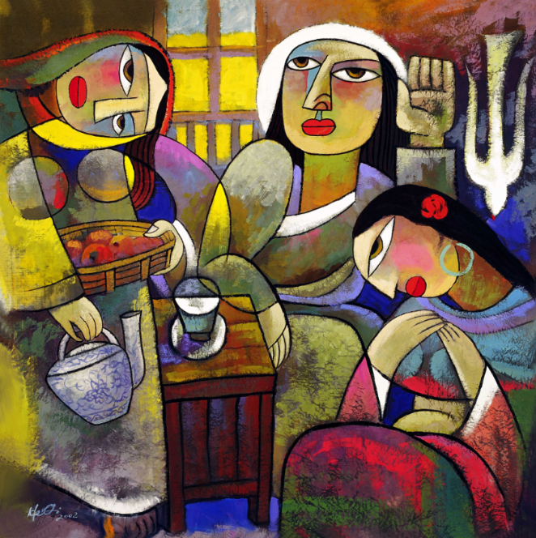  He Qi has painted a picture that shows the time that Jesus went to the house of a family who had shown him kindness and friendship. In this family there was a brother Lazarus and two sisters Martha and Mary.  Share the story on pg 107  Jesus loved Martha and Mary equally. Martha was trying to help but Jesus wanted both sisters to make time for their friendship to grow.  Reflect: Sit calmly, close your eyes. Imagine that you are sitting in a room with Jesus. What do you think he would say to you? What would you like to ask him?  Respond: Can you see the dove that He Qi painted above Mary. Why do you think he has done this? I have a pile of paper doves on our worship tables, if you would like to take one, during the week you could draw or write on it the place that you like to go and be quiet, at peace or to pray. As we listen to this beautiful calm music on our way out, use your imagination to see in your mind’s eye a special, peaceful place, | Class Bible and candle  Roots and Shoots pg 106 – 108  Paper doves
WB 11.10.21  Ethos Children to use the worship cards to open and close worship | “Encourage one another and build each other up.”  1 Thessalonians 5:11  Agents of Hope  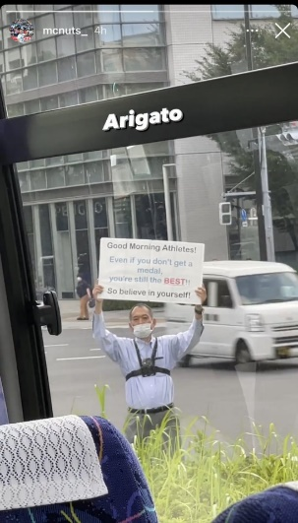  This man stood Outside Olympic venues every morning in Tokyo holding up this sign; “Even if you don’t get a medal you’re still the BEST!! So believe in yourself!”  He would arrive every morning at 7:15 and stand for two hours holding up the sign as buses carrying Olympic athletes drove past in him to the stadium. He started the day before the opening ceremony and did this every day till the closing ceremony. He says he originally held up a sign saying “Welcome” but four days into the Olympics he changed his message because he noticed people obsessing over medal counts.  This year there were no audiences in the stadiums and many were highlighting the need to support the mental health of athletes.  Lots of athletes took photos of the man as they went past and the photos quickly went viral. One person wrote on twitter, “The world needs more of this. This kind of message, this kind of support, this kind of dedication, this kind of genuine kindness, this kind of human.”  Another created a poll asking, “Is this man the real winner of the Olympics?” with the options being:  Yes  Of course  Absolutely  Have you met Tom Daley?  (the yes won with 46%)  Another said, “This is the true Olympic spirit embodied”  - What do you see in the picture, where is it taken from, who might have taken it?  Explain the story  - Why did the man originally have a sign saying “welcome”?  - “he noticed people obsessing over medals” why were people obsessing?  - How do you think people obsessing over medal counts affected the mental health of the athletes?  - How do you think this sign made athletes feel as they drove past?  - He could have fixed the sign to a lamp post and left it for two weeks for athletes to see every morning; why did he choose to turn up and hold it every day instead?  - Why do you think these photos went viral, what does this show about people around the world?  - “This is the true Olympic spirit embodied” what does this mean?  Reflect: What else could he have written on his sign to give the same message?  How does this worship help our understanding about encouraging each other and building one another up, just like the Bible teaches us in the book of Thessalonians.  Prayer: Allow the children time for personal prayer followed by our school prayer. | Class Bible and candle  https://www.timeout.com/tokyo/news/this-man-stands-outside-the-tokyo-olympic-village-every-day-to-motivate-athletes-080521  https://mymodernmet.com/man-holds-motivational-posters-tokyo-olympics/
WB 11.10.21  Date TBC with Vicar Andrew | HARVEST SERVICE IN CHURCH
WB 18.10.21  Ethos Children to use the worship cards to open and close worship | “Encourage one another and build each other up.”  1 Thessalonians 5:11  “A friend may be waiting behind a stranger’s face.”  Maya Angelou  Share the story Marmaduke The Very Different Dragon.  Reflect: How does this story reflect our quotes here on the worship table? The princess was a stranger to Marmaduke however they became wonderful friends.  Our Christian Value this half term has focused on Friendship and Hope. Share with the friend next to you what you have learnt about friendship and what makes you a good friend.  Prayer:  Lord, please go before us to lead, walk beside us to befriend, be above us to protect, stay behind us to direct, be beneath us to support and enfold us in your love. Amen | Class Bible and candle  Print the Maya Angelou for the worship table  Marmaduke story  Toy Story song “You’ve got a friend in me”

