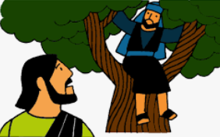
Hot Seating – Zacchaeus
Why were you a tax collector?

What do you think people felt about you?

Are you important to other people?

Are people scared of you?

Do you want to be rescued from this kind of life?

Do you sleep at night?

Why do you want to see Jesus?

Why were you taking more money from people than you should have done?

