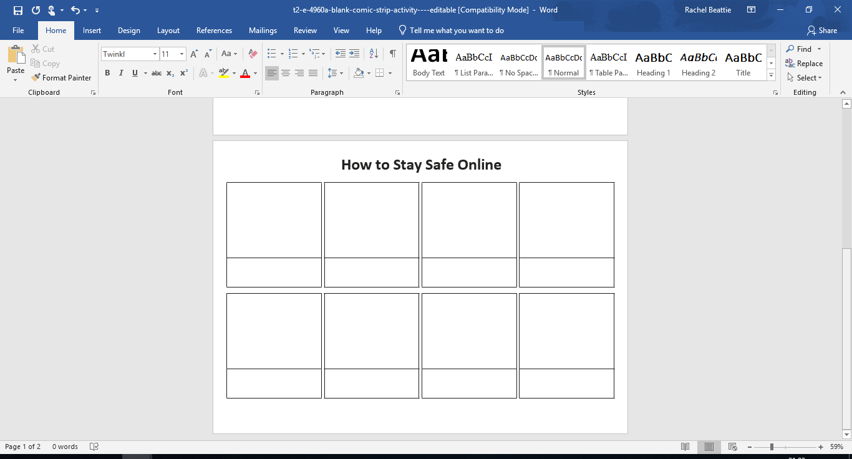

Create a scene explaining how we can stay safe online. You might want to include characters and speech bubbles to help you.

**How to Stay Safe Online:**

