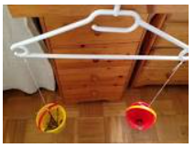
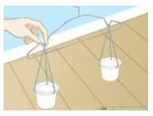
Make your own balance scales

Get a coat hanger, two small containers and some string or pegs (you could use a trouser coat hanger with clips if you have one)

- Hang the coat hanger on a door handle

- Secure the two pots onto either end of the hanger with pegs or string (you could punch holes if you’re using paper cups)

- Fill your containers with heavy / light objects and experiment with what happens

