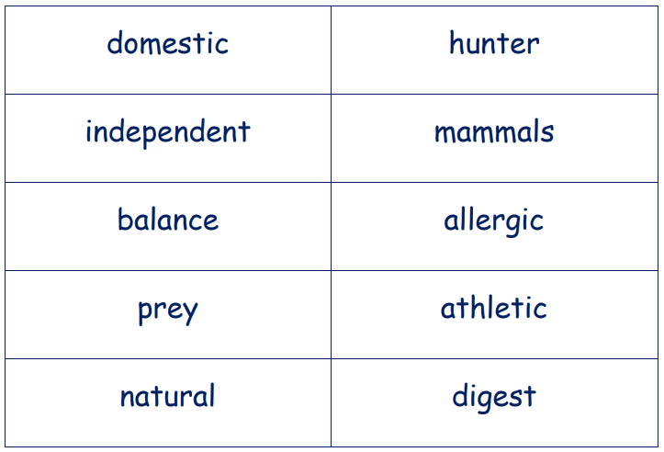
- Cut up the word cards and read them out one by one.
- Look at the matching definitions and cut them up.
- Take it in turns to choose one and match it up with the corresponding word.
