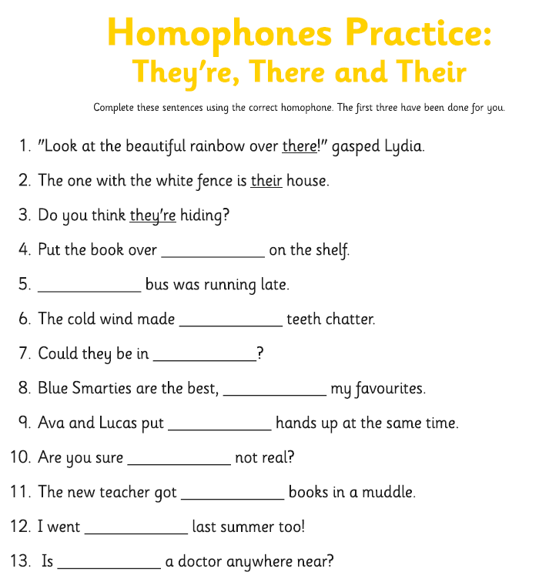
4. there

5. Their

6. their

7. there

8. they’re

9. their

10. they’re

11. their

12. there

13. there

Don’t worry if you found these tricky or got some wrong. These are difficult and many adults still get them muddled. There, their and there are spellings we will go over many more times in Y4.

