[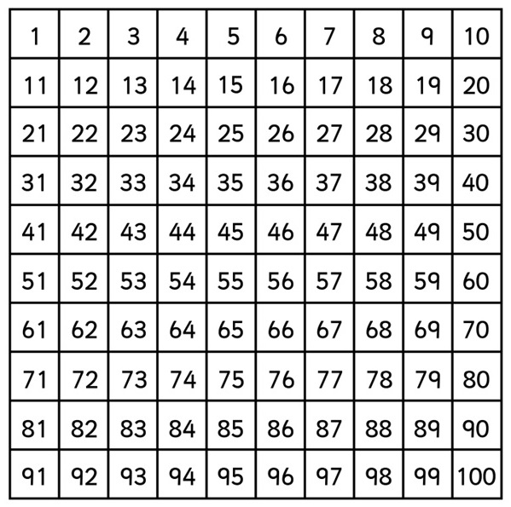](http://www.google.co.uk/url?sa=i&rct=j&q=&esrc=s&frm=1&source=images&cd=&cad=rja&uact=8&ved=0ahUKEwjWzc6OrZDKAhVD1xQKHaphDUEQjRwIBw&url=http://www.blackwell.w-sussex.sch.uk/index.php/curriculum/maths&psig=AFQjCNHcK4l5xKw3HqKpSwU76a0RxreIfw&ust=1452003610308172)