Answer each questions (you may need to use the internet to help you) and then take the first letter from each answer to work out the hidden question on page two.

1. | Who is the founder of Disneyland?
2. | What historic wall runs along the border between England and Scotland?
3. | Niall Horan, Liam Payne, Harry Styles and Louis Tomlinson were members of which group?
4. | What does water turn into at 0 degree Celsius?
5. | Who was the first man to walk on the moon?
6. | Who gets sent to the ‘Juicing Room’ in Willy Wonka?
7. | What is the most common language spoken in Australia?
8. | How many brains does an octopus have? (Write answer in words)
9. | Which dinosaur had three horns on its head?
10. | In which country are the Pyramids of Giza?
11. | Which of Snow White's seven dwarfs didn't have a beard?
12. | What’s the name of the river that flows through London?
13. | What is the name of Harry Potter’s pet owl?
14. | How many planets are in our solar system? (Write answer in words)
15. | What is the Capital City of England?
16. | Which country is famous for its coliseum?
17. | What sport is Tiger Woods famous for playing?
18. | What do you call a group of cows?
19. | How many zeros are there in one thousand? (Write answer in words)
20. | Who is the Prime Minister of Britain?
21. | Which small guitar-like instrument originated in Hawaii?
22. | Which artist painted the Mona Lisa?
23. | What’s the biggest animal in the ocean?

Hidden Question:

?

Answer to Hidden Question:

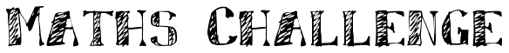
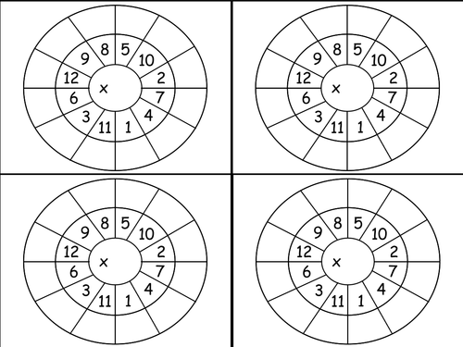

8
4
5
3

