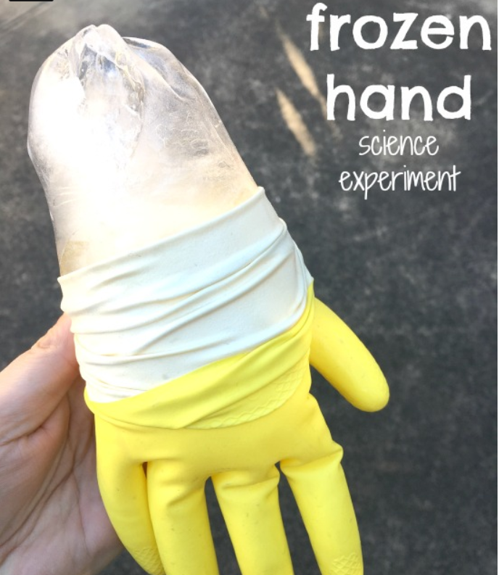
1)Use a rubber or surgical glove and fill it with water. Secure the end by tying a knot. If you want, you can use food colouring to add a colour.
2)Place in the freezer (takes 12 + hours so best to leave overnight)
3)Remove from freezer and carefully peel the glove off. Place in a tray or large bowl.
Now the fun begins. You will need your observing, predicting and measuring skills.
Predict:
Which part(s) of the hand will melt first or the quickest? Why do you think this?
Observe:
How long will the smallest finger take to melt? How will you record this? What measuring or recording equipment will you need?
Record:
How long did the whole hand take to melt? Did you sit and watch the whole time or did you find a way to record the melting process in intervals?
Extension:
Freeze 2 hands. Once removed from the freezer, place in 2 different areas where the temperature is different. Compare the speed each hand takes to melt.

