The estimated number of Vaquita remaining on the planet

Year | Number of Vaquita’s remaining
2000 |  | 92
2002 |  | 67
2004 |  | 55
2006 |  | 93
2008 |  | 84
2010 |  | 56
2012 |  | 32
2014 |  | 22

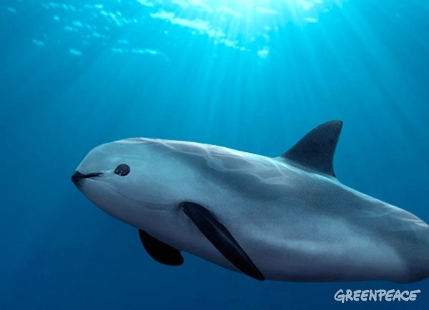

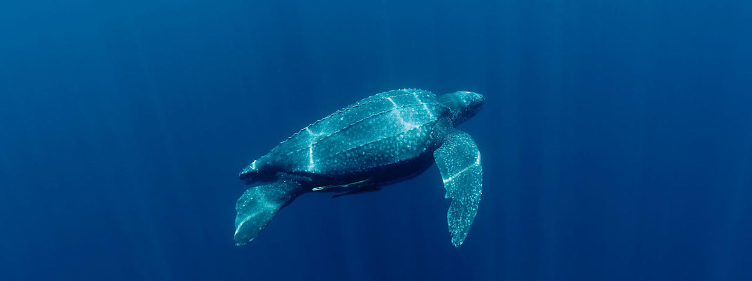

The estimated number of Leather – Back turtles remaining on the planet.

Year | Number of Leather –Back Turtles remaining on the planet
1980 |  | 358
1985 |  | 320
1990 |  | 312
1995 |  | 260
2000 |  | 213
2005 |  | 185
2010 |  | 145
2015 |  | 273

