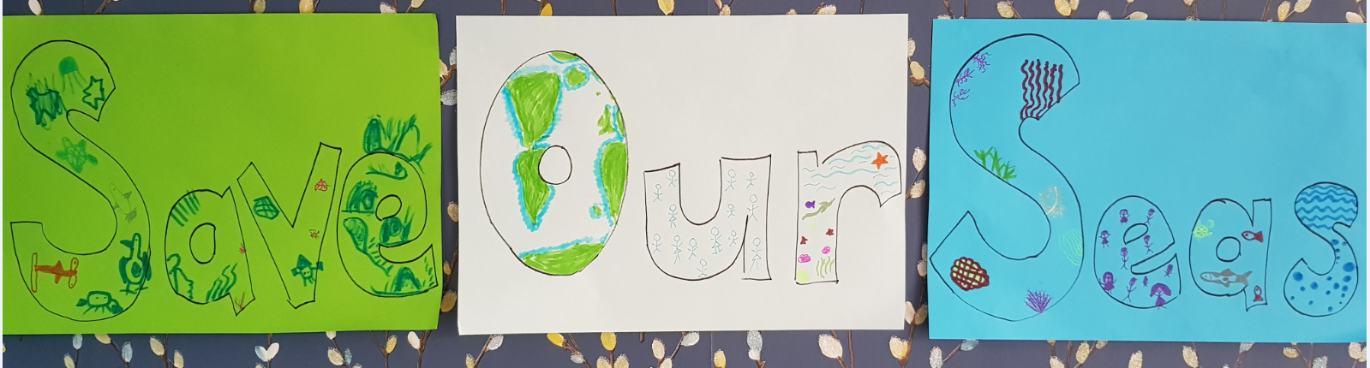
SAVE OUR SEAS
Useful websites:
https://kids.nationalgeographic.com/explore/nature/kids-vs-plastic/pollution/#/1470659139836
https://www.iucnredlist.org/
https://www.sciencekids.co.nz/sciencefacts/earth/oceans.html
https://www.kids-world-travel-guide.com/ocean-facts-for-kids.html
https://kids.britannica.com/kids/article/ocean/346185
https://www.wwf.org.uk/learn/fascinating-facts
https://www.theworldcounts.com/stories/Ocean-Facts-for-Children
https://modestfish.com/ocean-facts/
https://www.activityvillage.co.uk/sea-creature-maths-worksheets
https://conserveturtles.org/sea-turtle-tracking/ follow the migratory movements of endangered turtles
https://www.theschoolrun.com/homework-help/marine-habitats
http://www.fao.org/fao-stories/article/en/c/1258376/
Twinkl have lots of free resources (I have downloaded most of the ocean themed ones which will be attached to the daily blogs)
David Attenborough clips and programmes:
https://www.youtube.com/watch?v=IW3jEIYBFzg
https://www.youtube.com/watch?v=xLx4fVsYdTI
https://www.youtube.com/watch?v=xGfIsMMTbL4
https://www.bbcearth.com/shows/blue-planet/ Blue Planet 1
https://www.bbc.co.uk/programmes/p04tjbtx Blue Planet 2
Newsround programmes:
https://www.bbc.co.uk/newsround/42810179
https://www.bbc.co.uk/newsround/47979998
https://www.bbc.co.uk/newsround/47445196

Lovely Sea themed books and stories to share:
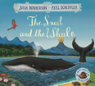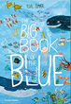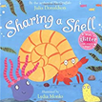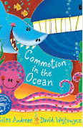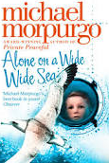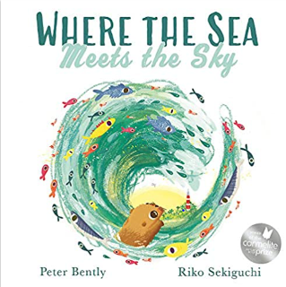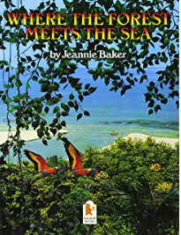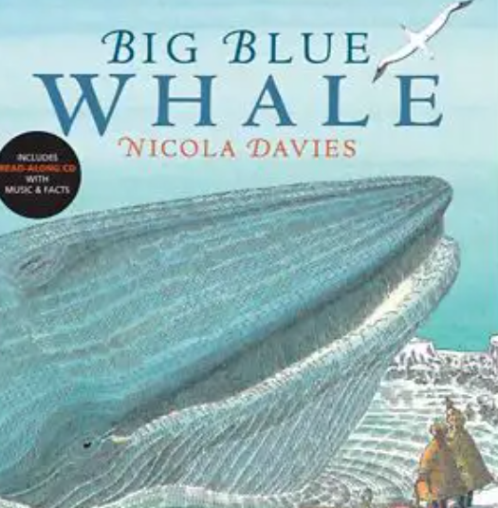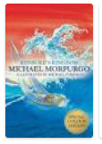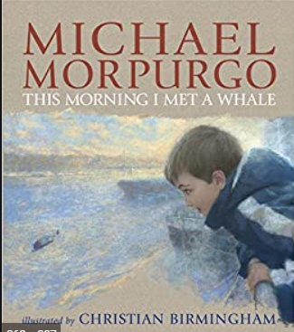
https://vimeo.com/60259773 - watch the reading of Big Blue Whale
https://www.youtube.com/watch?v=jamBzIML79o - Barry the Fish with Fingers

Ideas for activities: (Pick the ones you like or choose your own)
- Look at the Global Goals and particularly Number 14- Life Below Water
https://www.globalgoals.org/ https://www.globalgoals.org/14-life-below-water
- Watch the Pollution Problems clip on the https://worldoceanday.school/ website. Go around your house and do a survey of the single use plastic you have. Can you decide as a family to ‘Save Our Seas’ ‘Make One Change’ in something you buy from now on. Please Tweet your pledge to ‘Make One Change’ and we will spread the message and give ideas to others.
- Find out about the work of Surfers Against Sewage https://www.sas.org.uk/our-work/plastic-pollution/plastic-pollution-facts-figures/

- Make a ‘Save our Seas’ video, poster or leaflet with all your ideas. Here are 2 of Mrs Evans’ children showing an example. https://www.youtube.com/watch?v=XkSBV8UKwIc&feature=youtu.be

- Practise your geography with continents and oceans of the world using: https://world-geography-games.com/continents/index.html and
https://world-geography-games.com/oceans/index.html

- Choose a particular ocean or sea to find out about. I have attached lots of resources from Twinkl

- Have a go at this maths activity (Y3-6) https://nrich.maths.org/5929

- Use teddies or models you have at home to make a play or puppet show about the dangers facing the oceans.

- Find out which seas and rivers are linked with the Bible

- Go on a litter pick (with an adult from your house) in your local area.

- On your daily walk with an adult, visit a local pond, lake or river and talk about the local plants and wildlife there.

- Do a survey of the animals and wildlife you see at the local pond/river/lake. Make a pictograph or bar chart.

- Find out about an ocean animal or plant. Think about: Appearance, Habitat, Diet and whether it is endangered or not.

- Read sea poems and have a go at writing your own
https://www.michaelrosen.co.uk/2019/04/over-my-toes/ https://childrens.poetryarchive.org/poem/over-my-toes/
https://www.youtube.com/watch?v=l1sWlGCvcAQ - Michael Rosen Seagulls

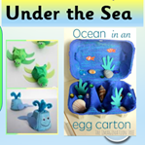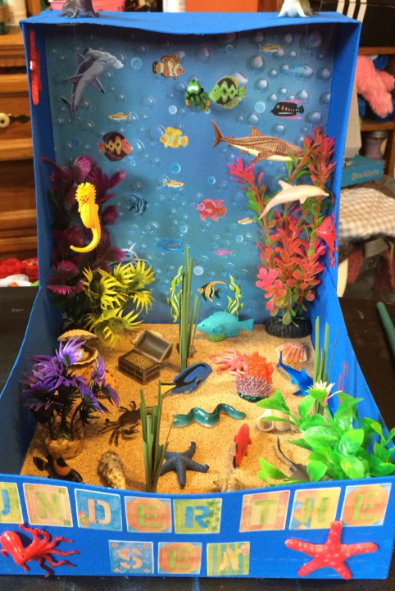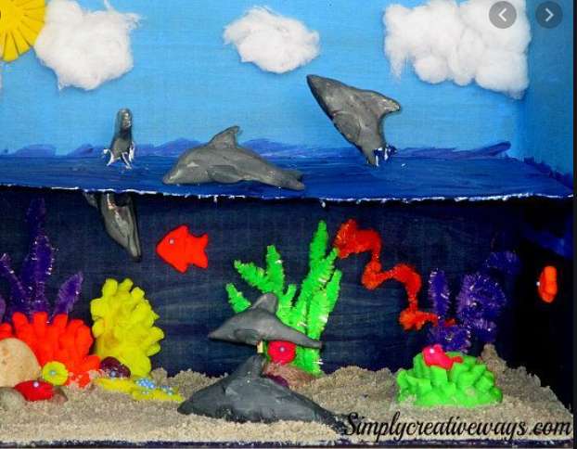
- Make an ocean biome out of an old shoe box. Or use play dough to create an ocean scene or habitat. Use the Salt dough recipe to make Salt Dough Starfish.

- Make your ocean themed word search https://thewordsearch.com/maker/

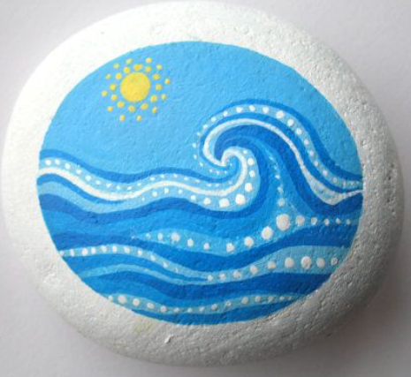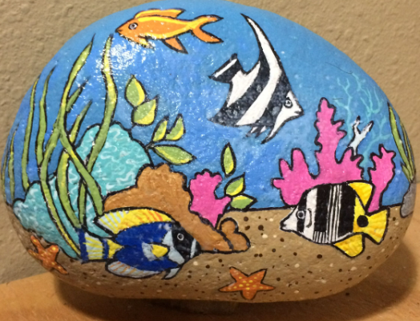
- Decorate a pebble with a sea theme and ‘Make One Change’ and put it outside school in front of the sharing window.

You can e-mail a photo or deliver any of your work to school to help us change our Sharing window into a Save Our Seas sharing window.
If you are Tweeting your work please add the tag @LostockGralamPrimary and add #Saveourseas and #Makeonechange
All the work which is currently on the sharing window will be moved to be displayed in church- which we think will bring a huge smile to everyone there.

Thank you and have fun
From the Lostock Gralam Team.

