Year 3  Robins | Before 9:00am | 9:00 – 10:00 | 10:00-11:00 | 11:00-12:00 | 12 – 12.30 | 12:30 – 1.00 | 1:00 – 2:00 | 2:00 – 3:15 | 3.15 – 4:00
Monday | Eat breakfast, make your bed, get washed and dressed and put any laundry in the basket. | Family walk (with the dog - if you have got one!)  Five-a-day/indoor exercises/indoor yoga if wet.  https://www.youtube.com/user/CosmicKidsYoga  https://www.gonoodle.com/  https://www.nhs.uk/10-minute-shake-up/shake-ups | Maths/Writing work from the packs, blogs or any of the following links:  TT Rock Stars - https://play.ttrockstars.com/auth/school  White Rose - https://whiterosemaths.com/homelearning/  I see reasoning - http://www.iseemaths.com/home-lessons/  The literacy company - http://www.theliteracycompany.co.uk/free-resources/  Oak National Academy - https://www.thenational.academy/online-classroom/year-3/ | Creative Time – Lego, drawing, crafting, music, cooking, baking, coding, painting.  coding - https://www.scratchjr.org/  https://code.org/ | Lunchtime | Tidy Time – Wipe down kitchen table and chairs, wash and dry kitchen dishes, tidy bedroom and lounge. | Quiet Time – Reading, Puzzles, Nap (No Electronics) | History/Geography  (See tasks on the next page) | Afternoon Fresh Air – Bike, Walk the dog, play outside.
Tuesday |  |  |  |  |  |  |  | Science  (See tasks on the next page)
Wednesday |  |  |  |  |  |  |  | History/Geography  (See tasks on the next page)
Thursday |  |  |  |  |  |  |  | Science  (See tasks on the next page)
Friday |  |  |  |  |  |  |  | RE  (See tasks on the next page)
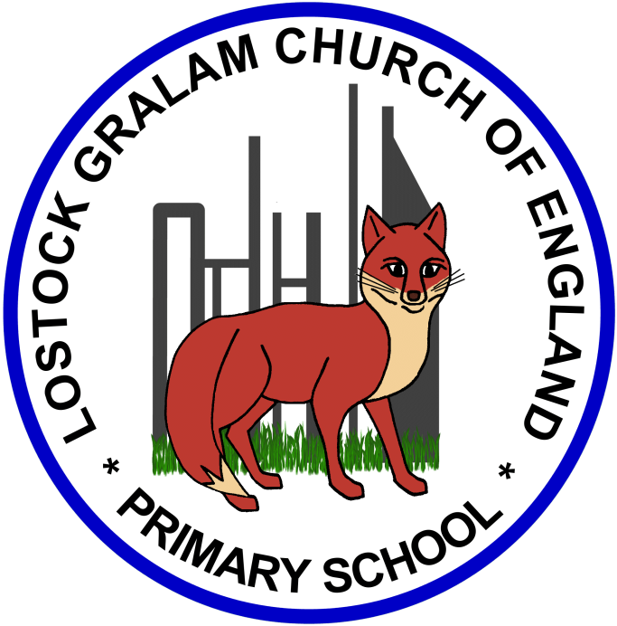
Home Learning – this timetable is intended as a guide to support learning at home during a prolonged period of school closure. We appreciate that you will have differing demands on your time but hope that this helps in continuing ‘a love learning’ at home. We will also be updating the class blog daily with any specific activities that you can do each day and further resources that you may need.
Under the timetable and suggested task list, I will also include a long list of free resources and websites that you may wish to use.
If you have issues with usernames and passwords, please contact admin@lostockgralam.cheshire.sch.uk

Weeks commencing 15.06.20 and 22.06.20:
Remember these projects will take you multiple days to complete – just do a little bit at a time
History and Geography | History/Geography Projects – Word Refugee Day (20th June 2020)  20th June 2020 is World Refugee Day which links in nicely with our Adrift Project that we were due to complete in the Summer Term.  - What is a refugee?  - Watch the follow clip about living as a refugee: https://www.bbc.co.uk/bitesize/clips/zbrd2hv  - What are the advantages and disadvantages of leaving your country as a refugee? – You could create a table to explain the pros and cons, using the video to help you.  - What could you do to help make a refugee feel more welcome? Draw and annotate a series of pictures showing how you could do this (you could present your work in a comic strip).  - Find out about a celebrity or famous person who is a refugee and create a fact file about their life.  - Put yourself in the shoes of a refugee and write a diary entry about the journey you have been on (Think back to the Adrift Theatre Performance we watched in school and the journey they went on to reach safety).  Useful Websites –  https://www.bbc.co.uk/newsround/48660079  https://www.bbc.co.uk/programmes/b01k7c4q/clips  https://www.teachwire.net/news/miss-whats-an-immigrant-8-great-resources-for-teaching-refugee-week-2017  https://refugeeweek.org.uk/simple-acts/
Science | Science Projects – Fossils  - What is a fossil? What is a palaeontologist?  - Research a famous Palaeontologist and the kinds of tools that palaeontologists use to carry out their work. You could draw/annotate pictures of the tools they use and explain how each is used.  - How are fossils formed? Create a storyboard explaining how a fossil is formed.  - Can you make your own model fossil using playdough, clay or even through baking?  Useful Websites –  https://www.bbc.co.uk/bitesize/topics/z9bbkqt  https://www.outstandingscience.co.uk/index.php?action=view_page&page=view_unit&unit=3c  https://www.youtube.com/watch?v=xQBkawjFVIA
RE | RE Projects – COMPETITION  This is an exciting RE project because it is a competition! Over recent years, over 350 000 children and young people have entered a competition to make a work of art in RE. Now is your chance to do the same. There are £25 prizes for the winners, and your work may appear on a web gallery. The art you make should be all about your own ideas on a big religious theme. It can be 2D art, painting, drawing, pastel colours. It can be 3D, fabric or sculpture, video art, music or poetry.  More information: https://www.natre.org.uk/about-natre/projects/spirited-arts/spirited-arts-2020/  Competition Task: https://www.natre.org.uk/uploads/Free%20Resources/Pupil%20resources%20amended/F2%207-11%20RE%20Today%20and%20NATRE%20home%20learning%20Spirited%20Arts.pdf  Submit your entry here: http://www.natre.org.uk/about-natre/projects/spirited-arts/spirited-arts-2020/submit-your-entry/

Online classrooms:
https://www.thenational.academy/online-classroom
https://www.bbc.co.uk/bitesize/dailylessons

Maths
https://whiterosemaths.com/homelearning/year-3/
http://www.iseemaths.com/home-lessons/

Times Tables
https://ttrockstars.com/
https://www.topmarks.co.uk/maths-games/hit-the-button

Spellings
https://spellingframe.co.uk/

PE
https://www.youtube.com/watch?v=X655B4ISakg
https://www.youtube.com/user/CosmicKidsYoga
https://www.gonoodle.com/
https://www.nhs.uk/10-minute-shake-up/shake-ups

