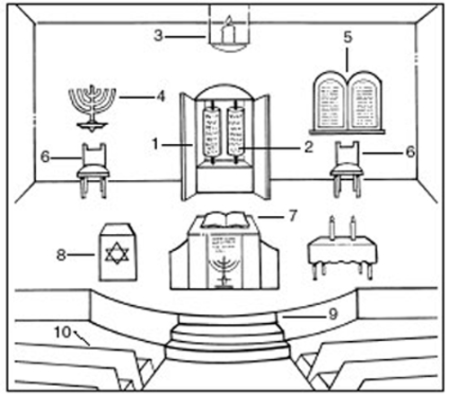

Can you label:
The Ark, The Torah Scrolls, The 10 Commandments,
The Bimah (stand where the Torah is read from)
The Menorah, The Rabbi’s Chair
The Ner Tamid (ever lasting light)

