Goldfinches  Summer 2 Week 3 | Before 9:00am | 9:00 – 10:00 | 10:00-11:00 | 11:00-12:00 | Lunchtime – 12:00 -12.30 | 12:30 – 1.00 | 1:00 – 2:00 | 2:00 – 3:15 | 3.15 – 4:00
Monday | Eat breakfast, make your bed, get washed and dressed, any laundry in the basket. | Family walk with the dog (if you have got one!)  Five-day/indoor exercises/indoor yoga or other exercise if wet.  https://www.youtube.com/user/CosmicKidsYoga  https://www.gonoodle.com/  https://www.nhs.uk/10-minute-shake-up/shake-ups | Work from the packs that have been sent home/CGP books/First4Maths activities/fluency grids/any specified work from the daily blog  TT Rock Stars - https://play.ttrockstars.com/auth/school  https://www.topmarks.co.uk/Search.aspx?q=angles | Creative Time – Lego, drawing, crafting, music, cooking, baking, coding, painting.  coding - https://www.scratchjr.org/ https://code.org/ |  | Tidy Time – Wipe down kitchen table and chairs, wash and dry kitchen dishes, tidy bedroom and lounge | Quiet Time – Reading, Puzzles, Nap (No Electronics) | History –  Research an important Historical Medical Hero.  Create a timeline, report, biography, play about their life and their discovery. | Afternoon Fresh Air – Bike, Walk the dog, play outside.
Tuesday

Wednesday
Thursday
Friday
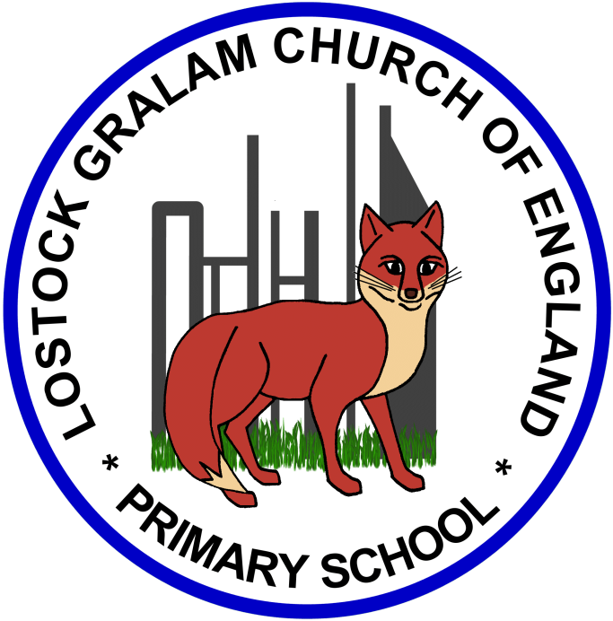
Home Learning – this timetable is intended as a guide to support learning at home during a prolonged period of school closure. We appreciate that you will have differing demands on your time but hope that this helps in continuing ‘a love learning’ at home. We will also be updating the class blog daily with any specific activities that you can do each day and further resources that you may need.
Mrs Evans, Mrs Brennan and Mrs O’Marah
If you have issues with usernames and passwords, please contact admin@lostockgralam.cheshire.sch.uk
Monday  15th June | English: Blue John- I have made a video to help you this week.  https://www.youtube.com/watch?v=ri5V4-Zp3lc&feature=youtu.be  Spelling: Words with different suffixes.  Times Tables: X tables using known facts. Use the 4x table to help you learn the 40x table and the 400x table. Challenge: 0.4x table.  Geography/Art: Lesson 1 (attached) | Geography/Art: Amazon Rainforest  Artist John Dyer takes us on a tour of the Amazon through his vibrant paintings of animal and plant life.  Have a look at the Power points to find out about the native people, plant and animal species. Each power point focuses on a different art technique and they build up to produce a final piece of art. I will attach a lesson each day.  If you are interested in learning more about Rainforests and building on your learning from Year 3 have a look at these David Attenborough programmes:  https://www.bbc.co.uk/iplayer/episode/b0074tgb/planet-earth-8-jungles  https://www.bbc.co.uk/iplayer/episode/b083wt7z/planet-earth-ii-3-jungles  https://www.bbc.co.uk/programmes/m000b9f8  Find out about the IUCN Red List to help you choose an animal https://www.iucnredlist.org/  And find out about other Amazon Rainforest facts.  https://www.natgeokids.com/uk/discover/geography/physical-geography/amazon-facts/  http://www.primaryhomeworkhelp.co.uk/rainforest.html  https://www.chesterzoo.org/schools/resources/which-rainforest-animals-are-at-chester-zoo/
Tuesday  16th June | Reading: Try the Forest Myth comprehension and answer half of the questions (attached)  Geography/Art: Lesson 2 (attached)  Maths: White Rose Maths Y4 Summer 2 week 2 Lesson 2 Halves and quarters. https://whiterosemaths.com/homelearning/year-4/  Spelling: Suffixes
Wednesday  17th June | English: Continue with the Blue John tasks.  Times Tables: Test your tables with https://mathsframe.co.uk/en/resources/resource/544/Stone-Age-Stu-Times-Tables  Mindfulness: Choose a different activity from the pack (attached)  Geography/Art: Lesson 3 (attached)
Thursday  18th June | Reading: Forest Myth comprehension -answer the second half of the questions (attached)  Maths: White rose maths Summer 2 Week 5 Lesson 2 Equivalent fractions. https://whiterosemaths.com/homelearning/year-4/  RE: Continue learning about Islam. Have a go at lesson 2.  https://www.thenational.academy/year-4/foundation/what-do-muslims-believe-year-4-wk5-4  Geography/Art: Lesson 4 (attached)
Friday  19th June | English: SPAG Recap using prepositions with this lesson. https://www.bbc.co.uk/bitesize/articles/zh8nscw  Maths: Fluency grid- choose a 3-digit number to go in the star and solve the calculations.  Reading: Curl up and read your book or listen to a free story from Audible.  Spelling: Have a go at the practise test for suffixes.  Geography/Art: Lesson 5 (attached)

‘A Love for Learning’ – Using the links above, please research each area and respond in the exercise book provided. This could be a written response; fact sheet, poster, poem, non-fiction report, diary entry, newspaper article, diagrams, maps…there are lots of things to learn on each part so break each activity up into sections to study and record.

