Summer Term 2 Week 3 Blue John by Berlie Doherty
Do these activities over two or 3 days this week. https://www.youtube.com/watch?v=ri5V4-Zp3lc&feature=youtu.be – this is me giving you instructions and reading chapter 2.
- Chapter 2 ‘Fire’. Look at the images of stalactites below.
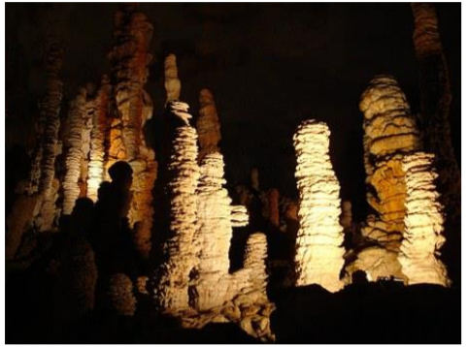
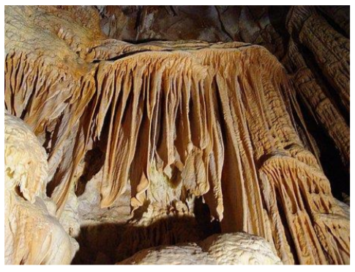
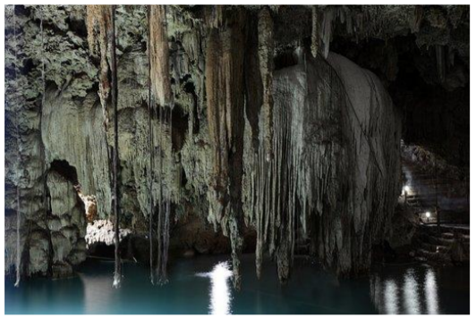
- https://www.kidsdiscover.com/quick-reads/how-stalactites-and-stalagmites-form/ find out about stalactites and how they form.

- The opening words of Chapter 2 are ‘Stalactites grew like…’
Think of your own similes to complete the sentence. Remember a simile uses like or as to compare something e.g. ‘The ash fluttered down like snowflakes’ and ‘Her hands were as cold as icicles’

- When you have thought of 3 or 4 similies for the stalactites, you can join them all together in a list like the next part of the story:
‘Stalactites grew like coral, like twisted icicles, like the horns of unicorns, like the crooked teeth of goblins.’

- Watch the video clip of me reading Chapter 2. If you like drama, you could re-enact the part of Blue John waking from his thousand-year sleep, as I read from ‘And still Blue John slept...’ to ‘The Queen of Darkness laughed and put her strong comforting arms around him’

- Dictionary work: (use a dictionary or google dictionary) find out the meaning of the words:
- Picks
- Ledge
- Any other words you are unsure of.

- Write a description of what Blue John could see, hear, feel or even smell in the cave around him. Try and imagine what it might feel like for him, what he is thinking and what he might want to do next.
- Write in the third person (he, him, his)
- Use your senses
- Use fronted adverbials e.g. ‘All around him, he could hear…
‘In the distance, was ….’ ‘Beneath his feet, he could feel….’
- Use these ideas to help you
