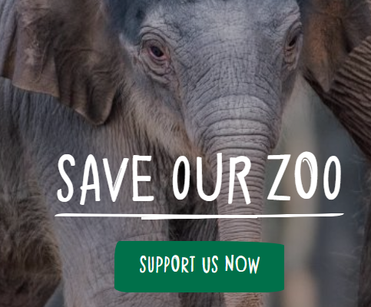
Dear Parents/Carers

Many of you may be aware that Chester Zoo is experiencing great financial difficulty during these challenging times. Despite the fact that places like Primark and Alton Towers are getting ready to re-open, Chester Zoo has been told to remain closed. Our partnership with the zoo project and all our conservation work last year has made Chester Zoo a place close to our hearts and I know many of you will be greatly saddened by the Zoo’s struggles.
Our conservation partners Ignite have asked for our help once again in reaching out to the powers above in a bid to share our voice. Please see extract below:

Dear Zoo Project Schools,

As I am sure many of you know, Chester Zoo is facing a challenge right now. We want to show our support and let the world know how vital their conservation work is.

Over the past three years we have built an army of conservationists and we have been blown away by the passion both the children and staff have shown us and the commitment to help prevent extinction.

We think it would be extremely powerful if we could create a video from all of our schools to let people know how important the zoo's work is. We would love for you to film some of your pupils talking about their engagement in the Ignite Zoo Project and how they have been inspired to make a difference. They could talk about why the zoo is so important and how it has helped them to become a conservationist. The videos only have to be up to 20/30 secs long. Please encourage your families to record videos at home and send them to you.

As you saw last year, the levels of passion and engagement from the children were amazing and I have no doubt they will do the most incredible job of this. If you would like to be involved, please make a video (no longer than 20 seconds long) sharing why the Zoo is so important to you and its importance in the conservation of many species of animal. Please send it via admin (admin@lostockgralam.cheshire.sch.uk) to Mrs Evans. The Ignite team are going to put some of the videos we send together in order to send a ‘Powerful message to those who make the decisions’. By sending the video, you are confirming your parental permission for me to send your video to be shared for wider use in social media.

I have worked with my children at home to have a go at doing this and have tweeted these as examples. https://twitter.com/LostockGralamPr

Kind Regards,
Jenny Evans

