Year 3  Robins | Before 9:00am | 9:00 – 10:00 | 10:00-11:00 | 11:00-12:00 | 12 – 12.30 | 12:30 – 1.00 | 1:00 – 2:00 | 2:00 – 3:15 | 3.15 – 4:00
Monday | Eat breakfast, make your bed, get washed and dressed and put any laundry in the basket. | Family walk (with the dog - if you have got one!)  Five-a-day/indoor exercises/indoor yoga if wet.  https://www.youtube.com/user/CosmicKidsYoga  https://www.gonoodle.com/  https://www.nhs.uk/10-minute-shake-up/shake-ups | Maths/Writing work from the packs, blogs or any of the following links:  TT Rock Stars - https://play.ttrockstars.com/auth/school  White Rose - https://whiterosemaths.com/homelearning/  I see reasoning - http://www.iseemaths.com/home-lessons/  The literacy company - http://www.theliteracycompany.co.uk/free-resources/  Oak National Academy - https://www.thenational.academy/online-classroom/year-3/ | Creative Time – Lego, drawing, crafting, music, cooking, baking, coding, painting.  coding - https://www.scratchjr.org/  https://code.org/ | Lunchtime | Tidy Time – Wipe down kitchen table and chairs, wash and dry kitchen dishes, tidy bedroom and lounge. | Quiet Time – Reading, Puzzles, Nap (No Electronics) | History/Geography  (See tasks on the next page) | Afternoon Fresh Air – Bike, Walk the dog, play outside.
Tuesday |  |  |  |  |  |  |  | Science  (See tasks on the next page)
Wednesday |  |  |  |  |  |  |  | History/Geography  (See tasks on the next page)
Thursday |  |  |  |  |  |  |  | Science  (See tasks on the next page)
Friday |  |  |  |  |  |  |  | RE  (See tasks on the next page)
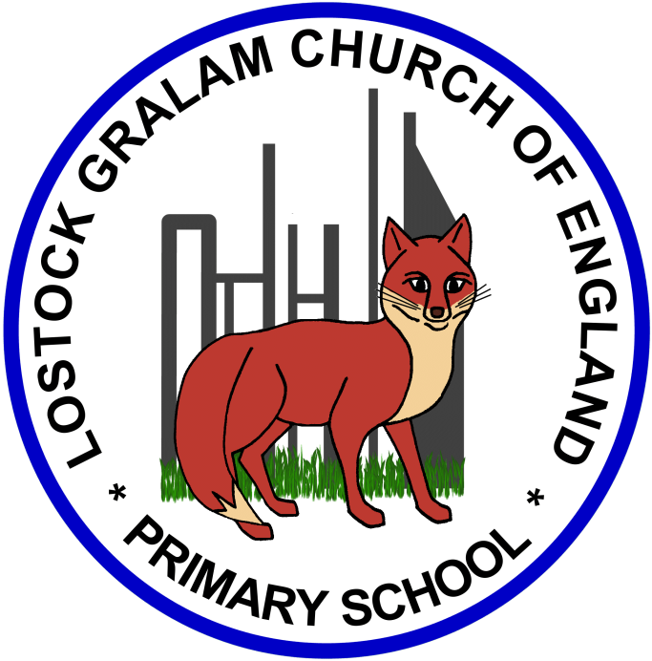
Home Learning – this timetable is intended as a guide to support learning at home during a prolonged period of school closure. We appreciate that you will have differing demands on your time but hope that this helps in continuing ‘a love learning’ at home. We will also be updating the class blog daily with any specific activities that you can do each day and further resources that you may need.
Under the timetable and suggested task list, I will also include a long list of free resources and websites that you may wish to use.
If you have issues with usernames and passwords, please contact admin@lostockgralam.cheshire.sch.uk

Weeks commencing 1.06.20 and 8.06.20:
Remember these projects will take you multiple days to complete – just do a little bit at a time
History and Geography  (Art Link) | History/Geography Projects – Ancient Civilisations continued (Art Link)  - I would like you to create a piece of art linked to Ancient Egypt and the burial masks they used.  - Look at this slideshow to learn more about Ancient Egyptian burial masks: https://www.slideshare.net/LRoseH/egyptian-burial-masks  - Before we make our own burial mask, you could sketch out your design, using the above PowerPoint as inspiration.  - Here are some YouTube Tutorials and step by step guides on how to draw Tutankhamun’s mask:  https://www.youtube.com/watch?v=hBQW27Sdxxk  https://www.youtube.com/watch?v=Ecg96d_MkMg  (Or of course you could design your own unique mask instead)  - When you are happy with your design, you can now bring your mask to life.  - Using, cardboard, newspaper, papier mache, paint, etc. you could make your design into a 3D mask. I have included links to demonstration videos below:  https://www.youtube.com/watch?v=5rbSh30Fhls  https://www.youtube.com/watch?v=JXU3Vd-c5sk  https://www.youtube.com/watch?v=ttp1B6E1BaU&t=5s  Please share your creations with me on Twitter!! I can’t wait to see them | 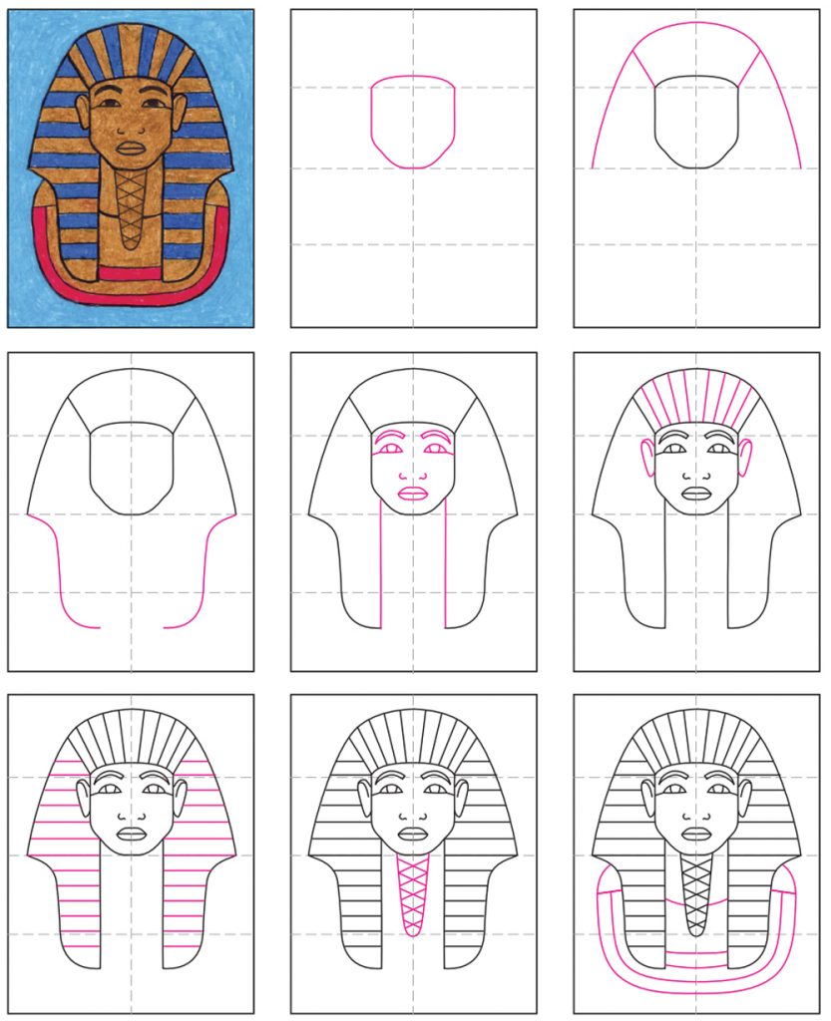
Science | Science Projects – Rocks and Soils (We have already covered this topic in school so let’s see what you remember)  We will focus on fossils and how they are made next week.  There is a lesson on the STEM website entitled ‘Rocks and Soils’ which includes a PowerPoint presentation and worksheet/activities.  https://www.stem.org.uk/remote-lessons/key-stage-2  - What is a rock? What is soil?  - You could go on a rock hunt around your local area (e.g. gravestones, old buildings, stones in your garden, rocks on the beach)  - Can you remember any specific names of rocks and soils? What are the 3 different types of rocks?  - Can you group rocks based on their properties (e.g. colour, texture, size, weight, etc.)?  Task: Can you become a rock detective and create a Rock Guide for others? You could draw and annotate some rocks describing their properties and where they can be found.  Useful Websites –  https://geology.com/rocks/ - Rock Classification Guide  https://www.stem.org.uk/resources/community/collection/12367/year-3-rocks  https://www.theschoolrun.com/what-are-igneous-sedimentary-and-metamorphic-rocks  https://www.bbc.co.uk/bitesize/topics/z9bbkqt  https://www.ducksters.com/science/rocks.php
RE | RE Projects – Islam  Recap: What can you remember from our first Islam topic? Who follows Islam? Who is Allah?  - Think about your personal items that are special to you – How do you treat them and how would you like others to treat them?  - Christians believe the bible is very special and should be treated with respect. What is the Muslim Holy Book called?  - Watch these short video clips about a man named Muhammad:  https://www.bbc.co.uk/bitesize/clips/zympvcw  https://www.bbc.co.uk/bitesize/clips/zv6sb9q  - So Muslims believe that the Qur’an is also a very special book because it is believed to be the words of Allah.  - Can you use the following video and website to help you describe how Muslims treat the Qu’ran? – What do they do before reading it? Where is it stored? How do they show respect towards it?  - You could draw a picture of a Qu’ran in the middle of your page and annote how Muslims treat it and show respect towards it around it.  https://www.bbc.co.uk/programmes/b05pc1c9  https://www.bbc.co.uk/bitesize/guides/zpmm97h/revision/3

Online classrooms:
https://www.thenational.academy/online-classroom
https://www.bbc.co.uk/bitesize/dailylessons

Maths
https://whiterosemaths.com/homelearning/year-3/
http://www.iseemaths.com/home-lessons/

Times Tables
https://ttrockstars.com/
https://www.topmarks.co.uk/maths-games/hit-the-button

Spellings
https://spellingframe.co.uk/

PE
https://www.youtube.com/watch?v=X655B4ISakg
https://www.youtube.com/user/CosmicKidsYoga
https://www.gonoodle.com/
https://www.nhs.uk/10-minute-shake-up/shake-ups

