Year 5  Skylarks | Before 9:00am | 9:00 – 10:00 | 10:00-11:00 | 11:00-12:00 | Lunchtime – 12:00 -12.30 | 12:30 – 1.00 | 1:00 – 2:00 | 2:00 – 3:15 | 3.15 – 4:00
Monday | Eat breakfast, make your bed, get washed and dressed, any laundry in the basket. | Family walk with the dog (if you have got one!)  Five-day/indoor exercises/indoor yoga or other exercise if wet.  https://www.youtube.com/user/CosmicKidsYoga  https://www.gonoodle.com/  https://www.nhs.uk/10-minute-shake-up/shake-ups | Work from the pages that have been sent home about decimals and timetables. Use CGP maths books alongside to complete any activities that will support this learning.  TT Rock Stars - https://play.ttrockstars.com/auth/school | Creative Time – Lego, drawing, crafting, music, cooking, baking, coding, painting.  Apps such as: book creator, quiver, tynker and imovie (all free)  coding - https://www.scratchjr.org/ https://code.org/ |  | Tidy Time – Wipe down kitchen table and chairs, wash and dry kitchen dishes, tidy bedroom and lounge | Quiet Time – Reading, Puzzles, Nap (No Electronics) | Spend this time working on the project given for the week. | Afternoon Fresh Air – Bike, Walk the dog, play outside.
Tuesday

Wednesday
Thursday
Friday
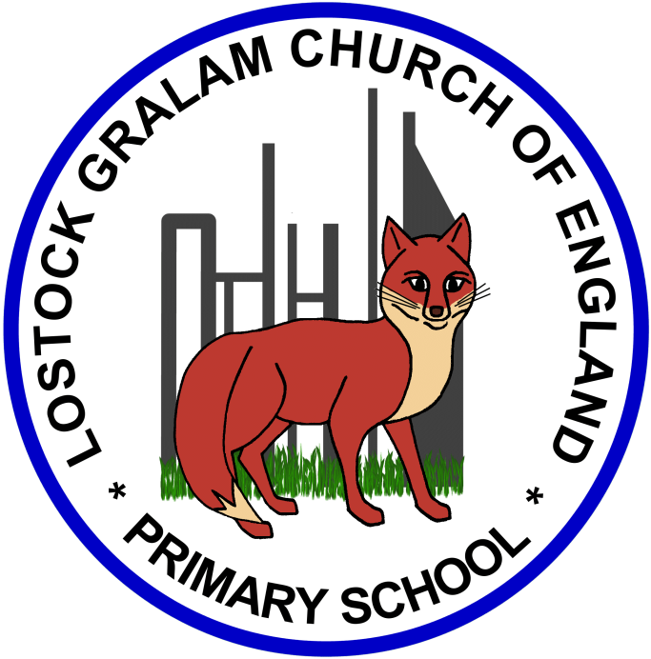
Home Learning – this timetable is intended as a guide to support learning at home during a prolonged period of school closure. We appreciate that you will have differing demands on your time but hope that this helps in continuing ‘a love learning’ at home. We will also be updating the class blog daily with any specific activities that you can do each day and further resources that you may need.
Miss Thwaites
If you have issues with usernames and passwords, please contact admin@lostockgralam.cheshire.sch.uk
Monday | The Last Chance to Paint (Borneo) Project:  Last year, you will remember being a key part to our palm oil project which we launched through researching different animals from the zoo. You were key members in our campaign and came up with some brilliant ideas and created the ‘Make One Change’. You were so invested in your learning and loved doing independent research and writing persuasively to ensure that people chose products that did not contain palm oil. For this week’s project, I would like you to think back to all the work you did last year and create a mini topic project which will recap your learning perfectly.  You are all super creative and brilliant artists and I know this will be an enjoyable project to complete.  Art and Design focus:  Follow this link which provides the outlines of the drawings you will complete. You can make a sketch book of your drawings and as a whole put the drawings together to make a piece of art that captures the life in Borneo. Think about the mood of the piece you will be creating? Is the scene sad or happy? What colours are you going to use that show off the mood? Could you add in some key words to your art using different forms (Newspaper cut letters for example) and attach these to your piece to make it persuasive?  file:///H:/Downloads/Born%20Free%20-%20Learn%20at%20Home%20Activity%20Pack%20(KS2)%20Art%20and%20Drama%20v3%20BB%20SC.pdf  Focus on slides 2-20.  If you want to share your finished piece of work with others then you can submit it to the following page: https://www.lastchancetopaint.com/submit-your-art/  Please also tweet the work that you have produced as I love seeing all of your achievements!  P.S. I know slide 15 will particularly interest you as it was the animal you researched for our project last year!
Tuesday

Wednesday

Thursday

Friday

