Goldfinches  Summer 2 Week 2 | Before 9:00am | 9:00 – 10:00 | 10:00-11:00 | 11:00-12:00 | Lunchtime – 12:00 -12.30 | 12:30 – 1.00 | 1:00 – 2:00 | 2:00 – 3:15 | 3.15 – 4:00
Monday | Eat breakfast, make your bed, get washed and dressed, any laundry in the basket. | Family walk with the dog (if you have got one!)  Five-day/indoor exercises/indoor yoga or other exercise if wet.  https://www.youtube.com/user/CosmicKidsYoga  https://www.gonoodle.com/  https://www.nhs.uk/10-minute-shake-up/shake-ups | Work from the packs that have been sent home/CGP books/First4Maths activities/fluency grids/any specified work from the daily blog  TT Rock Stars - https://play.ttrockstars.com/auth/school  https://www.topmarks.co.uk/Search.aspx?q=angles | Creative Time – Lego, drawing, crafting, music, cooking, baking, coding, painting.  coding - https://www.scratchjr.org/ https://code.org/ |  | Tidy Time – Wipe down kitchen table and chairs, wash and dry kitchen dishes, tidy bedroom and lounge | Quiet Time – Reading, Puzzles, Nap (No Electronics) | History –  Research an important Historical Medical Hero.  Create a timeline, report, biography, play about their life and their discovery. | Afternoon Fresh Air – Bike, Walk the dog, play outside.
Tuesday

Wednesday
Thursday
Friday
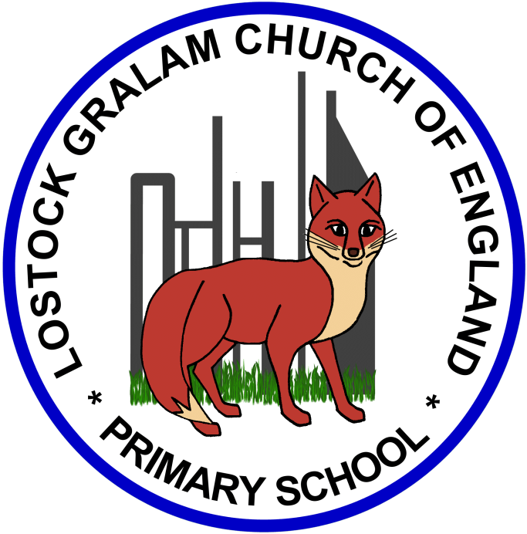
Home Learning – this timetable is intended as a guide to support learning at home during a prolonged period of school closure. We appreciate that you will have differing demands on your time but hope that this helps in continuing ‘a love learning’ at home. We will also be updating the class blog daily with any specific activities that you can do each day and further resources that you may need.
Mrs Evans, Mrs Brennan and Mrs O’Marah
If you have issues with usernames and passwords, please contact admin@lostockgralam.cheshire.sch.uk
Monday  8th June | English: Blue John  Spelling: Y3/4 words Column 6  Times Tables: TTRock stars and 3x, 6x and 9x tables revision with the Super Movers  https://www.bbc.co.uk/teach/supermovers/ks2-maths-the-3-times-table/z6sw382  https://www.bbc.co.uk/teach/supermovers/ks2-maths-the-6-times-table-with-fred-the-red/zrq3xyc  https://www.bbc.co.uk/teach/supermovers/ks2-maths-the-9-times-table/zr2gt39 | Geography: Caves  On our residential we would have gone down the Great Orme Copper Mine in Llandudno. What can you find out about The Great Orme Copper Mine in Llandudno?  1.Collect facts and information.  2.Make an information poster or leaflet or video yourself making an advert for the Great Orme Mines. https://www.greatormemines.info/  https://www.historic-uk.com/HistoryUK/HistoryofWales/The-Great-Orme-Mines/  Repeat from last week:  What can you find out about caves? Can you paint, draw, make a cave out of cardboard or Lego? What are the special features of caves you have found out about? What are the new words you have learned? What is Blue John?  https://bluejohnstone.com/gallery/#videoSection  https://kids.britannica.com/kids/article/cave/352930  http://www.bbc.com/earth/story/20170221-filming-inside-a-giant-bat-cave  https://www.bbc.co.uk/programmes/p0091ycj  https://easyscienceforkids.com/stalactites-and-stalagmites-video-for-kids/
Tuesday  9th June | Reading: Read all about The Great Orme Copper Mine  Maths: Remind yourself about decimals with the Super Mover https://www.bbc.co.uk/teach/supermovers/ks2-maths-decimals-fractions-with-naomi-wilkinson/zf2gt39 and have a look at the BBC Bitesize lesson and activities on tenths.  https://www.bbc.co.uk/bitesize/articles/zvyrkxs
Wednesday  10th June | English: Blue John  Spelling: Y3/4 words Column 6  Times Tables: 3x 6x and 9x division facts  Mindfulness: Choose a different activity from the pack (attached)
Thursday  11th June | Reading: Choose a comprehension from your pack.  Maths: Tenths as decimals with White Rose Maths Week 1 Lesson 1  RE: We would have been learning about the religion of Islam during this half term. There are a series of lessons on Islam. Have a go at lesson 1.  https://www.thenational.academy/year-4/foundation/how-did-the-religion-of-islam-begin-year-4-wk5-1
Friday  12th June | English: SPAG Pronouns and Nouns. Have a look at this bitesize lesson to recap your knowledge. https://www.bbc.co.uk/bitesize/articles/z64q7nb  Maths: Fluency grid- choose a 3-digit number to go in the star and solve the calculations.  Reading: Curl up and read your book or listen to James and the Giant Peach https://www.roalddahl.com/taika-and-friends  Spelling: Have a go at the practise test on Spelling Frame or make up your own test.

‘A Love for Learning’ – Using the links above, please research each area and respond in the exercise book provided. This could be a written response; fact sheet, poster, poem, non-fiction report, diary entry, newspaper article, diagrams, maps…there are lots of things to learn on each part so break each activity up into sections to study and record.

