**Challenge 1**

**Varied Fluency**

1. Complete these sequences in your book.

a. ___, 9, 18, 27, ___, 45

b. 54, ___, 72, ___, 90

c. 36, ___, 54, 63, ___, ___

2. Circle the multiples of 9 in each of the clouds.

3. Colour the multiples of 9 in the 100 square.

What do you notice about the pattern created? Can you explain this pattern?

**Challenge 1**

**Varied Fluency**

1. Complete these sequences in your book.

a. ___, 9, 18, 27, ___, 45

b. 54, ___, 72, ___, 90

c. 36, ___, 54, 63, ___, ___

2. Circle the multiples of 9 in each of the clouds.

3. Colour the multiples of 9 in the 100 square.

What do you notice about the pattern created? Can you explain this pattern?

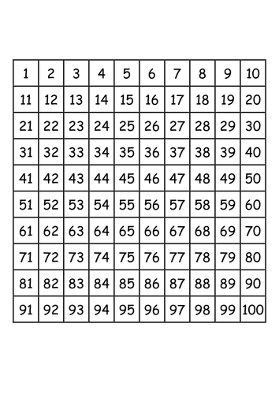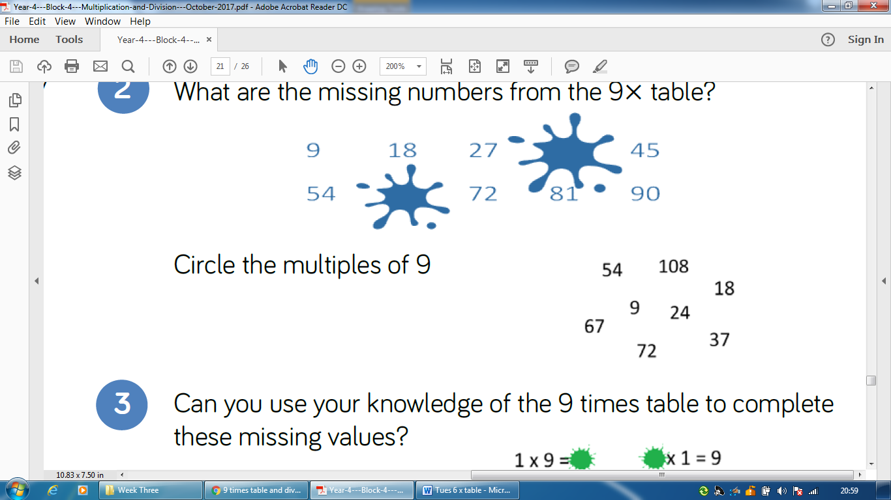

63

90

0

83

100

26

83

100

26

0

90

63

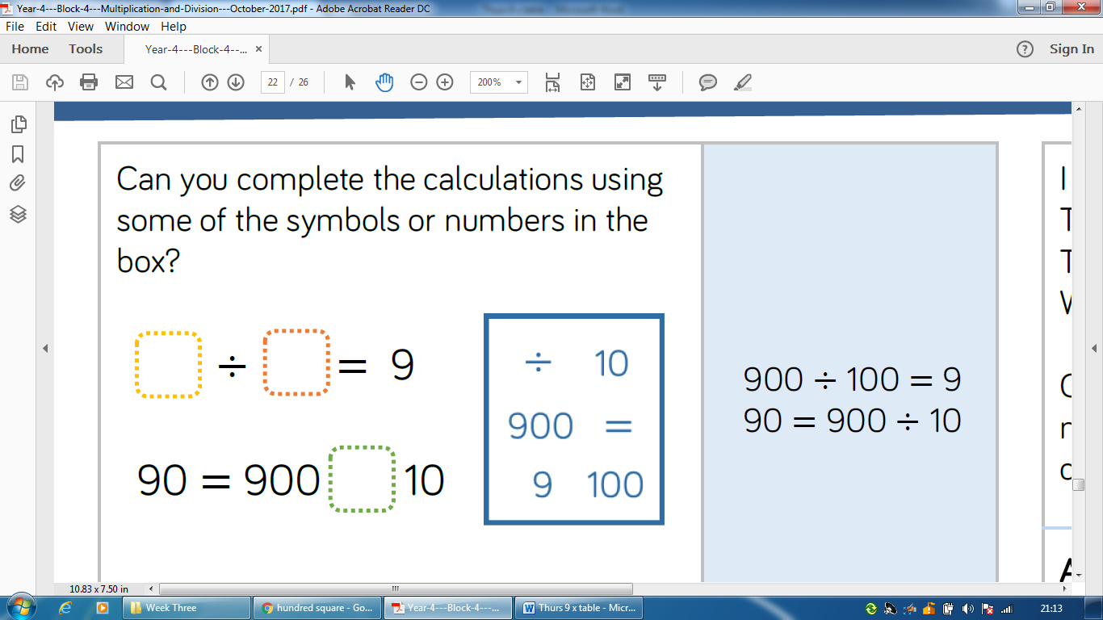

Challenge 2

Reasoning and Problem Solving

Challenge 2

Reasoning and Problem Solving



Challenge 3

Reasoning and Problem Solving

**Always, Sometimes or Never?**

All multiples of 9 have digits which have a sum of 9.

Prove it!

Challenge 3

Reasoning and Problem Solving

**Always, Sometimes or Never?**

All multiples of 9 have digits which have a sum of 9.

Prove it!

Extra Challenge

Reasoning and Problem Solving

I am thinking of 2 numbers where the sum of the numbers is 17 and the product is 72.

What are my numbers?

Extra Challenge

Reasoning and Problem Solving

I am thinking of 2 numbers where the sum of the numbers is 17 and the product is 72.

What are my numbers?