Class Discussion – Pupil Guidance

1. Log in to the pupil area of our school website using your personal PUPIL login details (Parents can access their child’s login details through their parent VLE)
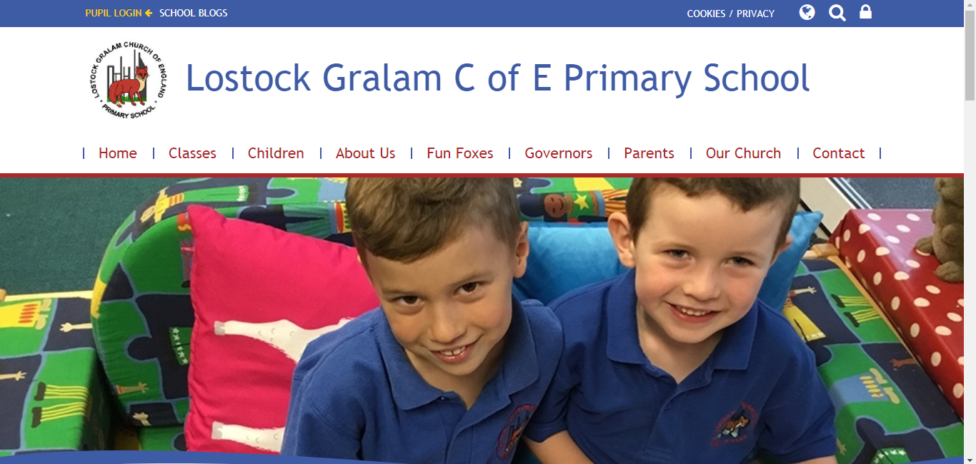

2. Your dashboard will load. Click the ‘Discussions’ tab at the top of the page.
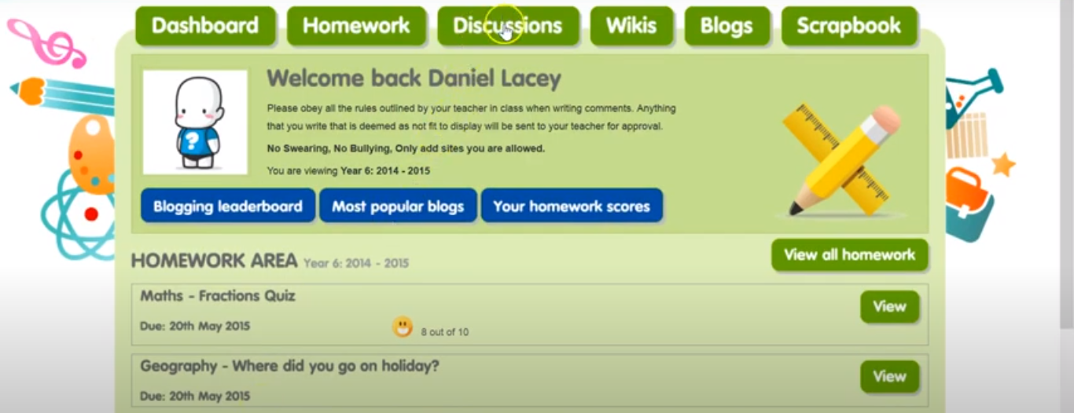

3. Your discussions page will load with any discussions that your teacher has started – There will be a new discussion each morning. Click ‘View’ on the discussion started for that day.
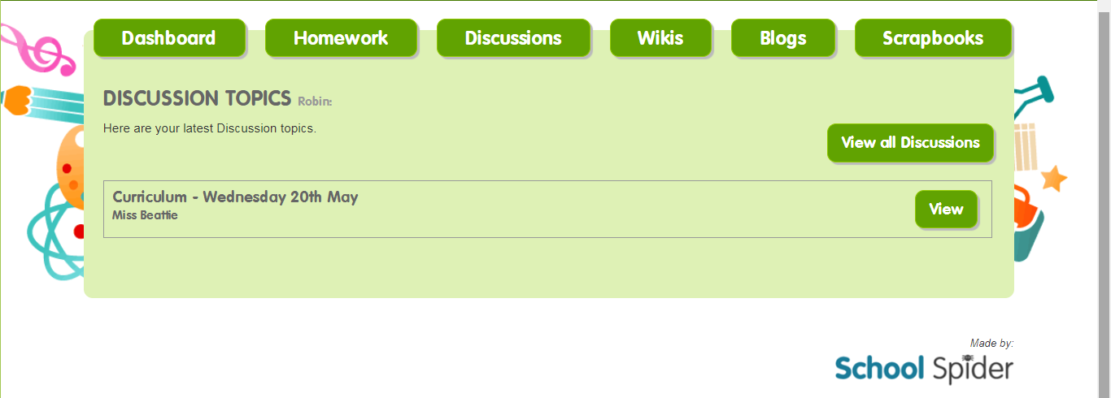
4. You can now reply to your teacher, ask any questions you might have, share a photo or upload any work that you have completed online. Your comments and work will be visible to the rest of the children in your class and you will also be able to see comments and work shared by your peers. Click ‘Post your reply’ when you are finished.
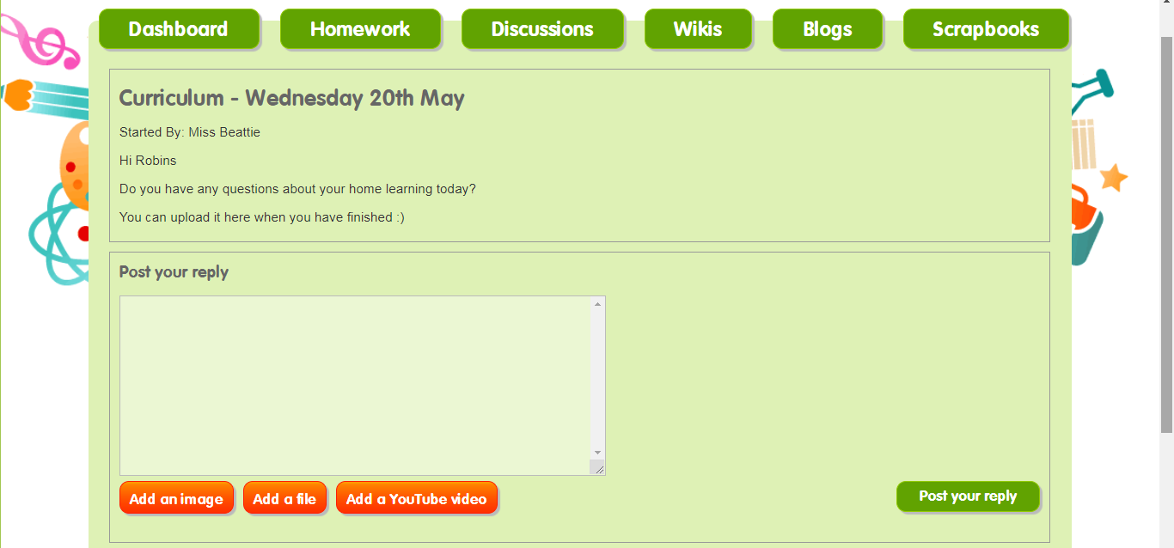

5. Keep checking the discussion for feedback from your teacher or an answer to your question – we will get back to you as soon as possible.

