HABITAT AND ENVIRONMENT CARDS
Identify the habitat of the plant or animal, as you hear its name.

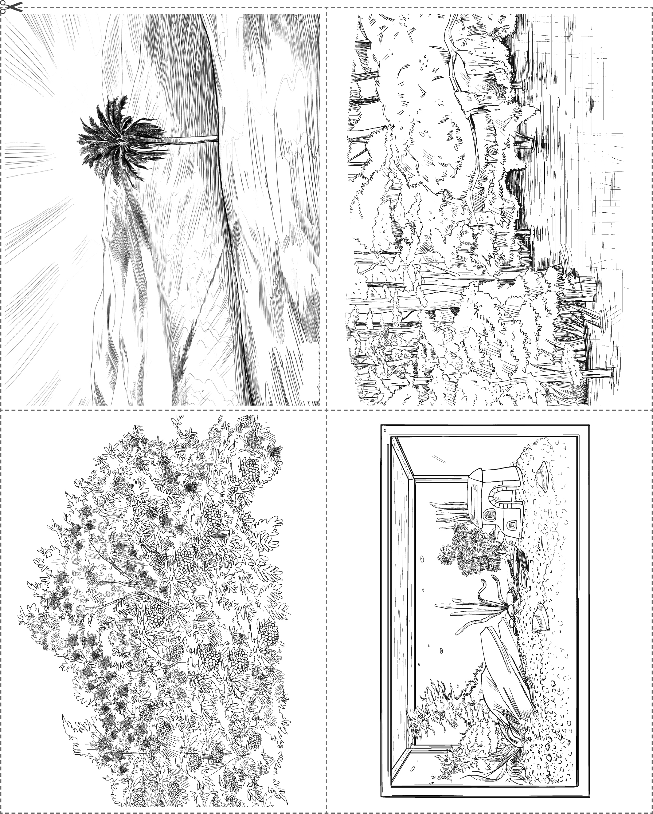

SwampSwamp
Desert

Aquarium

Bush

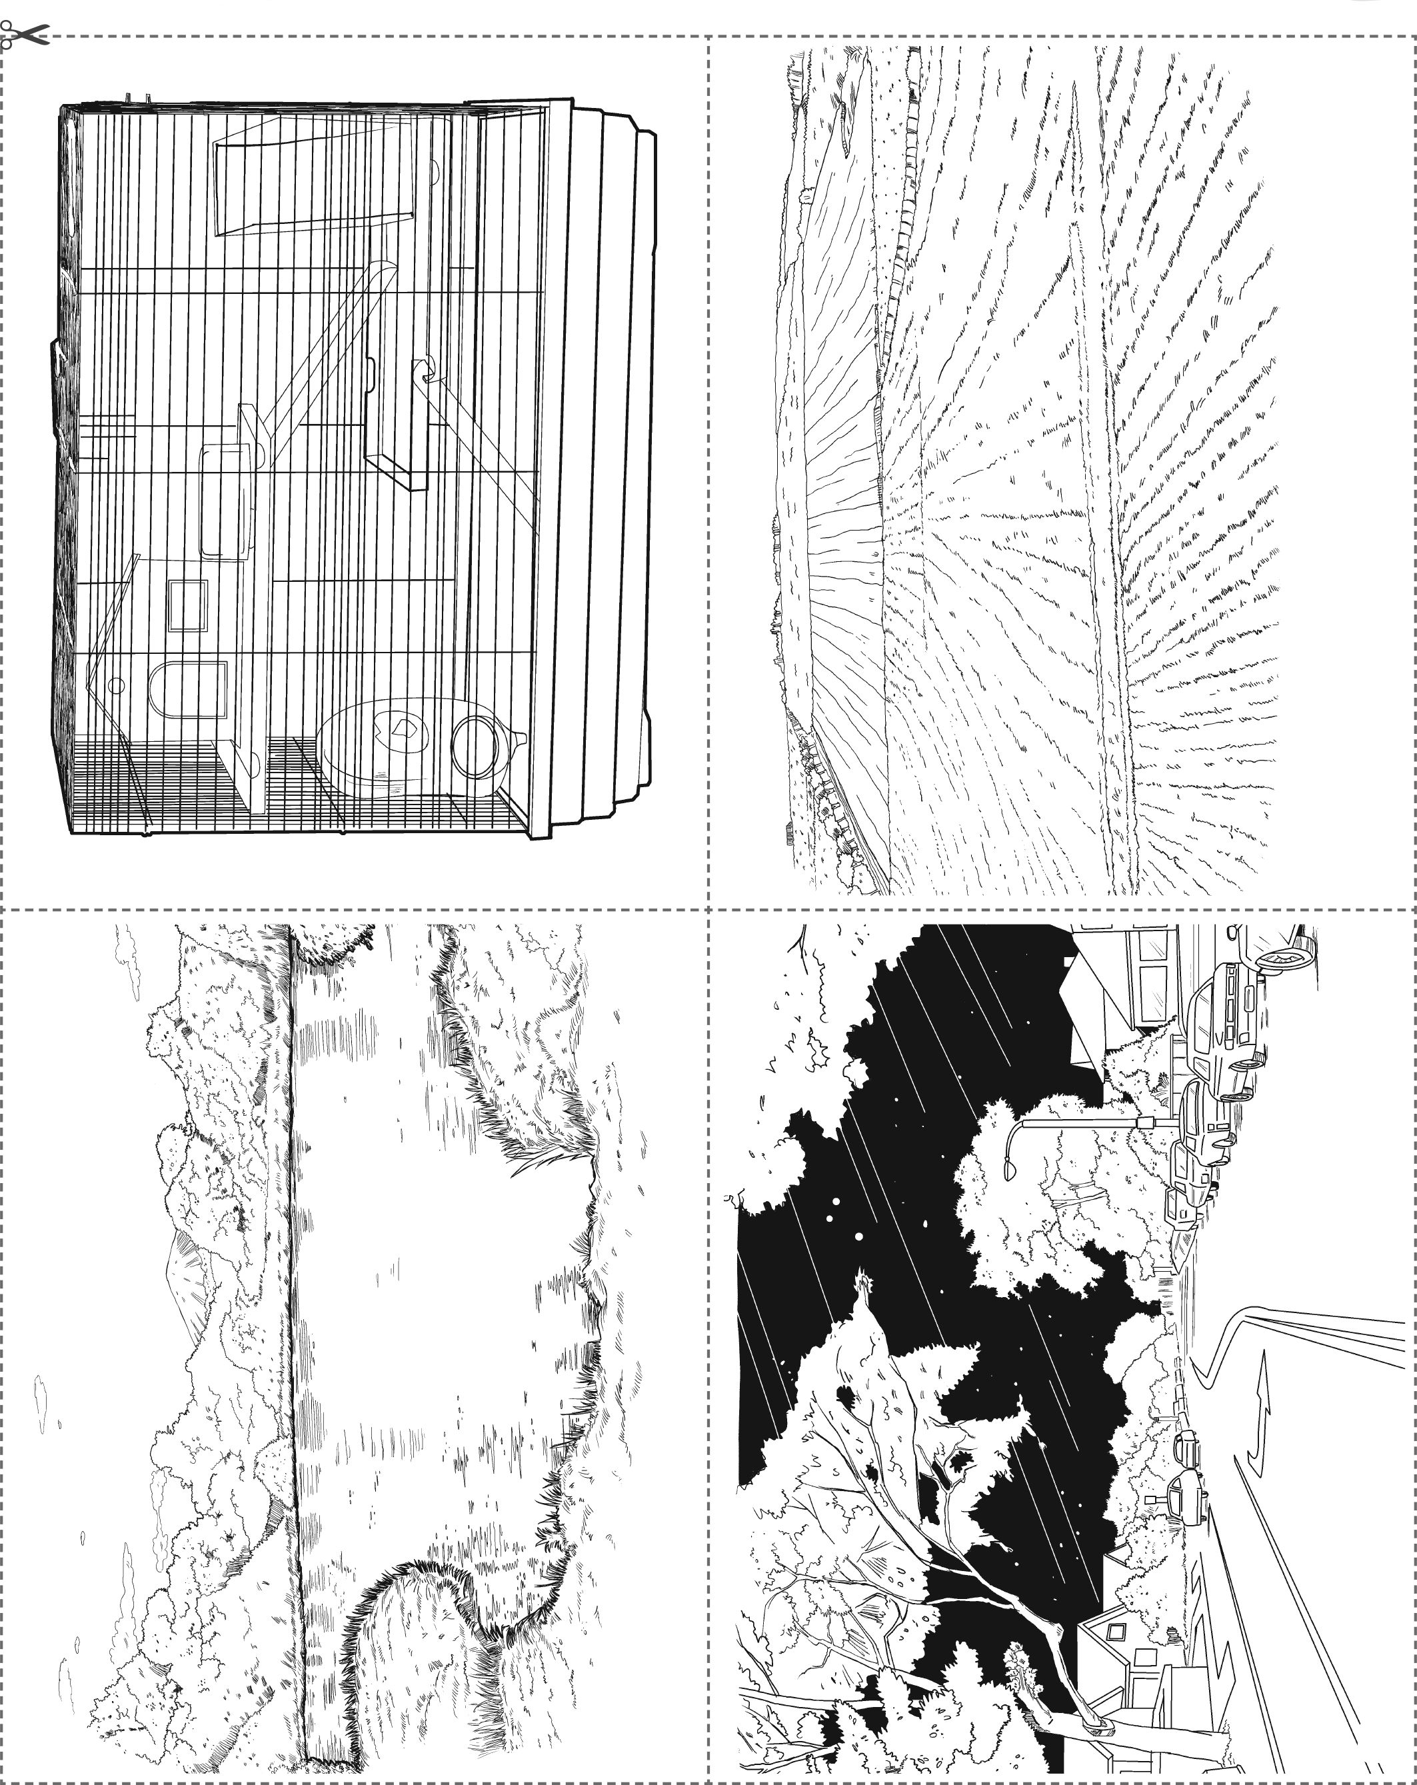
HABITAT AND ENVIRONMENT CARDS

Field
Cage

Pond Pond
Street

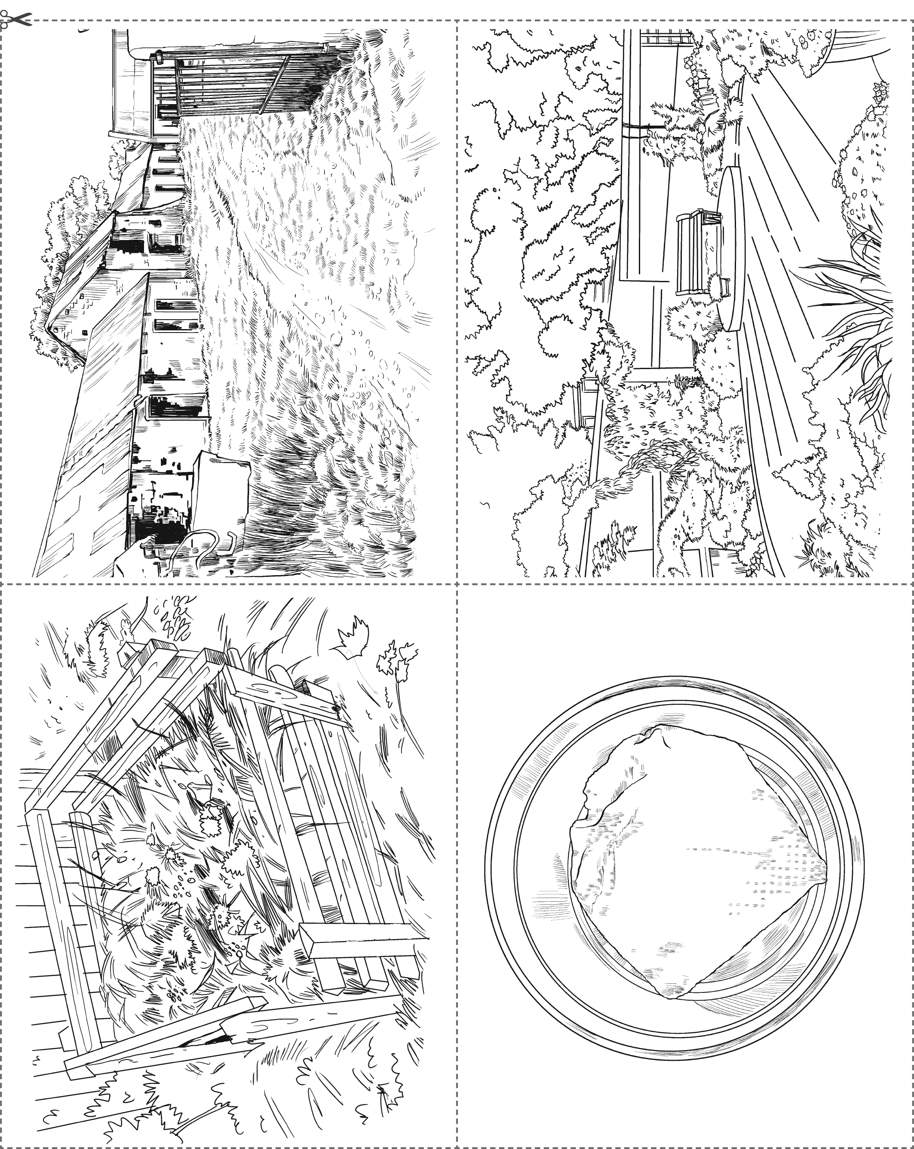
HABITAT AND ENVIRONMENT CARDS

StreetStree
Farmyard
Garden

Damp kitchen paperDamp kitchen paper

Compost heap Compost heap

