Goldfinches  Summer 2 Week 1 | Before 9:00am | 9:00 – 10:00 | 10:00-11:00 | 11:00-12:00 | Lunchtime – 12:00 -12.30 | 12:30 – 1.00 | 1:00 – 2:00 | 2:00 – 3:15 | 3.15 – 4:00
Monday | Eat breakfast, make your bed, get washed and dressed, any laundry in the basket. | Family walk with the dog (if you have got one!)  Five-day/indoor exercises/indoor yoga or other exercise if wet.  https://www.youtube.com/user/CosmicKidsYoga  https://www.gonoodle.com/  https://www.nhs.uk/10-minute-shake-up/shake-ups | Work from the packs that have been sent home/CGP books/First4Maths activities/fluency grids/any specified work from the daily blog  TT Rock Stars - https://play.ttrockstars.com/auth/school  https://www.topmarks.co.uk/Search.aspx?q=angles | Creative Time – Lego, drawing, crafting, music, cooking, baking, coding, painting.  coding - https://www.scratchjr.org/ https://code.org/ |  | Tidy Time – Wipe down kitchen table and chairs, wash and dry kitchen dishes, tidy bedroom and lounge | Quiet Time – Reading, Puzzles, Nap (No Electronics) | History –  Research an important Historical Medical Hero.  Create a timeline, report, biography, play about their life and their discovery. | Afternoon Fresh Air – Bike, Walk the dog, play outside.
Tuesday

Wednesday
Thursday
Friday
Home Learning – this timetable is intended as a guide to support learning at home during a prolonged period of school closure. We appreciate that you will have differing demands on your time but hope that this helps in continuing ‘a love learning’ at home. We will also be updating the class blog daily with any specific activities that you can do each day and further resources that you may need.
Mrs Evans, Mrs Brennan and Mrs O’Marah
If you have issues with usernames and passwords, please contact admin@lostockgralam.cheshire.sch.uk
Monday  1st June | English: Blue John by Berlie Doherty. See attached lesson.  Spelling: Y3/4 words Column 6  https://spellingframe.co.uk/spelling-rule/72/34-Word-list-years-3-and-4---sep--to-su-  Times Tables: TTRock stars and practise your 2x 4x and 8x table. | Geography: Caves  Our new class book is called Blue John by Berlie Doherty and is set in a cave.  What can you find out about caves? Can you paint, draw, make a cave out of cardboard, an old shoebox, playdoh, moon sand or Lego?  What are the special features of caves you have found out about? What are the new words you have learned? What is Blue John? Where are the Blue John Caverns?  https://bluejohnstone.com/gallery/#videoSection  https://www.bluejohn-cavern.co.uk/  https://kids.britannica.com/kids/article/cave/352930  http://www.bbc.com/earth/story/20170221-filming-inside-a-giant-bat-cave  https://www.bbc.co.uk/programmes/p0091ycj  https://easyscienceforkids.com/stalactites-and-stalagmites-video-for-kids/
Tuesday  2nd June | Reading: Choose a comprehension from your pack or one of the pick and mix activities.  Maths: Dividing a 2-digit by 1-digit number. Summer term WEEK 3 LESSON 3. https://whiterosemaths.com/homelearning/year-4/  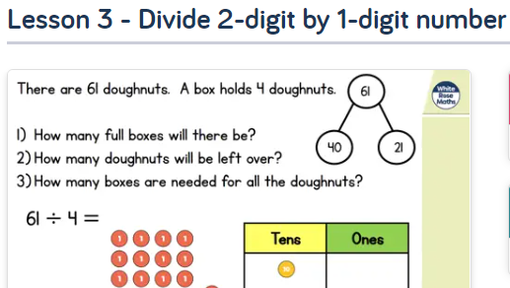
Wednesday  3rd June | English: Continue with the Blue John activities (attached)  Spelling: Y3/4 words Column 6  https://spellingframe.co.uk/spelling-rule/72/34-Word-list-years-3-and-4---sep--to-su-  Times Tables: 2x 4x 8x division facts  Mindfulness: Activity pack attached and a link to calm music while you relax https://www.youtube.com/watch?v=qFZKK7K52uQ
Thursday  4th June | Reading: First News attached- which article has captured your interest most?  Maths: Dividing a 3-digit number by a 1-digit number. Summer Term WEEK 3 LESSON 4 https://whiterosemaths.com/homelearning/year-4/  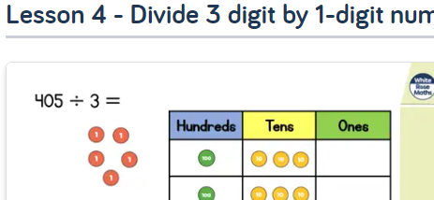
Friday  5th June | English: SPAG- Possessive apostrophe. Attached poster to support https://www.bbc.co.uk/bitesize/topics/zvwwxnb/articles/zx9ydxs  Maths: Fluency grid- choose a 3-digit number to go in the star and solve the calculations.  Reading: Chapter 1 of Blue John https://issuu.com/barringtonstoke/docs/blue_john_chapter_samples  Spelling: Have a go at the online practise test for this week’s words.  https://spellingframe.co.uk/spelling-rule/50/32-Word-list-years-3-and-4---or--to-pre-

