Summer Term 2 Week 1 Blue John by Berlie Doherty
Blue John is a children’s folk tale written by Berlie Doherty to accompany a piece of music entitled ‘From My Life’ by the 19th century Czech composer, Smetana.
Berlie was inspired by the Blue John Caverns near her home in Derbyshire.
These are suggested activities to do over 2 sessions this week.
- Look at the images of caves from the Blue John Mine at Treak Cliff Cavern. https://bluejohnstone.com/gallery/#videoSection
- Now listen to the music by Smetana.
https://www.barringtonstoke.co.uk/blog/2017/02/27/getting-to-know-blue-john/
- Draw and write your ideas about what sort of story you might be inspired to write.
- Collect words and phrases describing the caves and what it feels like to be inside one.
Things to talk about: What kinds of stories are set in caves? Do you know any? Are there any common themes among the stories you know? (Myths - Cyclops, Theseus and the Minotaur, smuggling stories or prehistoric tales).
- Look closely at the picture of the cover and of the inside cover: Think and talk to someone about your predictions about the story.
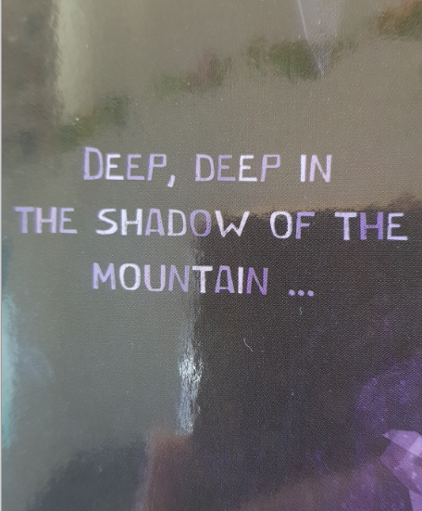
- Can you complete this sentence with your own ideas? ‘Deep, deep in the shadow of the mountain…’

