**How to make using sounds for spelling fun!**

Whilst practice spellings, why not try to make it fun:

Write each sound in a different colour.

e.g. make look



Roll and Spell.

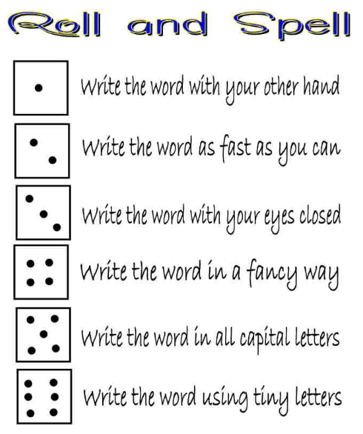

Make spelling

flashcards.

Play word hunt. Verbally say a sentence then write it.

Cut out letters from newspapers or magazines to spell words.

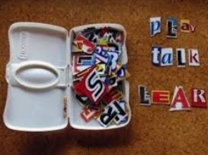

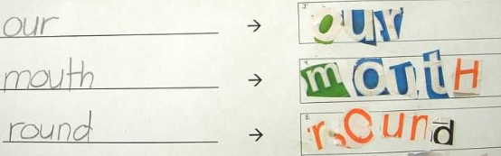

Select the word, build the word and write the word.

OR Draw the word, build the word and write the word.

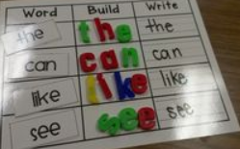 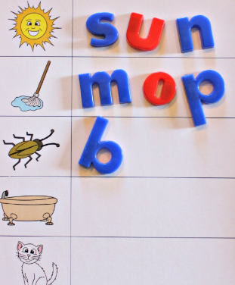

Use magnetic letters on a fridge, tray or tin box to spell the word.

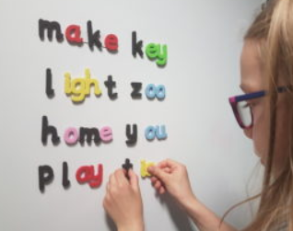 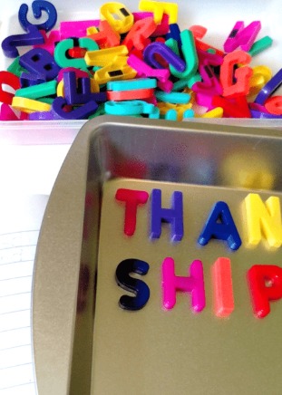

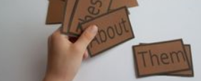

Verbally say the sounds of the words – in the car, out walking etc.

Play online games. e.g. ICTgames <https://www.ictgames.com/mobilePage/lcwc/index.html>

Use letter beads to spell words on a string.

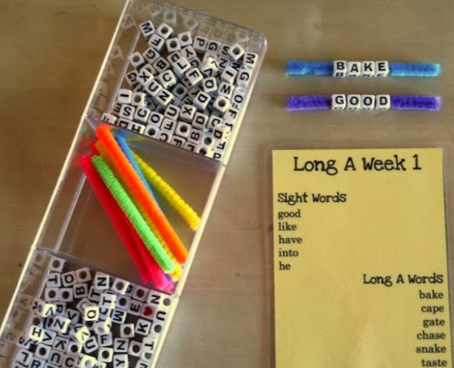

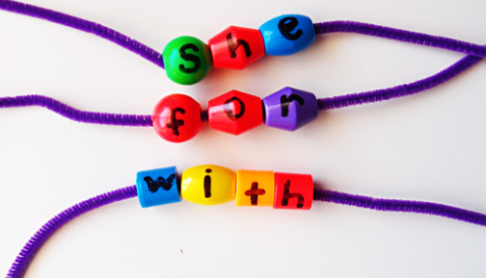

Write the letter sounds of the word in sand.

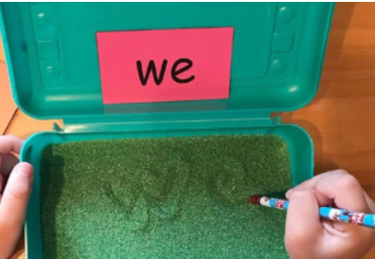

Write words in chalk.



Play hopscotch with words.

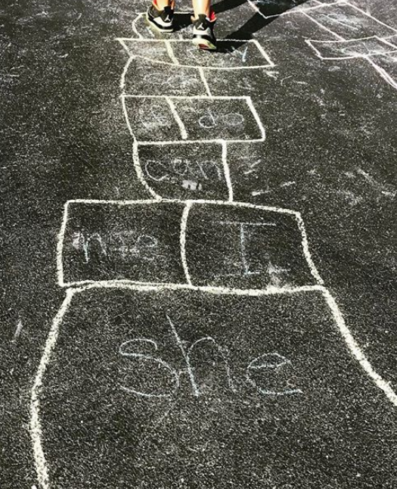

Write each word in an arch of a rainbow or web.

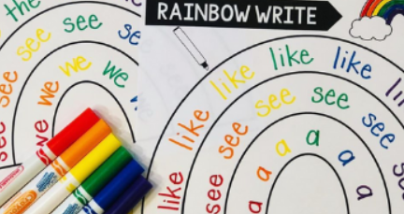 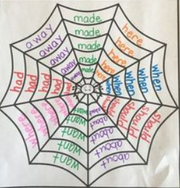

Use blocks to spell words.

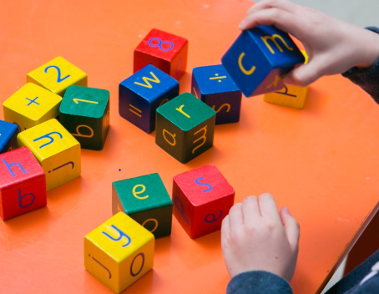

If you have a magna doodle or similar – write your spellings on it

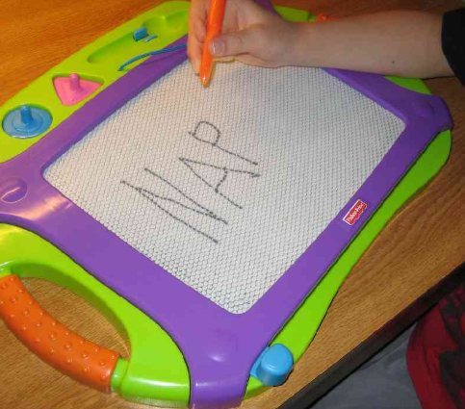

Scrabble Spelling.

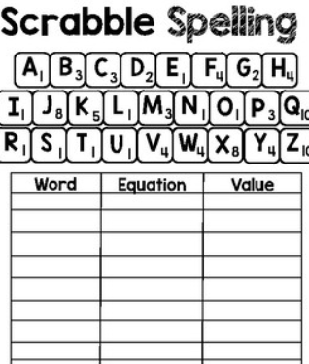

Hunt for the words everywhere you go and make a collection. Maybe cuttings from anything written around the home (magazines, leaflets, newspapers), photos you take on walks etc.

