Year 3  Robins | Before 9:00am | 9:00 – 10:00 | 10:00-11:00 | 11:00-12:00 | 12 – 12.30 | 12:30 – 1.00 | 1:00 – 2:00 | 2:00 – 3:15 | 3.15 – 4:00
Monday | Eat breakfast, make your bed, get washed and dressed and put any laundry in the basket. | Family walk (with the dog - if you have got one!)  Five-a-day/indoor exercises/indoor yoga if wet.  https://www.youtube.com/user/CosmicKidsYoga  https://www.gonoodle.com/  https://www.nhs.uk/10-minute-shake-up/shake-ups | Maths/Writing work from the packs, blogs or any of the following links:  TT Rock Stars - https://play.ttrockstars.com/auth/school  White Rose - https://whiterosemaths.com/homelearning/  I see reasoning - http://www.iseemaths.com/home-lessons/  The literacy company - http://www.theliteracycompany.co.uk/free-resources/  Oak National Academy - https://www.thenational.academy/online-classroom/year-3/ | Creative Time – Lego, drawing, crafting, music, cooking, baking, coding, painting.  coding - https://www.scratchjr.org/  https://code.org/ | Lunchtime | Tidy Time – Wipe down kitchen table and chairs, wash and dry kitchen dishes, tidy bedroom and lounge. | Quiet Time – Reading, Puzzles, Nap (No Electronics) | History/Geography  (See tasks on the next page) | Afternoon Fresh Air – Bike, Walk the dog, play outside.
Tuesday |  |  |  |  |  |  |  | Science  (See tasks on the next page)
Wednesday |  |  |  |  |  |  |  | History/Geography  (See tasks on the next page)
Thursday |  |  |  |  |  |  |  | Science  (See tasks on the next page)
Friday |  |  |  |  |  |  |  | RE  (See tasks on the next page)
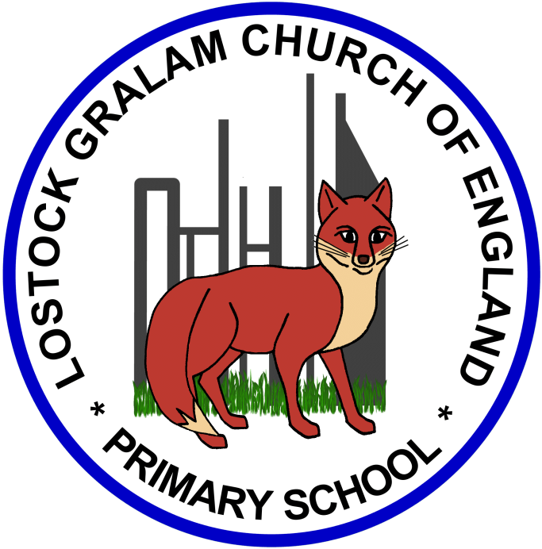
Home Learning – this timetable is intended as a guide to support learning at home during a prolonged period of school closure. We appreciate that you will have differing demands on your time but hope that this helps in continuing ‘a love learning’ at home. We will also be updating the class blog daily with any specific activities that you can do each day and further resources that you may need.
Under the timetable and suggested task list, I will also include a long list of free resources and websites that you may wish to use.
If you have issues with usernames and passwords, please contact admin@lostockgralam.cheshire.sch.uk

Weeks 7 and 8 (commencing 18.05.20 and 25.05.20):
Remember these projects will take you multiple days to complete – just do a little bit at a time
History and Geography | History/Geography Projects – Ancient Civilisations Continued  - Choose one of the Ancient Civilisations looked at last week (Ancient Sumer; The Indus Valley; Ancient Egypt; The Shang Dynasty)  - Carry out an in-depth study of it – Where did they settle, why did they settle here, when did they settle and what did they achieve?  - You could include writing, drawings, diagrams and maps and could present your findings in a booklet, PowerPoint, posters, etc.  - You could also do some art work inspired by your chosen Ancient Civilisation.  - Writing Link – if you were a time traveller, which Ancient Civilisation would you travel back to and why? Why not write a Fantasy Story in which your character enters this Civilisation through a portal?  Useful Websites –  https://www.bbc.co.uk/teach/class-clips-video/history-ks2-lost-lands/zfp6gwx  https://www.theschoolrun.com/homework-help/shang-dynasty  http://www.ancient-chinese-dynasties-facts.com/Chinese-Shang-Dynasty-Facts/Shang-Dynasty-Achievements-Facts.html  https://www.bbc.co.uk/bitesize/topics/zxn3r82/articles/zcsbr82  https://www.theschoolrun.com/homework-help/ancient-sumer-and-mesopotamia  https://www.bbc.co.uk/teach/class-clips-video/history-ks2-introducing-ancient-sumer/zmgnvk7  https://www.bbc.co.uk/bitesize/topics/zg87xnb  https://www.ducksters.com/history/ancient_egyptian_pharaohs.php
Science | Science Projects –  - How do flowers change throughout the year? – Choose a flower and create a visual representation of its life cycle (Dandelion example: https://www.bbc.co.uk/bitesize/clips/zs9c87h)  - Use the following website to learn about the 4 different types of seed dispersal: https://www.bbc.co.uk/bitesize/clips/znvfb9q  - Now use your new knowledge to sort seeds according to their method of dispersal: wind, water, animals and explosions. You could split your page into 4 for each of the methods, research different seeds and how they are dispersed and sort them by drawing and labelling the seeds into the correct section of your grid.  Useful Websites –  https://www.bbc.co.uk/bitesize/clips/znvfb9q  https://www.bbc.co.uk/bitesize/clips/zgqyrdm  https://www.bbc.co.uk/bitesize/clips/zs9c87h  https://www.teachitprimary.co.uk/?resource=18966
RE | RE Projects – The Kingdom of God  - ‘Kingdom of God’: What do you think this phrase might mean? Is the Kingdom of God a physical place? Who is its leader? Who is part of the Kingdom of God? How can someone become part of it?  - Christians have been trying to make the world look more like the Kingdom of God. What might the world be like if God really did rule in everyone’s heart? Draw a picture and label what you think this might look like.  - Look at the words of the Lord’s Prayer. Go through it line by line. What do you think each line means? What clues does that give to what Christians might believe the Kingdom of God should be like?  - Could you rewrite the Lord’s Prayer in a more child-friendly way? Imagine you are writing it for a child in reception to help them understand what it means.  Useful Websites –  https://www.learnreligions.com/the-meaning-of-the-lords-prayer-542579  https://www.bbc.co.uk/teach/class-clips-video/religious-studies-ks2-christian-prayer/zbjv92p  http://www.dltk-bible.com/cv/lords_prayer.htm

Online classrooms:
https://www.thenational.academy/online-classroom
https://www.bbc.co.uk/bitesize/dailylessons

Maths
https://whiterosemaths.com/homelearning/year-3/
http://www.iseemaths.com/home-lessons/

Times Tables
https://ttrockstars.com/
https://www.topmarks.co.uk/maths-games/hit-the-button

Spellings
https://spellingframe.co.uk/

PE
https://www.youtube.com/watch?v=X655B4ISakg
https://www.youtube.com/user/CosmicKidsYoga
https://www.gonoodle.com/
https://www.nhs.uk/10-minute-shake-up/shake-ups

