CIRCULATORY SYSTEM WHEEL: CHALLENGE 1

Cut out both wheels below and the hole marked in wheel 1. Colour the diagram in the correct scientific way, add the appropriate explanations to your own wheel and use a split pin to attach the two parts.

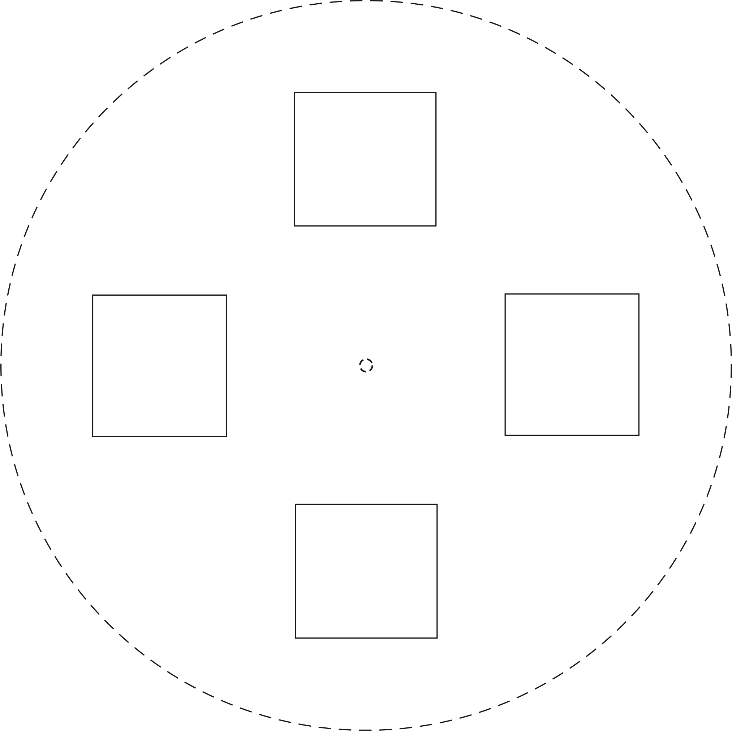
HEART
LUNGS
VEINS
ARTERIES

CIRCULATORY SYSTEM WHEEL: CHALLENGE 1

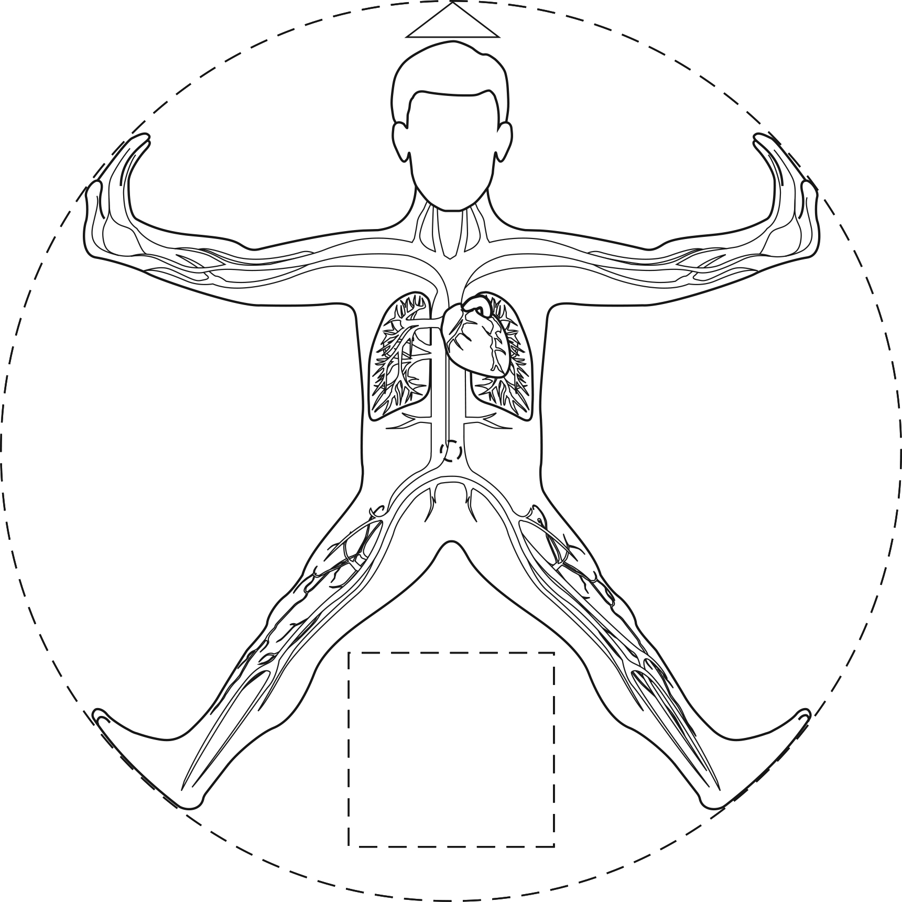
HEART
LUNGS

