Year 1  Starlings  Week Beginning 11.5.20 | Before 9:00am | 9:00 – 10:00 | 10:00-11:00 | 11:00-12:00 | Lunchtime – 12:00 -12.30 | 12:30 – 1.00 | 1:00 – 2:00 | 2:00 – 3:15 | 3.15 – 4:00
Monday | Eat breakfast, make your bed, get washed and dressed, any laundry in the basket. | Active Time  Five-day/indoor exercises/indoor yoga or other exercise if wet.  https://www.youtube.com/user/CosmicKidsYoga  https://www.gonoodle.com/  https://www.nhs.uk/10-minute-shake-up/shake-ups  PE with Joe Wicks at 9am - https://www.youtube.com/user/thebodycoach1 | Daily Tasks set by Miss Gillam  - Maths – complete 1 online maths lesson of your choice  - Arithmetic – complete one frequency grid each day  - Writing – Complete one online writing lesson of your choice  - Reading – Watch one of our daily speed sound lessons and read an online reading book on the Oxford Owl website  - Answer some of your reading comprehension questions - verbally  - Spellings | Creative Time – Lego, drawing, crafting, music, cooking, baking, coding, painting.  coding - https://www.scratchjr.org/ https://code.org/ |  | Tidy Time – Wipe down kitchen table and chairs, wash and dry kitchen dishes, tidy bedroom and lounge | Quiet Time – Reading, Puzzles, Nap (No Electronics) | Geography-  What is it like in South America? History - Who was King Henry VIII?  Art – Can you make a self-portrait using natural or recycled materials?  Computing – What is a computer code?  Science - How can we measure rainfall?  Art –  Can you make insects using natural materials? | Afternoon Fresh Air – Bike, Walk the dog, play outside.
Tuesday

Wednesday
Thursday
Friday
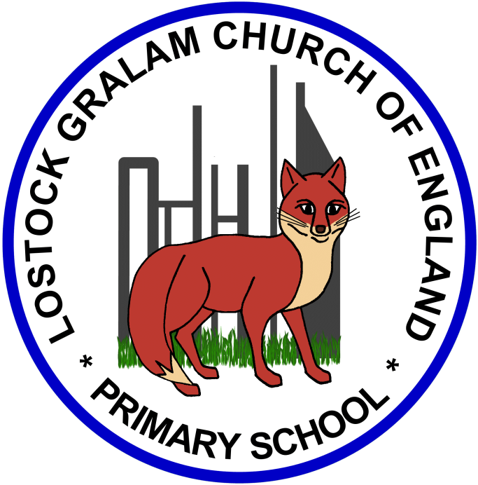
Home Learning – this timetable is intended as a guide to support learning at home during a prolonged period of school closure. We appreciate that you will have differing demands on your time but hope that this helps in continuing ‘a love learning’ at home. We will also be updating the class blog daily with any specific activities that you can do each day and further resources that you may need.
Miss Gillam
If you have issues with usernames and passwords, please contact admin@lostockgralam.cheshire.sch.uk
Monday | Geography – What is South America like?  In this lesson we are going to be virtually flying to South America which is in the southern hemisphere. First we will be filling our brains with facts about the population and how many countries are in South America. Then we will be learning about the physical features on this continent.  https://www.thenational.academy/year-1/foundation/what-is-south-america-like-year-1-wk4-1  History - Who was King Henry VIII?  In this lesson we are going to learn about the life of King Henry VIII. Can you remember the key events from Henry VIII's life? Can you put the events in order?  https://www.bbc.co.uk/bitesize/articles/zhhsf4j
Tuesday | Art Project – To make a self-portrait using natural or recycled materials  In this lesson, we will be learning all about the artist Jane Perkins, she is a British artist who uses recycled materials to make portraits.  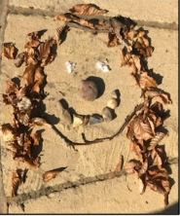  https://www.thenational.academy/year-1/foundation/to-make-a-self-portrait-using-natural-or-recycled-materials-year-1-wk3-5
Wednesday | Computing Lesson – What is a computer code?  https://www.bbc.co.uk/bitesize/articles/zmp98xs  In this lesson, children will learn that a computer code is a set of rules or instructions. It is made up of words and numbers and when you put them in the right order it will tell your computer what you want it to do. You can program lots of things with code. Watch the videos to find out more and have a go at the coding activities.
Thursday | Science - How can we measure rainfall?  In this lesson we are going to be answering the question, how can you measure rainfall? We will be finding out what a liquid is and observing some examples. We will then be moving on to making our own rain gauge to measure the amount of rainfall we have during 1 week.  https://www.thenational.academy/year-1/foundation/how-can-you-measure-rainfall-year-1-wk4-3
Friday | Art - To make insects using natural materials  In this lesson, we will be making insects using natural materials we can find on our walk, run or cycle! You will need things like small twigs, leaves, petals and stones. You can watch the lesson first, then complete the activity!  https://www.thenational.academy/year-1/foundation/to-make-insects-using-natural-materials-year-1-wk4-5

‘A Love for Learning’ – Using the links below, please research each area and respond in the exercise book provided. This could be a written response; fact sheet, poster, poem, non-fiction report, diary entry, newspaper article, diagrams, maps…there are lots of things to learn on each part so break each activity up into sections to study and record.

