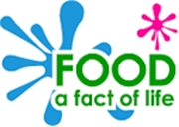
Eatwell food list
Worksheet 156
© Food – fact of life 2016
Food group | Foods included in this group
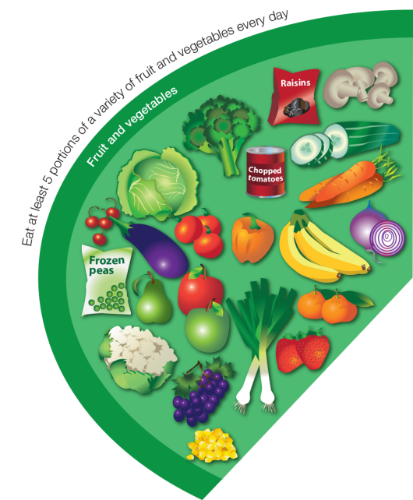  Fruit and vegetables | Apple, Baked beans, Banana, Broccoli, Cabbage, Carrots, Cauliflower, Cucumber, Fruit juice, Fruit smoothie, Kiwi, Lettuce, Melon, Oranges, Pears, Peas,  Pineapple, Plums, Raisins, Strawberries, Sweetcorn  Fresh, frozen, dried, canned and juiced all count.
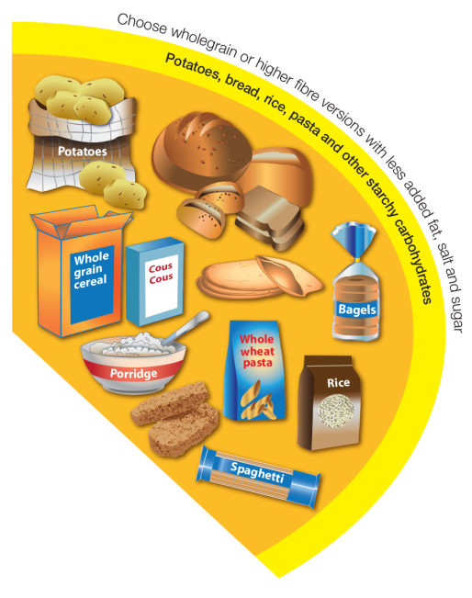  Potatoes, bread, rice, pasta and other starchy carbohydrates | Bread: soda bread, rye bread, pitta, flour tortilla, baguettes, chapatti, bagels  Rice, potatoes, breakfast cereal, oats, pasta, noodles, maize, cornmeal, couscous, bulgar, polenta, millet, spelt, wheat, pearl barley, yams, plantains.
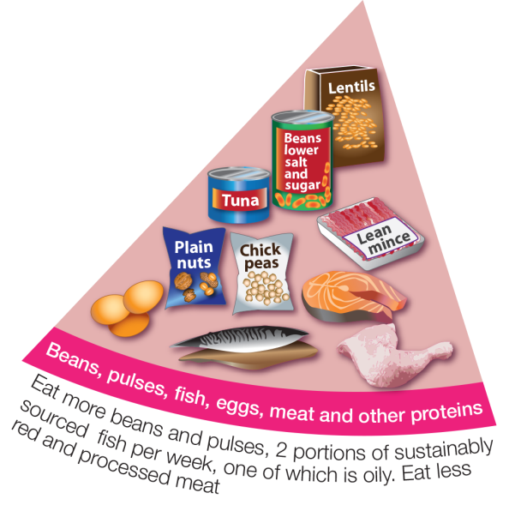  Beans, pulses, fish, eggs, meat and other proteins | Meat, poultry and game including: lamb, beef, pork, chicken, bacon, sausages, burgers  White fish (fresh frozen or canned) including: haddock, plaice, pollock, coley, cod, canned tuna  Oily fish (fresh frozen or canned) including:  prawns, mussels, crab, squid oysters  Nuts, eggs, beans and other pulses including:  lentils, chickpeas, baked beans, kidney beans, butter beans  Vegetarian meat alternatives e.g. tofu, micoprotein
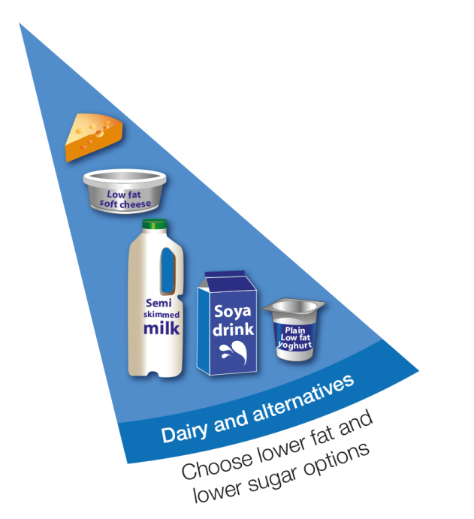  Dairy and alternatives | Milk, cheese, yogurt, fromage frais, quark, cream cheese.  This includes non-diary alternatives to these foods.
Oils and spreads | Vegetable oil, rapeseed oil, olive oil, sunflower oil.  Soft spreads made from unsaturated oils.

