BLOOD FACTS: CHALLENGE 1

Create a fact file to earn parts of blood for your blood soup.
Size:
Job:
Part of the blood:
Further fact:
Part of the blood:
Further fact:
Size:
Job:
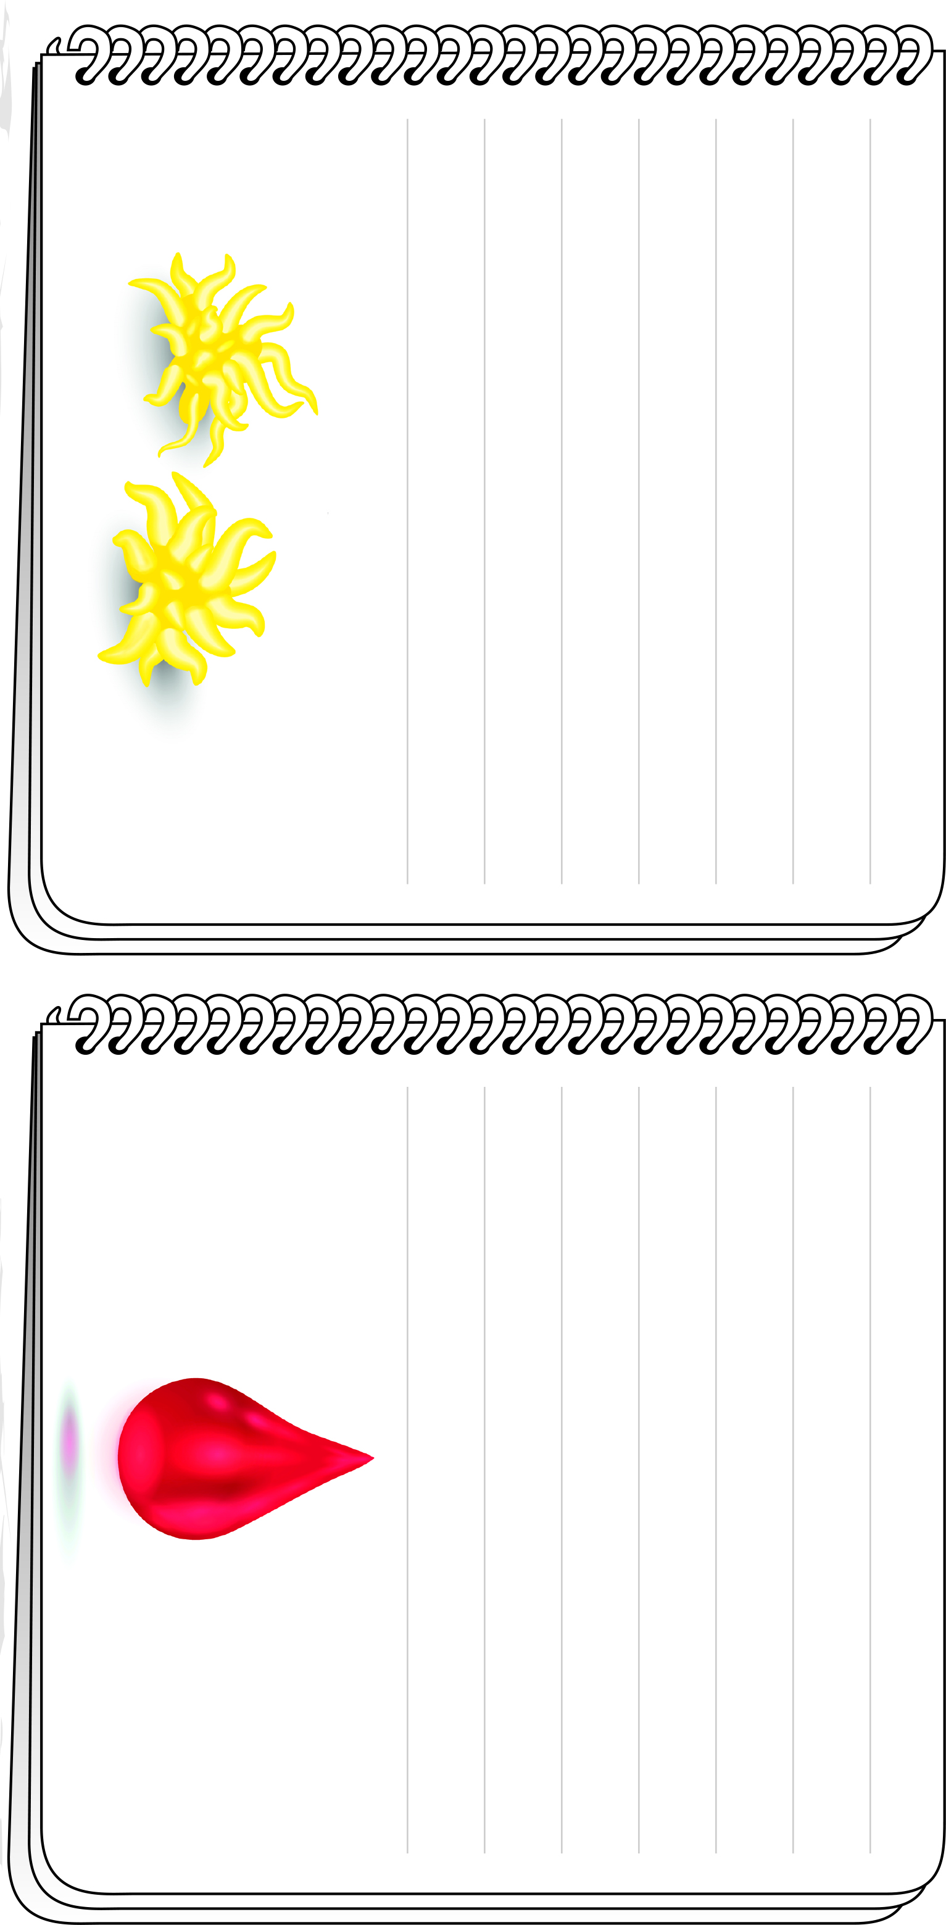
BLOOD FACTS: CHALLENGE 1

Create a fact file to earn parts of blood for your blood soup.
Job:
Size:
Part of the blood:
Further fact:
Part of the blood:
Further fact:
Size:
Job:

