Year 1  Starlings  Week Beginning 4.5.20 | Before 9:00am | 9:00 – 10:00 | 10:00-11:00 | 11:00-12:00 | Lunchtime – 12:00 -12.30 | 12:30 – 1.00 | 1:00 – 2:00 | 2:00 – 3:15 | 3.15 – 4:00
Monday | Eat breakfast, make your bed, get washed and dressed, any laundry in the basket. | Active Time  Five-day/indoor exercises/indoor yoga or other exercise if wet.  https://www.youtube.com/user/CosmicKidsYoga  https://www.gonoodle.com/  https://www.nhs.uk/10-minute-shake-up/shake-ups  PE with Joe Wicks at 9am - https://www.youtube.com/user/thebodycoach1 | Daily Tasks set by Miss Gillam  - Maths – complete 1 online maths lesson of your choice  - Arithmetic – complete one frequency grid each day  - Writing – Complete one online writing lesson of your choice  - Reading – Watch one of our daily speed sound lessons and read an online reading book on the Oxford Owl website  - Answer some of your reading comprehension questions - verbally  - Spellings | Creative Time – Lego, drawing, crafting, music, cooking, baking, coding, painting.  coding - https://www.scratchjr.org/ https://code.org/ |  | Tidy Time – Wipe down kitchen table and chairs, wash and dry kitchen dishes, tidy bedroom and lounge | Quiet Time – Reading, Puzzles, Nap (No Electronics) | Science – How do trees change across the seasons?  Geography – What is Asia like?  Geography – What is North America like?  History – To learn about the life of Boudicca and how she fought against the Romans.  Art – To make a self-portrait using natural or recycled materials. | Afternoon Fresh Air – Bike, Walk the dog, play outside.
Tuesday

Wednesday
Thursday
Friday
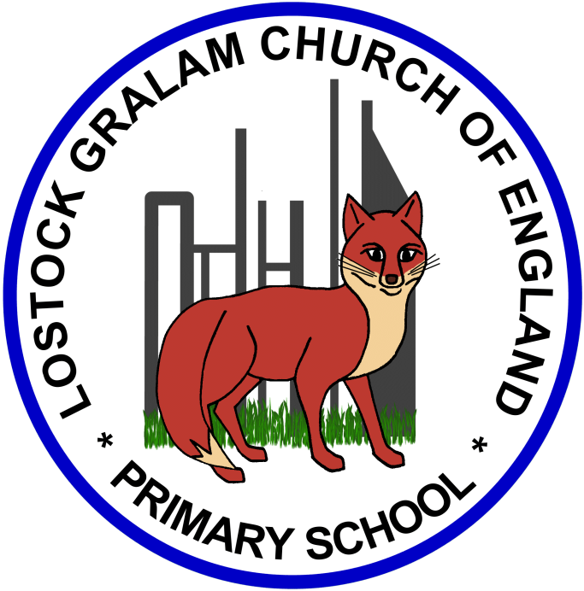
Home Learning – this timetable is intended as a guide to support learning at home during a prolonged period of school closure. We appreciate that you will have differing demands on your time but hope that this helps in continuing ‘a love learning’ at home. We will also be updating the class blog daily with any specific activities that you can do each day and further resources that you may need.
Miss Gillam
If you have issues with usernames and passwords, please contact admin@lostockgralam.cheshire.sch.uk
Monday | Science – How do trees change across the seasons?  In this lesson we are going to be observing the changes that occur to trees during different seasons. We will then be analysing the annual calendar and comparing events to the seasons. We will be recapping which weather can be seen in each season and how this may affect our calendar events. Lastly, we will be reading about a female scientist!  Links: https://www.thenational.academy/year-1/foundation/how-do-trees-change-across-the-seasons-year-1-wk3-3
Tuesday | Geography – What is Asia like?  In this lesson we are going to be virtually flying to Asia, which is the largest continent. First we will be filling our brains with facts about the population and how many countries are in Asia. Then we will be looking deeper into what the landscape is like, it ranges from rainforests to mountains to plains! There are lots of different animals you could see if you visited parts of Asia, and lots of interesting fruit is also grown in the continent.  https://www.thenational.academy/year-1/foundation/what-is-asia-like-year-1-wk3-1
Wednesday | Geography Project – What is North America like?  In this lesson we are going to be virtually flying to North America, which is the third largest continent. First we will be filling our brains with facts about the population and how many countries are in North America. We will be looking at the second largest island which is in North America, called Greenland. There are lots of different languages and animals in the continent, we will be learning all about them. Finally, we will be studying some different places in North America, that you might not have heard of before! We will finish this lesson by reading a story about some animals from Africa.  https://www.thenational.academy/year-1/foundation/what-is-north-america-like-year-1-wk3-4
Thursday | History Project - To learn about the life of Boudicca and how she fought against the Romans.  Who is Boudicca?  What does her name mean?  Why do we not know exactly what she looked like?  What did her soldiers do to make themselves look more frightening?  https://www.bbc.co.uk/bitesize/articles/zvs4kmn
Friday | Art Project – To make a self-portrait using natural or recycled materials  In this lesson, we will be learning all about the artist Jane Perkins, she is a British artist who uses recycled materials to make portraits.  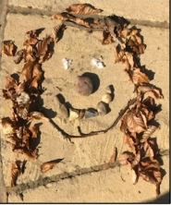  https://www.thenational.academy/year-1/foundation/to-make-a-self-portrait-using-natural-or-recycled-materials-year-1-wk3-5

‘A Love for Learning’ – Using the links below, please research each area and respond in the exercise book provided. This could be a written response; fact sheet, poster, poem, non-fiction report, diary entry, newspaper article, diagrams, maps…there are lots of things to learn on each part so break each activity up into sections to study and record.

