Year 5  Skylarks | Before 9:00am | 9:00 – 10:00 | 10:00-11:00 | 11:00-12:00 | Lunchtime – 12:00 -12.30 | 12:30 – 1.00 | 1:00 – 2:00 | 2:00 – 3:15 | 3.15 – 4:00
Monday | Eat breakfast, make your bed, get washed and dressed, any laundry in the basket. | Family walk with the dog (if you have got one!)  Five-day/indoor exercises/indoor yoga or other exercise if wet.  https://www.youtube.com/user/CosmicKidsYoga  https://www.gonoodle.com/  https://www.nhs.uk/10-minute-shake-up/shake-ups | Work from the pages that have been sent home about decimals and timetables. Use CGP maths books alongside to complete any activities that will support this learning.  TT Rock Stars - https://play.ttrockstars.com/auth/school | Creative Time – Lego, drawing, crafting, music, cooking, baking, coding, painting.  Apps such as: book creator, quiver, tynker and imovie (all free)  coding - https://www.scratchjr.org/ https://code.org/ |  | Tidy Time – Wipe down kitchen table and chairs, wash and dry kitchen dishes, tidy bedroom and lounge | Quiet Time – Reading, Puzzles, Nap (No Electronics) | Spend this time working on the project given for the week. | Afternoon Fresh Air – Bike, Walk the dog, play outside.
Tuesday

Wednesday
Thursday
Friday
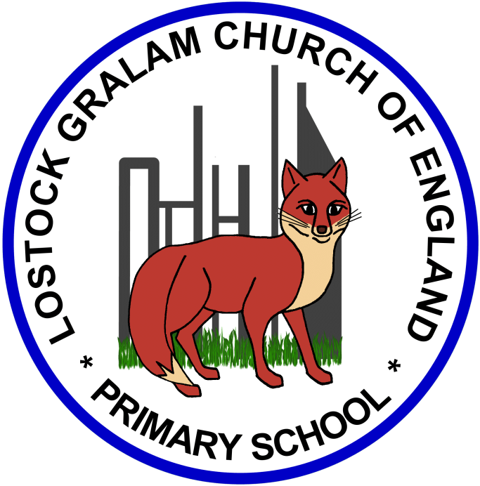
Home Learning – this timetable is intended as a guide to support learning at home during a prolonged period of school closure. We appreciate that you will have differing demands on your time but hope that this helps in continuing ‘a love learning’ at home. We will also be updating the class blog daily with any specific activities that you can do each day and further resources that you may need.
Miss Thwaites
If you have issues with usernames and passwords, please contact admin@lostockgralam.cheshire.sch.uk
Monday | Science: Find out about what the term ‘gestation’ means. From this, I would like you to develop an understanding of the period of time it takes for gestation to take place in different mammals. You could draw pictures of the mammals and explain how long it takes for them to grow from a foetus. Then, add to this information about the ‘life expectancy’ of the mammals you have been researching.  RE: Hinduism  Think: What do you think are the most important changes you will have in life? Write these ideas down  Look at the following words and write down what you think the words mean: reincarnation, resurrection, soul, moksha, karma.  Research the words and write down the meaning of them to really understand.  Watch the following video extract from My Life My Religion, ‘The cycle of life and death’. https://www.bbc.co.uk/programmes/p02n5v2q  Make notes whilst watching the video based on the key points that are mentioned. What do Hindus believe about the afterlife?  Create a drawing of a river and write creatively on the art what Hindus believe about the new beginning and the rebirth that happens after death.  https://www.bbc.co.uk/bitesize/articles/z43v382  History:  This week we will be celebrating VE day on the 8th May. Please have a listen to the video to find out about the day. https://www.bbc.co.uk/teach/class-clips-video/history-ks2-ve-day/z7xtmfr  VE day will look very different this year due to being in lockdown. However, we can still celebrate in our own way. Why not have a go at baking a cake to celebrate? Drawing a picture for our Lostock sharing window? Make some bunting? Why not create your own picnic in the garden?  https://bletchleypark.org.uk/cms/2020/03/ve-day-pack-bunting.pdf  https://www.bbc.co.uk/food/recipes/mary_berrys_perfect_34317  https://www.bbcgoodfood.com/recipes/collection/picnic-recipes-kids
Tuesday

Wednesday

Thursday

Friday

