WB 4.5.20 Spellings from Y3/4 words 5th column
particular
peculiar
perhaps
popular
position
possess
possession
possible
potatoes
pressure

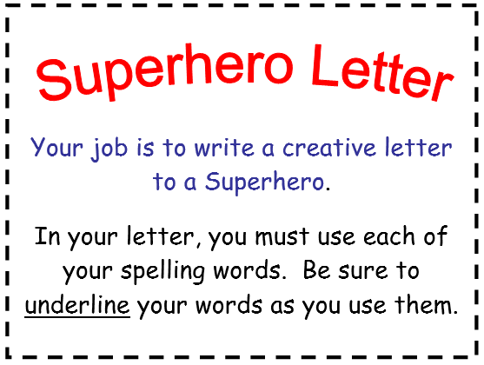 Remember how Mrs Evans uses our weekly spellings to make silly sentences? …. You can do this in your Superhero letter too!

