Year 1  Starlings  Week Beginning 26.4.20 | Before 9:00am | 9:00 – 10:00 | 10:00-11:00 | 11:00-12:00 | Lunchtime – 12:00 -12.30 | 12:30 – 1.00 | 1:00 – 2:00 | 2:00 – 3:15 | 3.15 – 4:00
Monday | Eat breakfast, make your bed, get washed and dressed, any laundry in the basket. | Active Time  Five-day/indoor exercises/indoor yoga or other exercise if wet.  https://www.youtube.com/user/CosmicKidsYoga  https://www.gonoodle.com/  https://www.nhs.uk/10-minute-shake-up/shake-ups  PE with Joe Wicks at 9am - https://www.youtube.com/user/thebodycoach1 | Daily Tasks set by Miss Gillam  - Maths – complete 1 online maths lesson of your choice  - Arithmetic – complete one frequency grid each day  - Writing – Complete one online writing lesson of your choice  - Reading – Watch one of our daily speed sound lessons and read an online reading book on the Oxford Owl website  - Answer some of your reading comprehension questions - verbally  - Spellings | Creative Time – Lego, drawing, crafting, music, cooking, baking, coding, painting.  coding - https://www.scratchjr.org/ https://code.org/ |  | Tidy Time – Wipe down kitchen table and chairs, wash and dry kitchen dishes, tidy bedroom and lounge | Quiet Time – Reading, Puzzles, Nap (No Electronics) | Science  -Name the Animal  Science – Mammals and Reptiles  Geography – What is Australia like?  Geography – What is Africa like?  Art – Texture Hunt | Afternoon Fresh Air – Bike, Walk the dog, play outside.
Tuesday

Wednesday
Thursday
Friday
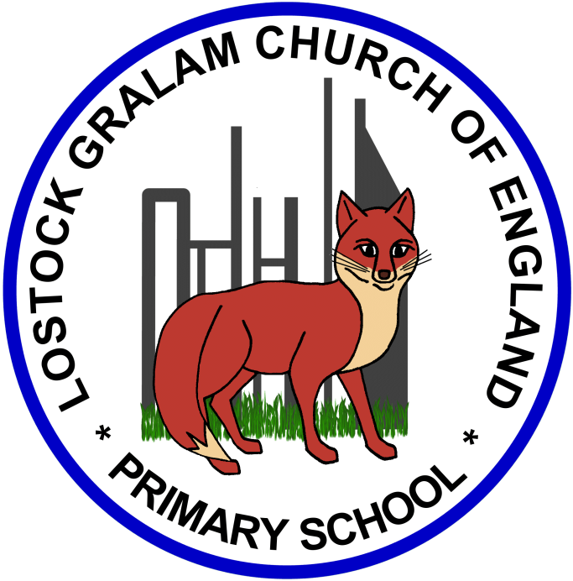
Home Learning – this timetable is intended as a guide to support learning at home during a prolonged period of school closure. We appreciate that you will have differing demands on your time but hope that this helps in continuing ‘a love learning’ at home. We will also be updating the class blog daily with any specific activities that you can do each day and further resources that you may need.
Miss Gillam
If you have issues with usernames and passwords, please contact admin@lostockgralam.cheshire.sch.uk

Monday | Science – Name the Animal – p68  Today we are going to be starting our learning about animals. Have a look on the Chester Zoo website and play ‘Name the Animal’ with your family.  Tip: You might need to hide the name from your partner. Please then complete page 68 of your pack. Circle the correct name for each animal shown.  https://www.chesterzoo.org/our-zoo/animals/
Tuesday | Science Project – Mammals and Reptiles – p69  What is a mammal? What is a reptile? Can you use the internet to find out what these scientific words mean? Use a page of your exercise book to tell me what you find out. You could draw some animals under each heading, write a list or do something completely different. Please then complete page 69 of your pack, using what you found out to help you.  https://www.bbc.co.uk/bitesize/topics/z6882hv/articles/zp92xnb - Mammals  https://www.bbc.co.uk/bitesize/topics/z6882hv/articles/zp9pfg8 - Reptiles  https://www.youtube.com/watch?v=pap2a3PSkbw
Wednesday | Geography Project – What is Australia like?  In this lesson, we are going to be virtually flying to Australia; the continent is also known as Oceania and Australasia. Today, we are learning more about this small continent. First, we will be filling our brains with facts about the population, how many countries are in Australia and the currency they use. Then we will be looking at the interesting animals and landmarks you could see if you visited Australia. Use a page of your exercise book to tell me what you found out.  https://www.thenational.academy/year-1/foundation/what-is-australia-like-year-1-wk2-1
Thursday | Geography Project – What is Africa like?  In this lesson, we are going to be virtually flying to Africa! Today, we are learning more about this huge continent. First, we will be filling our brains with facts about the population and how many countries are in Africa. I am so excited that we will be looking at different foods which are grown in Africa and transported all over the world. Then we will be looking at the interesting animals and landmarks you could see if you visited Africa. Get your passport ready, let’s virtually fly to Africa! Use a page of your exercise book to tell me what you found out . Would you rather live in Africa or Australia?  https://www.thenational.academy/year-1/foundation/what-is-africa-like-year-1-wk2-4
Friday | Art Project – Texture Hunt  In this lesson, we will be learning about an artist called Max Ernst. He created a technique in art called frottage. This is when you use your pencil to make rubbings of textured objects which you find around your home. All you will need is a pencil and paper.  https://www.thenational.academy/year-1/foundation/to-go-on-a-texture-treasure-hunt-year-1-wk2-5
‘A Love for Learning’ – Using the links below, please research each area and respond in the exercise book provided. This could be a written response; fact sheet, poster, poem, non-fiction report, diary entry, newspaper article, diagrams, maps…there are lots of things to learn on each part so break each activity up into sections to study and record.

