Goldfinches  Summer Week 2 | Before 9:00am | 9:00 – 10:00 | 10:00-11:00 | 11:00-12:00 | Lunchtime – 12:00 -12.30 | 12:30 – 1.00 | 1:00 – 2:00 | 2:00 – 3:15 | 3.15 – 4:00
Monday | Eat breakfast, make your bed, get washed and dressed, any laundry in the basket. | Family walk with the dog (if you have got one!)  Five-day/indoor exercises/indoor yoga or other exercise if wet.  https://www.youtube.com/user/CosmicKidsYoga  https://www.gonoodle.com/  https://www.nhs.uk/10-minute-shake-up/shake-ups | Work from the packs that have been sent home/CGP books/First4Maths activities/fluency grids/any specified work from the daily blog  TT Rock Stars - https://play.ttrockstars.com/auth/school  https://www.topmarks.co.uk/Search.aspx?q=angles | Creative Time – Lego, drawing, crafting, music, cooking, baking, coding, painting.  coding - https://www.scratchjr.org/ https://code.org/ |  | Tidy Time – Wipe down kitchen table and chairs, wash and dry kitchen dishes, tidy bedroom and lounge | Quiet Time – Reading, Puzzles, Nap (No Electronics) | History –  Research an important Historical Medical Hero.  Create a timeline, report, biography, play about their life and their discovery. | Afternoon Fresh Air – Bike, Walk the dog, play outside.
Tuesday

Wednesday
Thursday
Friday
Home Learning – this timetable is intended as a guide to support learning at home during a prolonged period of school closure. We appreciate that you will have differing demands on your time but hope that this helps in continuing ‘a love learning’ at home. We will also be updating the class blog daily with any specific activities that you can do each day and further resources that you may need.
Mrs Evans, Mrs Brennan and Mrs O’Marah
If you have issues with usernames and passwords, please contact admin@lostockgralam.cheshire.sch.uk
Monday  27th April | Writing: https://www.thenational.academy/year-4/english/poetry-reading-comprehension-word-meaning-year-4-wk1-1/ Have a go at the lesson on the Magic Box by Kit Wright from the Oak National Academy.  Reading: Use the websites for History to read all about your chosen Historical Medical Hero.  Times Tables: 11x table https://www.youtube.com/watch?v=dNHC-oU8tt8 | History Project: Research a famous Scientist who was important to medicine.  Our NHS and care workers are our heroes of today. Can you find out about some important historical medical heroes?  Choose one of these famous scientists to research:  Florence Nightingale, Edward Jenner, Louis Pasteur  Marie Curie, Mary Secole, Alexander Flemming  How to present it:  Create a fun facts leaflet.  Write or act a play about their life.  Make a time line about them main events of their life. (You could cut these up and peg them on a piece of string!  Write a biography (this is a true story all about a person’s life written in chronological order)  Useful websites:  https://www.ducksters.com/biography/scientists/scientists_and_inventors.php  https://www.sciencekids.co.nz/sciencefacts/scientists.html  https://www.theschoolrun.com/welcome-homework-gnome (then scroll to the History Tab)  https://www.dkfindout.com/uk/science/famous-scientists/  https://www.coolkidfacts.com/famous-scientists/
Tuesday  28th April | Writing: Have a go at the second lesson from Oak National Academy.  https://www.thenational.academy/year-4/english/poetry-reading-comprehension-language-year-4-wk1-2/  Maths: Use The ISEEMATHS home learning lesson for Y3/4. Continue with Thursday 26th March. 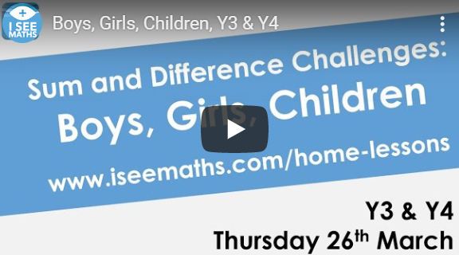 http://www.iseemaths.com/lessons34/  Spelling: Practise this week’s spellings- could you write out each word in rainbow colours?
Wednesday  29th April | History: Start writing about your chosen Historical Medical Hero.  Relaxation/My happy Mind:  https://myhappymind.kartra.com/page/ParentKitBundle  Have a go at the My Happy Mind activties. If you are not linked in yet, try your happy breathing or put some relaxing music on for peer massage. Cosmic Yoga can also be relaxing and fun.  Maths: ISEEMATHS home learning lesson for Y3/4. Continue with the next lesson (Friday 27th March) http://www.iseemaths.com/lessons34/
Thursday  30th April | Writing: Have a go at the third lesson from Oak National Academy  https://www.thenational.academy/year-4/english/features-of-poetry-year-4-wk1-3/  Spelling: Can you use your spellings to make your own word search? Either use squared paper or the link below to make it online.  https://thewordsearch.com/maker/  Maths: Try out an activity from the ‘Arty Maths’ attachment.
Friday  1st May | History: Continue writing about your chosen Historical Medical Hero.  Times Tables: Have a go at the 11 x table activities suggested on the attached sheet. (You do not need to print anything out, just look on screen and have a go in your workbook)  Reading: Read the Picture newspaper or the First News articles and tell somebody at home about them. (Optional reading book/game review)

‘A Love for Learning’ – Using the links above, please research each area and respond in the exercise book provided. This could be a written response; fact sheet, poster, poem, non-fiction report, diary entry, newspaper article, diagrams, maps…there are lots of things to learn on each part so break each activity up into sections to study and record.

