BODY SYSTEMS

DIGESTIVE SYSTEM

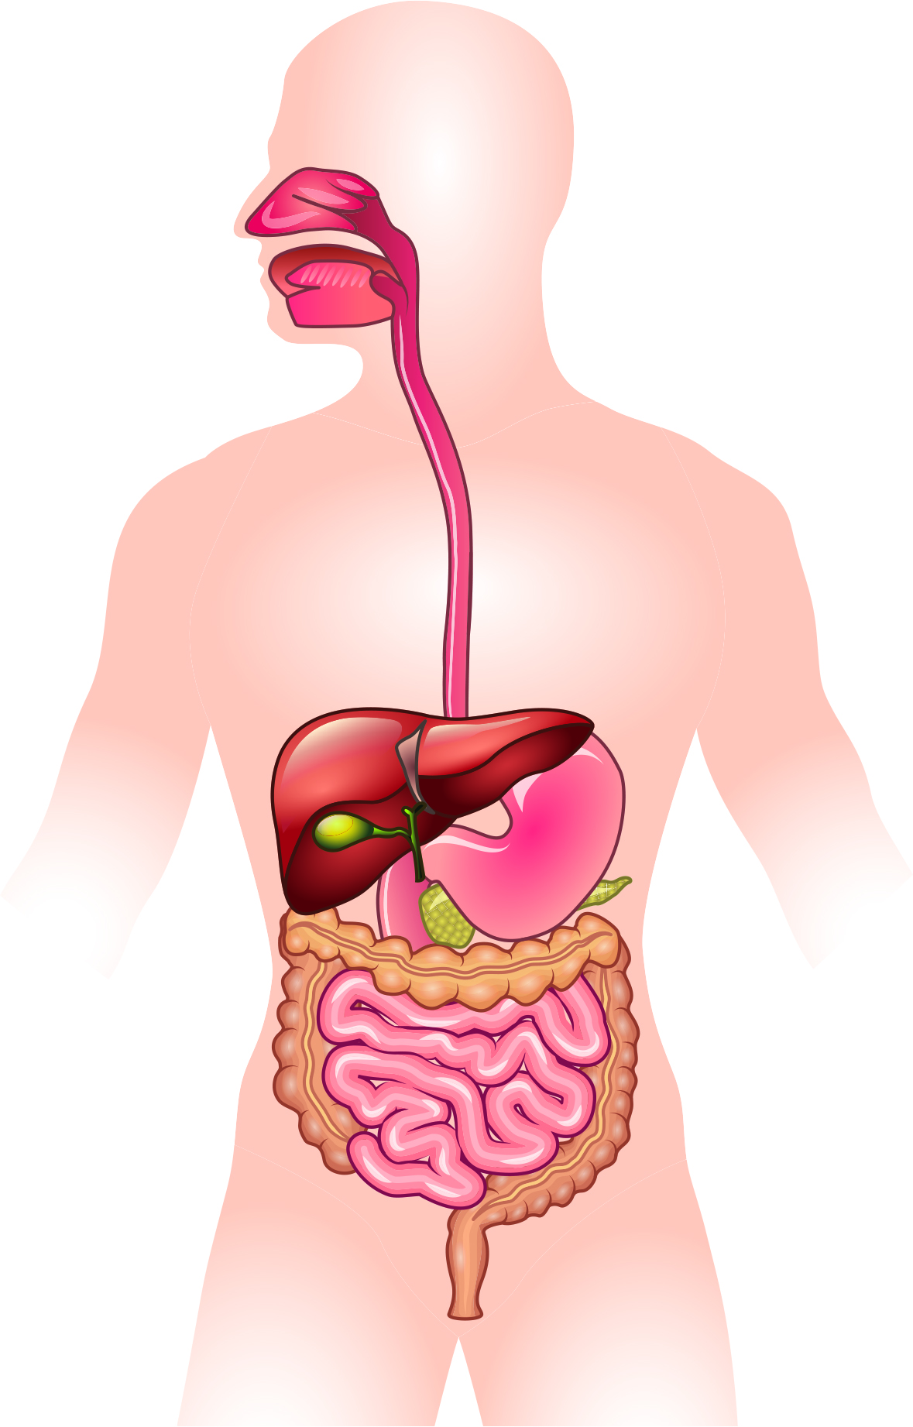

BODY SYSTEMS

MUSCULAR SYSTEM

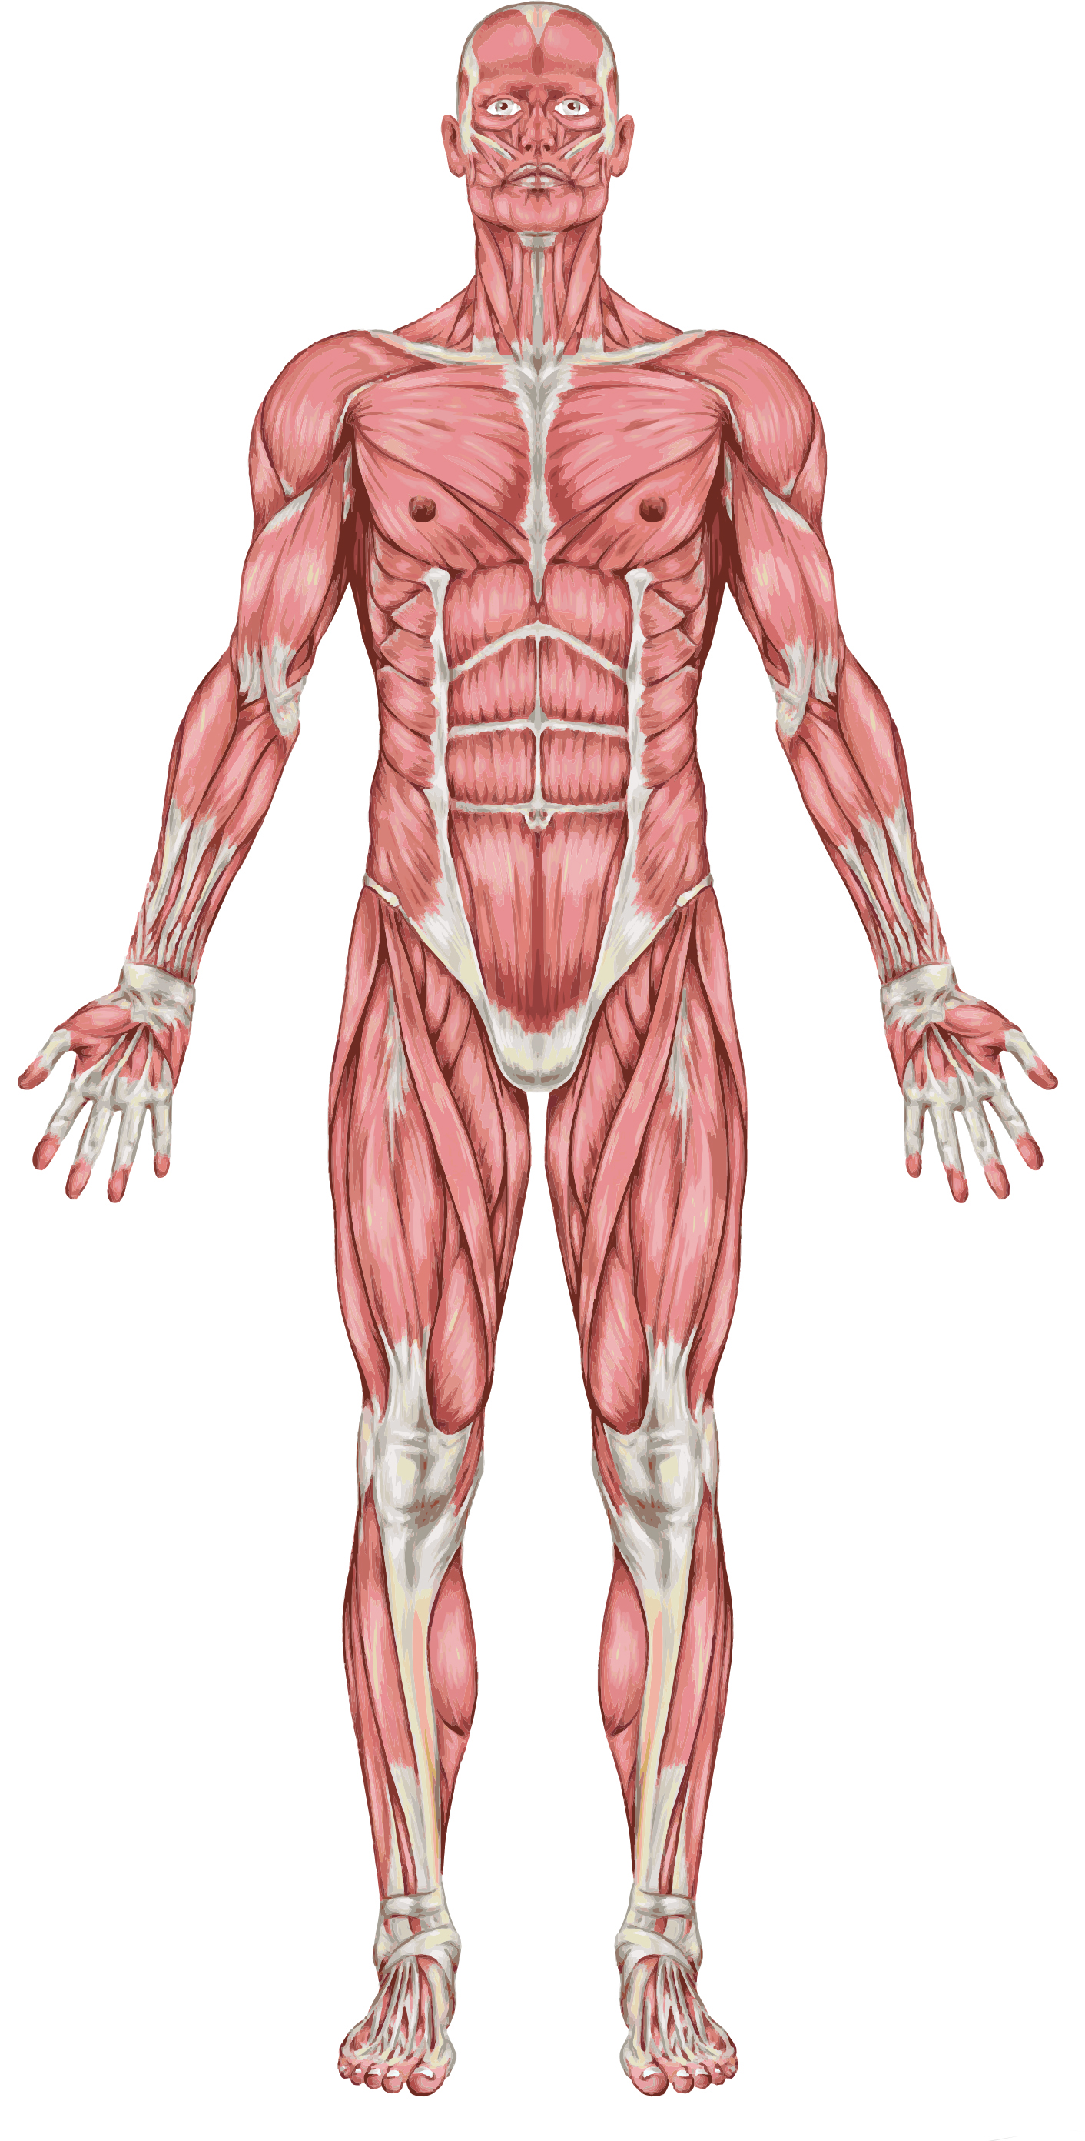

BODY SYSTEMS

SKELETAL SYSTEM

