BODY PARTS

BODY

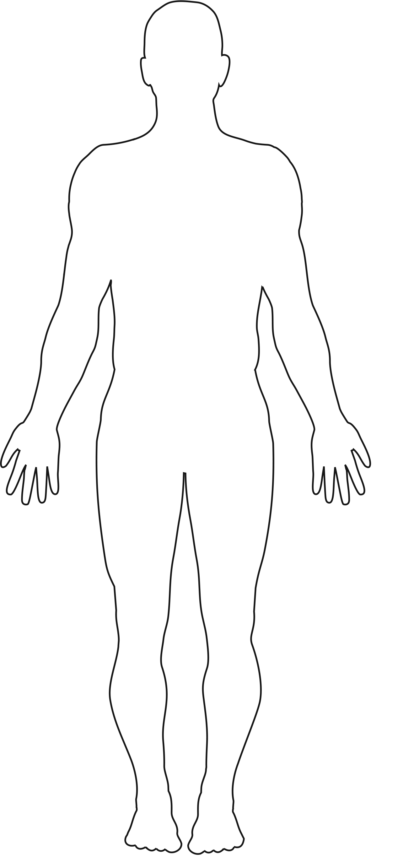

BODY PARTS

HEART

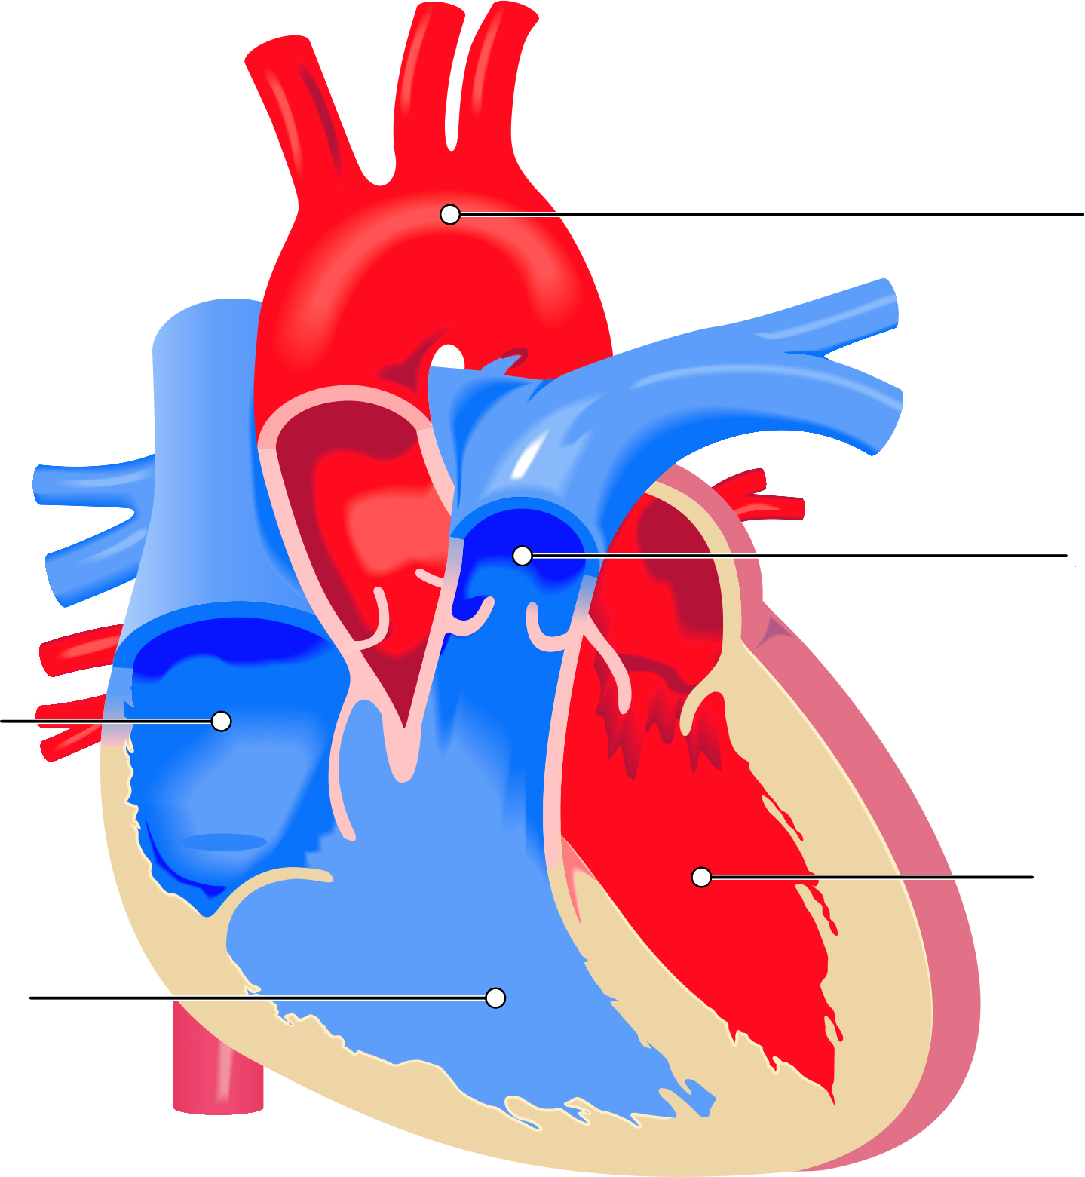

Left  
Ventricle

Left  
Atrium

Right  
Ventricle

Right  
Atrium

Aorta

BODY PARTS

LUNGS

