OLD WIVES’ TALES
Read what it says on your card.
• What message is it giving about that particular food?
• Is it positive or negative?
• Do you think there is any truth in it?
• What evidence do you have to explain your answer?

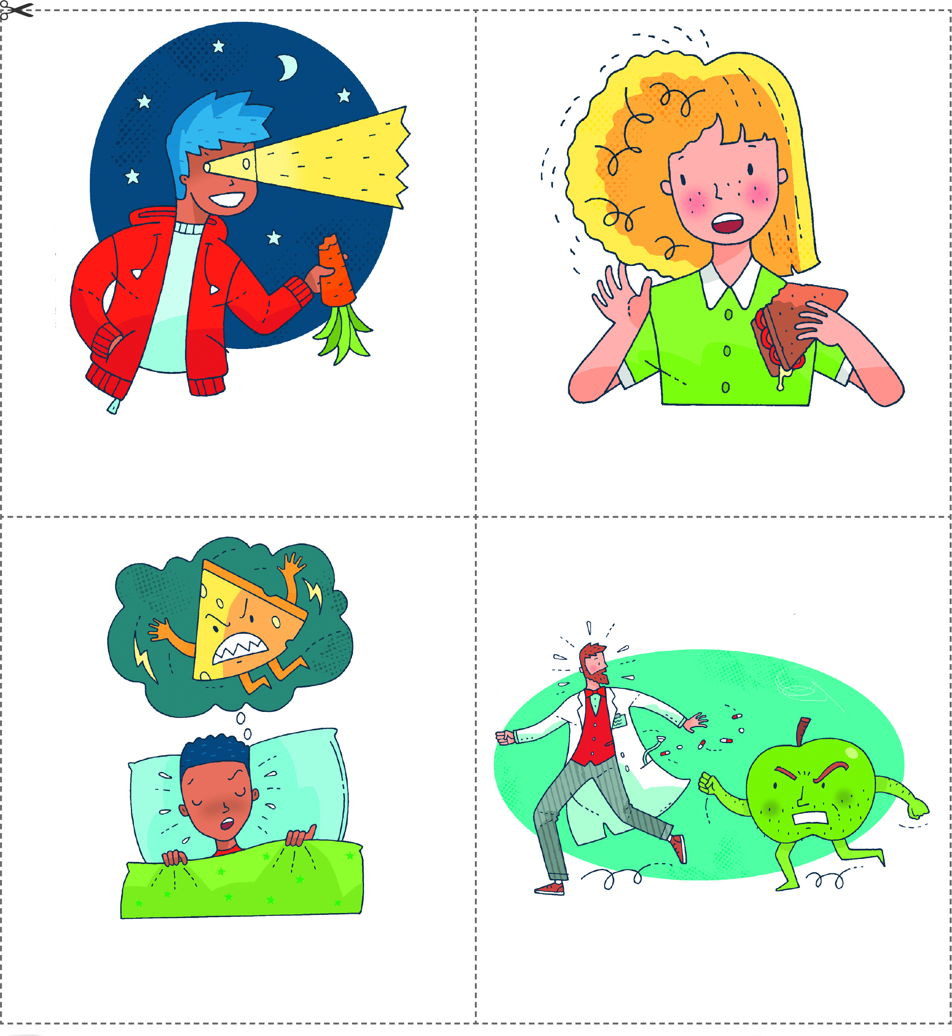
An apple a day keeps
the doctor away.
Eating cheese before bedtime
gives you nightmares.
Eating the crusts on your bread
makes your hair curly.
Eating carrots helps you
to see in the dark.

OLD WIVES’ TALES
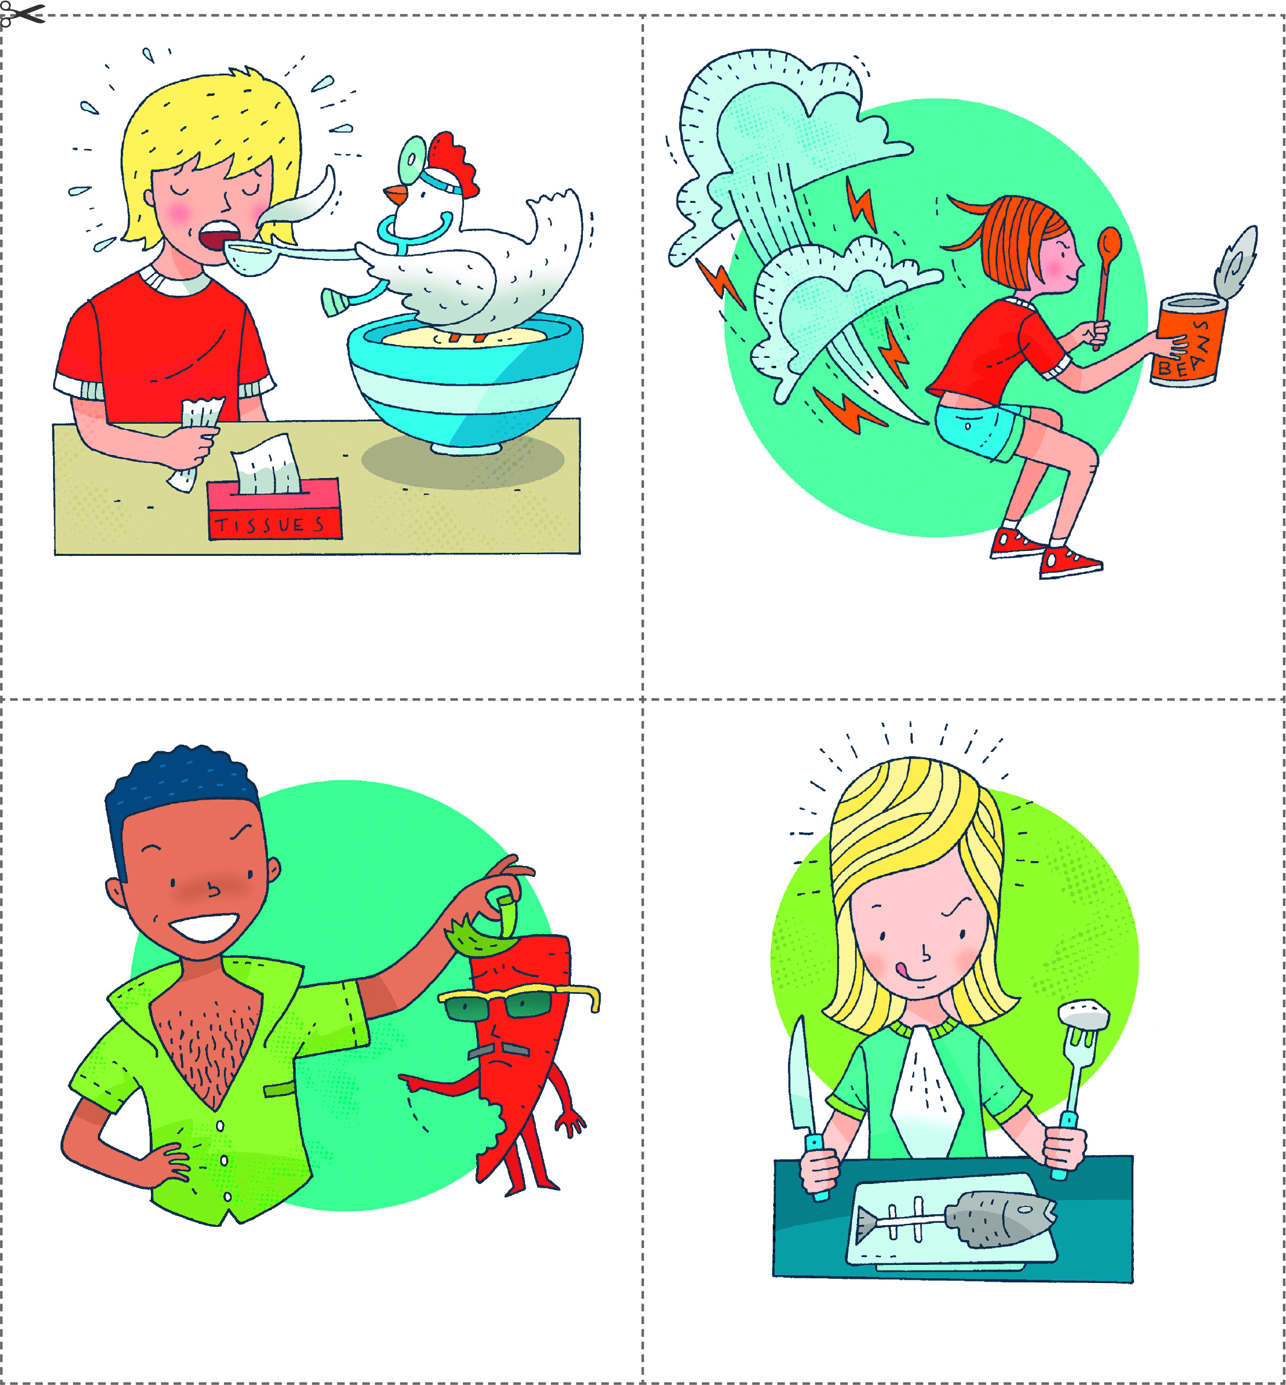
Eating fish is good for your brain.
Eating spicy food will put
hairs on your chest.
Eating baked beans
gives you wind.
Eating chicken soup
is good for a cold.

