Read Write Inc Daily Speed Sound session
LESSONS UPDATE:
From 20th April, new films will be released at the times shown below from Monday to Friday.
Each film is approximately ten to fifteen minutes long and will be available on YouTube for 24 hours.
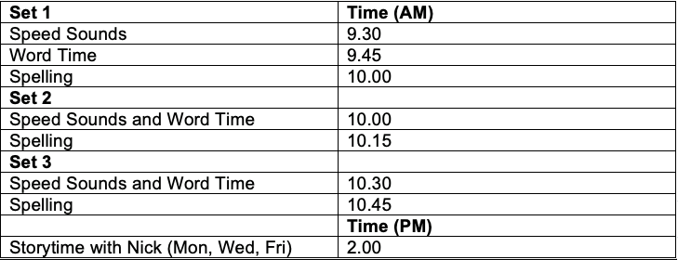
https://www.youtube.com/channel/UCo7fbLgY2oA_cFCIg9GdxtQ
https://www.facebook.com/miskin.education/

I have attached a table below to help you identify which set your child should watch. The colour of the groups corresponds to the reading book colour/colour of writing book they have in their pack.

Set 1 | Daily Ditties  Red Group
Set 2 | Green Group  Purple Group
Set 3 | Pink Group  Yellow Group  Orange Group  Blue Group

The lessons are carried out in the same way to our daily RWI sessions so will be familiar to the children. Enjoy!
Thank you so much for your continued support.
Miss Gillam

