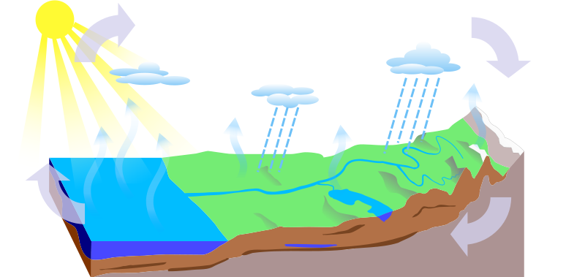

Key words

evaporation condenses groundwater flow precipitation

surface runoff sea

**Extension: Explain how the water moves from sea, air and land and back.**

Firstly the water starts off in the s__________ it then is transferred to the air by the process of e____________ this is when the sun heats the water and it turns into water vapour. The water vapour then cools and c_______________ to form clouds, and falls as p____________ (rain, sleet, snow). The precipitation then goes back to the sea either by s_______________ r________________ or g_______________ f_____________.

SEA

S

a) Add the key words to the diagram: condensation precipitation evaporation groundwater flow surface run off transpiration

b) Draw on transpiration.

**The water cycle**

G

C

P

E



Key words

evaporation condenses groundwater flow precipitation

surface runoff sea

**Extension: Explain how the water moves from sea, air and land and back.**

Firstly the water starts off in the _________________ it then is transferred to the air by the process of ____________ this is when the sun heats the water and it turns into water vapour. The water vapour then cools and _______________ to form clouds, and falls as ______________. The precipitation then goes back to the sea either by_______________ or ___________________.

a) Add the key words to the diagram: condensation precipitation evaporation groundwater flow surface run off transpiration

b) Draw on transpiration.

**The water cycle**



**Extension: Explain how the water moves from sea, air and land and back.**

__________________________________________________________________________________________________________________________________________________________________________________________

__________________________________________________________________________________________________________________________________________________________________________________________

__________________________________________________________________________________________________________________________________________________________________________________________

SEA

a) Add the key words to the diagram.

b) Draw on transpiration.

**The water cycle**