Goldfinches  Summer Week 1 | Before 9:00am | 9:00 – 10:00 | 10:00-11:00 | 11:00-12:00 | Lunchtime – 12:00 -12.30 | 12:30 – 1.00 | 1:00 – 2:00 | 2:00 – 3:15 | 3.15 – 4:00
Monday | Eat breakfast, make your bed, get washed and dressed, any laundry in the basket. | Family walk with the dog (if you have got one!)  Five-day/indoor exercises/indoor yoga or other exercise if wet.  https://www.youtube.com/user/CosmicKidsYoga  https://www.gonoodle.com/  https://www.nhs.uk/10-minute-shake-up/shake-ups | Work from the packs that have been sent home/CGP books/First4Maths activities/fluency grids/any specified work from the daily blog  TT Rock Stars - https://play.ttrockstars.com/auth/school  https://www.topmarks.co.uk/Search.aspx?q=angles | Creative Time – Lego, drawing, crafting, music, cooking, baking, coding, painting.  coding - https://www.scratchjr.org/ https://code.org/ |  | Tidy Time – Wipe down kitchen table and chairs, wash and dry kitchen dishes, tidy bedroom and lounge | Quiet Time – Reading, Puzzles, Nap (No Electronics) | Geography/ Science  Water Cycle project. Research, investigate and create a poster/ diagram or leaflet to explain. | Afternoon Fresh Air – Bike, Walk the dog, play outside.
Tuesday

Wednesday
Thursday
Friday

Home Learning – this timetable is intended as a guide to support learning at home during a prolonged period of school closure. We appreciate that you will have differing demands on your time but hope that this helps in continuing ‘a love learning’ at home. We will also be updating the class blog daily with any specific activities that you can do each day and further resources that you may need.
Mrs Evans, Mrs Brennan and Mrs O’Marah
If you have issues with usernames and passwords, please contact admin@lostockgralam.cheshire.sch.uk
Monday  20th April | Maths: Use The ISEEMATHS home learning lesson for Y3/4. If you haven’t started any of these yet, then it is important to start at the beginning with Monday 23rd March.  http://www.iseemaths.com/lessons34/ 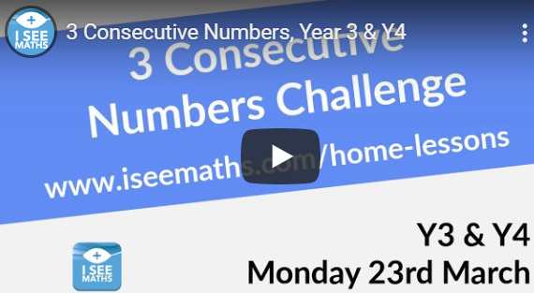  Spelling: Practise this week’s spellings. Think about how we do it in class with the pyramid. (Spellings attached to today’s Blog) | Geography/Science Project: The Water Cycle  Research what the water cycle is and how it works.  Have a go at setting your own investigation up like the video clip. Perhaps take some photos of each stage.  Draw/paint your own diagram or make a leaflet to explain the water cycle.  Can you include this vocabulary?  evaporation, transpiration, precipitation, condensation  Have a go at explaining the water cycle to someone else in your family. (Perhaps record your own video clip of you doing this!  Useful websites: https://www.bbc.co.uk/bitesize/topics/zkgg87h/articles/z3wpp39  https://www.theschoolrun.com/homework-help/water-and-the-water-cycle  https://www.natgeokids.com/uk/discover/science/nature/water-cycle/  https://www.youtube.com/watch?v=U80LVjVX75k  Further resources are also attached (power point, reading comprehension, key terms)
Tuesday  21st April | Times Tables: Focus on 9x table this week. Lots of ways of practising online with the link below:  https://www.timestables.co.uk/9-times-table.html  Reading: Have a go at the Danny the Rain Droplet Reading Comprehension. Choose which level of difficulty you want to have a go at.
Wednesday  22nd April | Maths: ISEEMATHS home learning lesson for Y3/4. Continue with the next lesson (Tuesday 24th March)  Spelling/Handwriting: Find out the meaning of your words. Make sentences out of your spellings and practise your handwriting when recording them.
Thursday  23rd April | Times Tables: Look at the loop card game (attached) for the 7 x table. Can you make your own version for the 9x table? You just need some scrap rectangles of paper or card.  Writing: Write the explanation for your Water Cycle. Include the key words in it. Make labels for each part of your diagram.
Friday  24th April | Maths: ISEEMATHS home learning lesson for Y3/4. Continue with the next lesson (Wednesday 25th March)  Spelling: Chalk your spellings outside or make your own spelling doodle for this week’s words. Ask an adult in your house to test you on your spellings. Perhaps you could test them!

‘A Love for Learning’ – Using the links above, please research each area and respond in the exercise book provided. This could be a written response; fact sheet, poster, poem, non-fiction report, diary entry, newspaper article, diagrams, maps…there are lots of things to learn on each part so break each activity up into sections to study and record.

