Maths 20th April
This week we will be learning all about repeated patterns. Below are ideas of challenges you may want to try to help at home.
Activity 1  Create simple patterns such as red brick, green brick, red brick, green brick, red brick, green brick for the children to copy and continue.  Challenge them to create their own patterns using AB or ABC structures.  E.g- Red, green (AB) red, green, yellow (ABC)  This activity can be done with blocks, playdough, beads natural items, pens and crayons etc.  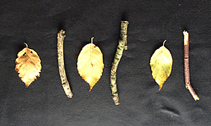  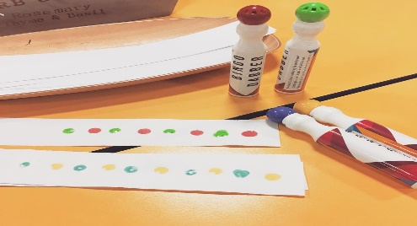 | 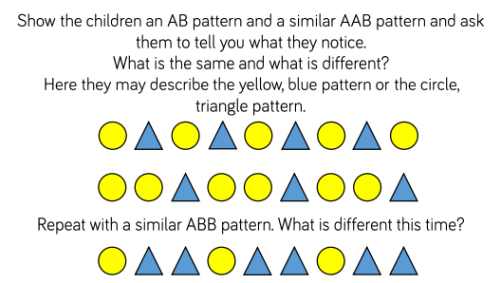  Activity 2 | Activity 3  Provide a selection of fruit (and skewers if you have them-can be done without) in small pieces such as grapes, banana and apple. Allow the children to create their own fruit kebabs using repeated patterns.  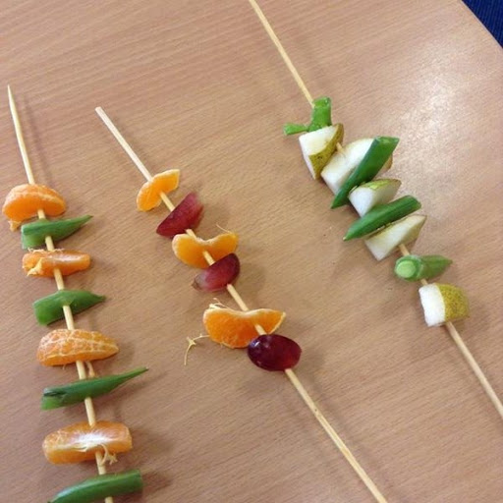
Activity 4  Use clap, stomp and snap to create your own sound patterns.  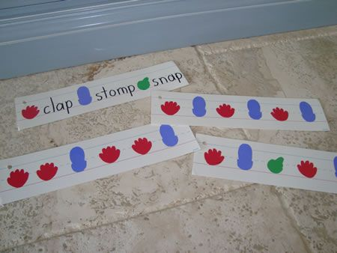 | Activity 5  Pattern games online:  http://resources.hwb.wales.gov.uk/VTC/simple_patterns/eng/Introduction/MainSession.htm  https://www.topmarks.co.uk/ordering-and-sequencing/shape-patterns | Activity 6  Provide children with a range of loose parts such as buttons, beads, seeds, shells. They can use these to create a variety of patterns. You can add variety by adding wavy or zig zag lines for them to build patterns along.  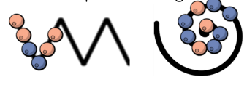
Challenge
