ELLIE SIMMONDS

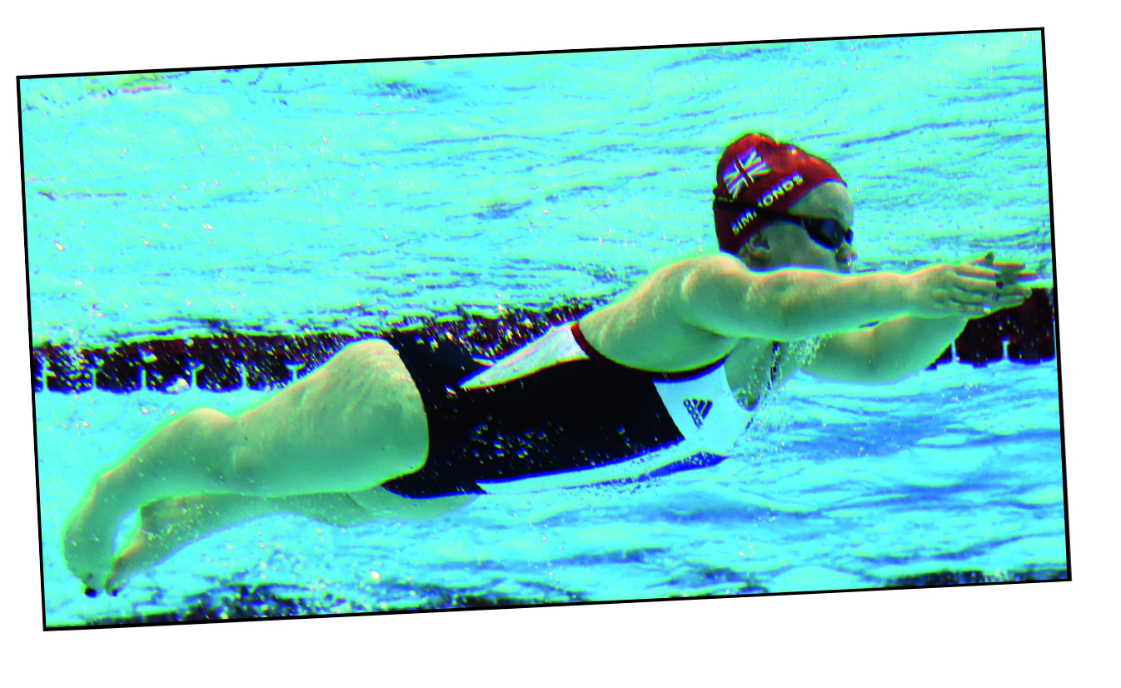
Ellie Simmonds is a Paralympic four-time gold-medal swimmer.

Read the information from the interview with her.

Use it to map her diet onto an ‘eatwell’ plate.

Look carefully at Ellie’s training regime and particularly the different types of training. Write about the different types
of training she does and what she gains from it.

Back home for a bowl of porridge before my history A-level tutorial, then have a short nap.
On a training day I’m up early. I packed my bags last night so I can just put my swimming costume on, dress and get straight out the door.
Eat a banana at the pool. I train five mornings per week, with a small group of Paralympian swimmers. Today’s two-hour session is all about endurance, swimming 100m more than 20 times.
Have some beans on toast to keep me going during the afternoon.
Banana or cereal back at the pool, before a two-hour gym session involving squats, weights and core-strength exercises.
If I don’t have homework I meet up with friends.
I try to keep my diet varied, but I have to eat sensibly to reach my raceweight before competitions. Tonight’s dinner is chicken with potatoes, broccoli and carrots.
Apple juice and a cup of tea after dinner.
5.15am
6am
10am
1pm
2pm
5pm
7pm
7.30pm

ELLIE SIMMONDS
Ellie’s diet is designed to provide fuel. Just like petrol to a car, blood sugars need to be topped up to keep her going. Contrary to popular belief, carbs for energy are an athlete’s best friend – not protein for muscle building. For Ellie, bananas, oats, bread, beans and potatoes are perfect energy foods
Nigel Denby, dietitian

“The motto at my training pool is:
‘Coming second is not an option.’”

I train every Monday, Wednesday, Friday and Saturday morning and every night. Sunday is my one day off. I have to be at the pool at 6am, but I find it easy to get up now.

Ellie Simmonds’
training schedule 2009

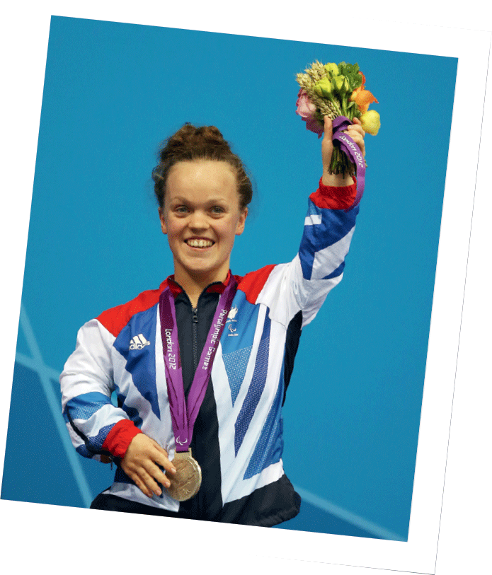
ELLIE SIMMONDS

My typical week

Monday 6–7.45 am: aerobic and skill-based swimming for 3,500 m. Then I go to school for the day. Training starts again, from 3.30 to 5.30pm, with pre-pool exercises (arm and leg stretches). I practice step-ups to strengthen my knees. (I had an operation last year to correct the bowing in my legs.) I also do injury-prevention exercises. As a swimmer it’s important to keep your shoulder muscles working properly. Then I’ll swim for 4000 m with a heart rate monitor on. I swim 20–30 beats below maximum (bpm).

Tuesday Training starts after school at 3.30 pm with 4000 m of short sprints and kick work in the 25 m pool.

Wednesday Another morning session of 3500m before school. Before my afternoon session I have 15 minutes pre-pool stretching, followed by 4000 m working through the training zones: 30 bbm, 20 bbm and 10 bbm (with a heart rate of 175, 185 and 195).

Thursday I have the morning off, then an afternoon session of 4000 m short sprint and quality kick work.

Friday Up early again for more aerobic and skill-based swimming – at total of
3500 m. In the afternoon, I have 15 minutes of pre-pool exercise followed by 4000 m race-specific speed-work in the pool.

Saturday My Saturday sessions involve 4000 m based on reps of 400 m freestyle.

Sunday Rest day!

