Year 1  Starlings  Week 2 | Before 9:00am | 9:00 – 10:00 | 10:00-11:00 | 11:00-12:00 | Lunchtime – 12:00 -12.30 | 12:30 – 1.00 | 1:00 – 2:00 | 2:00 – 3:15 | 3.15 – 4:00
Monday | Eat breakfast, make your bed, get washed and dressed, any laundry in the basket. | Family walk with the dog (if you have got one!)  Five-day/indoor exercises/indoor yoga or other exercise if wet.  https://www.youtube.com/user/CosmicKidsYoga  https://www.gonoodle.com/  https://www.nhs.uk/10-minute-shake-up/shake-ups  PE with Joe Wicks at 9am - https://www.youtube.com/user/thebodycoach1 | Work from the packs that have been sent home  Maths – complete 1 page of Power Maths each day  Arithmetic – complete one frequency grid each day  Writing – Complete one of our daily writing challenges  Reading – Watch one of our daily speed sound lessons and read an online reading book on the Oxford Owl website  Spellings | Creative Time – Lego, drawing, crafting, music, cooking, baking, coding, painting.  coding - https://www.scratchjr.org/ https://code.org/ |  | Tidy Time – Wipe down kitchen table and chairs, wash and dry kitchen dishes, tidy bedroom and lounge | Quiet Time – Reading, Puzzles, Nap (No Electronics) | History/Geography  Science  History/Geography  Science  RE | Afternoon Fresh Air – Bike, Walk the dog, play outside.
Tuesday

Wednesday
Thursday
Friday
Home Learning – this timetable is intended as a guide to support learning at home during a prolonged period of school closure. We appreciate that you will have differing demands on your time but hope that this helps in continuing ‘a love learning’ at home. We will also be updating the class blog daily with any specific activities that you can do each day and further resources that you may need.
Miss Gillam
If you have issues with usernames and passwords, please contact admin@lostockgralam.cheshire.sch.uk

‘A Love for Learning’ – Using the links below, please research each area and respond in the exercise book provided. This could be a written response; fact sheet, poster, poem, non-fiction report, diary entry, newspaper article, diagrams, maps…there are lots of things to learn on each part so break each activity up into sections to study and record.
Monday | History/Geography Project – Can I find out about a famous explorer from the past?  Watch the video below. Can you find out about Mary Anning? What was she famous for?  Please use a clean page of your yellow book to draw and write about Mary Anning. What stopped Mary Anning from taking the credit for her work? Do you think it would be the same for a female explorer now?  Useful Websites – https://www.bbc.co.uk/bitesize/topics/zd8fv9q/articles/zf6vb82  https://www.bbc.co.uk/teach/class-clips-video/ks1-ks2-mary-anning/zn7gd6f
Tuesday | Science Project – In the Toy Box – p63 in your pack  Please draw five of your toys in or near the toy box. Label each one saying what it is, E.G. doll, teddy, car. Then draw another label for each toy to show what material it is made from. Watch the video below to help you.  Challenge: Can you create an exciting model using a range of materials? Can you label each material?  Useful Websites –  https://www.youtube.com/watch?v=XnkQcP-RHCw
Wednesday | History/Geography Project –  Take a virtual tour of the Natural History Museum in London. Can you add any information to work on fossils and Mary Anning from earlier in the week?  Useful Websites – https://artsandculture.google.com/partner/natural-history-museum  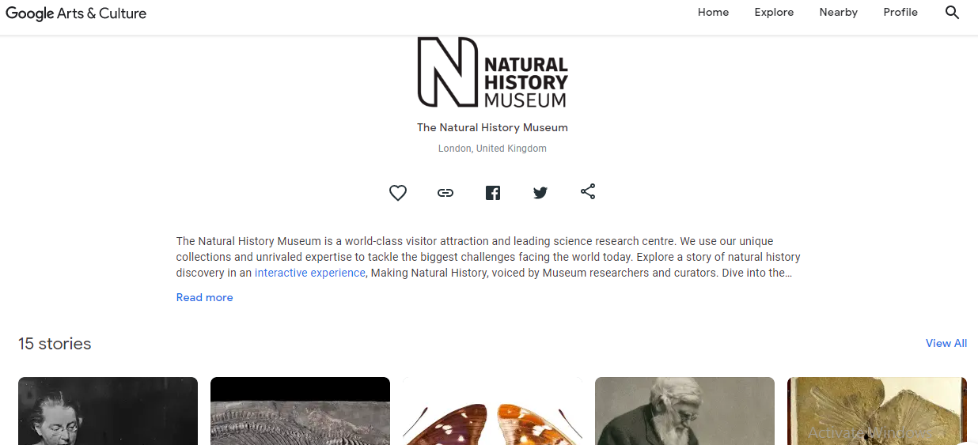  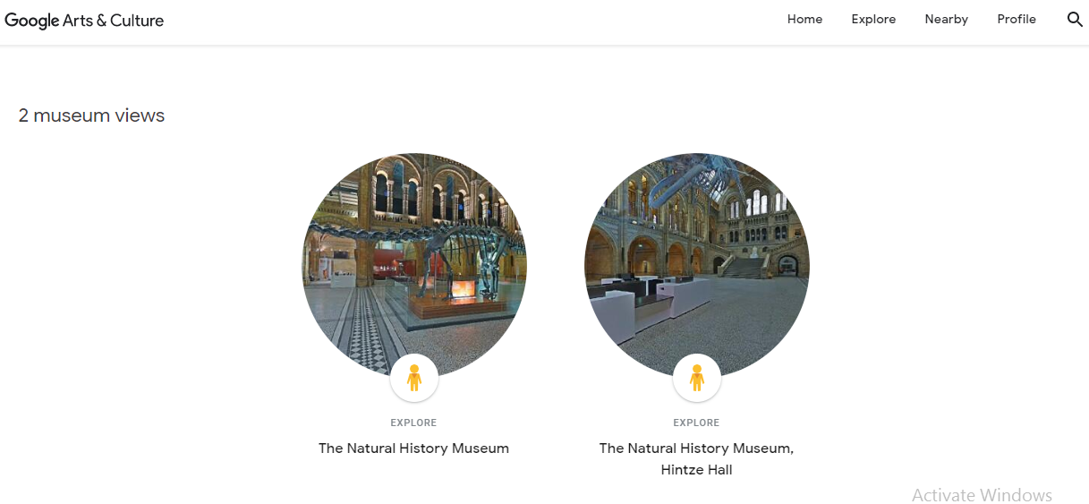  https://artsandculture.google.com/exhibit/mary-anning-history-s-pioneer-of-palaeontology%C2%A0/RwLC8g-VfbBAJA
Thursday | Science Project – Materials Hunt  Have a hunt around your house and see how many things you can find that are made from each material. Record your work on page 64 of your pack.  Challenge: How many things can you find that are made from more than more material? Write them down and say what materials they are made from.  Useful Websites – Here are some interesting video clips on how different items are made. There are many more available in the suggests on each web page below.  https://www.bbc.co.uk/teach/class-clips-video/primary-science-how-paper_is_made/zryb92p  https://www.bbc.co.uk/teach/class-clips-video/primary-science-how-glass_is_made/zm2tf4j  https://www.bbc.co.uk/teach/class-clips-video/primary-science-how-crayons-are-made/zv6hf4j
Friday | RE Project – Good Friday  On Sunday 5th April it will be Palm Sunday. Can you find out what Palm Sunday is? How is it celebrated in Church?  Watch the video below and use a blank page of your yellow book to draw and write about Palm Sunday.  ‘’It’s the front of my hand, the day before Monday, it’s the start of Easter. It’s ______________ ___________________.’’  Useful Websites – https://www.bbc.co.uk/bitesize/clips/zdsfcdm

