Twitter Guidance
Now we are getting into the swing of home learning, I would love to see some of the amazing things you are getting up to at home. Please use @LostockGralamPr to tag us in your tweets. I will then be able to see and respond to the wonderful things to you are completing via Twitter. This can be anything from family fun in the garden to a brilliant piece of writing.
Step 1
Click the add tweet button on your screen. Write what you would like to say making sure that you do not use any names. Type @LostockGralamPr to tag us in the post.
Step 2
Select the images from your camera roll.
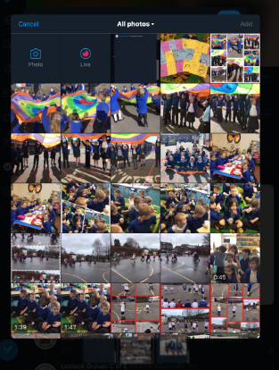

Step 3
Tweet!
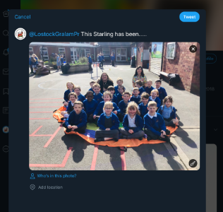

I can’t wait to see what you have been up to!
Miss Gillam

