Year 3  Robins | Before 9:00am | 9:00 – 10:00 | 10:00-11:00 | 11:00-12:00 | 12 – 12.30 | 12:30 – 1.00 | 1:00 – 2:00 | 2:00 – 3:15 | 3.15 – 4:00
Monday | Eat breakfast, make your bed, get washed and dressed and put any laundry in the basket. | Family walk (with the dog - if you have got one!)  Five-a-day/indoor exercises/indoor yoga if wet.  https://www.youtube.com/user/CosmicKidsYoga  https://www.gonoodle.com/  https://www.nhs.uk/10-minute-shake-up/shake-ups | Maths/Writing work from the packs that have been sent home or any specified work from the daily blog on the school website.  TT Rock Stars - https://play.ttrockstars.com/auth/school | Creative Time – Lego, drawing, crafting, music, cooking, baking, coding, painting.  coding - https://www.scratchjr.org/  https://code.org/ | Lunchtime | Tidy Time – Wipe down kitchen table and chairs, wash and dry kitchen dishes, tidy bedroom and lounge. | Quiet Time – Reading, Puzzles, Nap (No Electronics) | History/Geography  (See tasks on the next page – check the blog for useful resources and help) | Afternoon Fresh Air – Bike, Walk the dog, play outside.
Tuesday |  |  |  |  |  |  |  | Science  (See tasks on the next page – check the blog for useful resources and help)
Wednesday |  |  |  |  |  |  |  | History/Geography  (See tasks on the next page – check the blog for useful resources and help)
Thursday |  |  |  |  |  |  |  | Science  (See tasks on the next page – check the blog for useful resources and help)
Friday |  |  |  |  |  |  |  | RE  (See tasks on the next page – check the blog for useful resources and help)
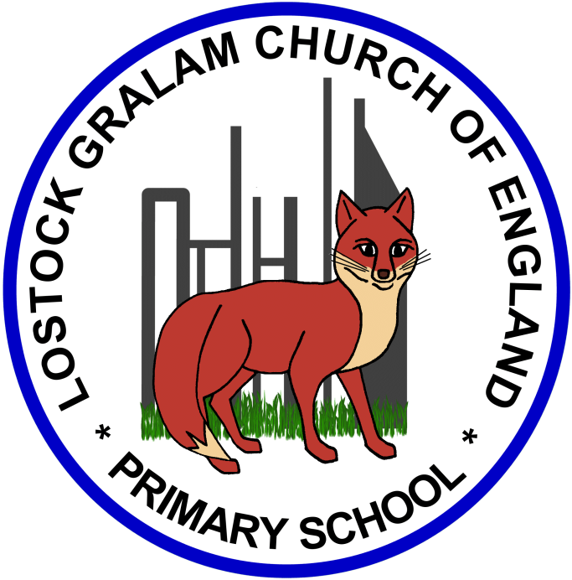
Home Learning – this timetable is intended as a guide to support learning at home during a prolonged period of school closure. We appreciate that you will have differing demands on your time but hope that this helps in continuing ‘a love learning’ at home. We will also be updating the class blog daily with any specific activities that you can do each day and further resources that you may need.
Miss Beattie and Mrs Esling
If you have issues with usernames and passwords, please contact admin@lostockgralam.cheshire.sch.uk

Using the links below, please research each area and respond in the exercise book provided. This could be a written response; fact sheet, poster, poem, non-fiction report, diary entry, newspaper article, diagrams, maps… there are lots of things to learn for each subject so break it up over different days!
History and Geography | History/Geography Projects –  - Draw or Label your own map of Europe (include countries such as Russia, Syria, Turkey and Germany) – There are lot of fun games to help you with this (see links below).  - Revise the 8 points of a compass (see games below) – Can you say which direction you are travelling in if you travel from England to each of the countries listed above?  - Where do most refugees come from and where do they go? - Research and locate on a map the top countries which Refugees flee from and to – You could present your findings in a bar chart, pictogram or table (use the squared paper in your packs).  Games:  https://www.mathsisfun.com/games/direction-nsew-.html  https://www.bbc.co.uk/cbbc/quizzes/european-countries-quiz  https://www.ducksters.com/games/europe_map_game.php  Useful Websites –  https://www.worldvision.org/refugees-news-stories/forced-to-flee-top-countries-refugees-coming-from  https://www.amnesty.org/en/what-we-do/refugees-asylum-seekers-and-migrants/global-refugee-crisis-statistics-and-facts/  https://www.redcross.org.uk/get-involved/teaching-resources/refugees-and-migration?utm_campaign=edm-yed-feb19-youthed-update-primary&utm_medium=email&utm_source=salesforce&utm_content=link&utm_term=link
Science | Science Projects – Skeletons and Muscles  - Investigate skeleton types - endoskeleton, exoskeleton and hydro skeleton – What do these new words mean? Start by recording the definitions in your exercise book. You could sketch and label what an endoskeleton, exoskeleton and hydro skeleton look like.  - Can you research and group animals based on whether they have an endoskeleton, exoskeleton or hydro skeleton?  - Name and label muscles – You could sketch the human body and draw/label the different muscles (See wordwall game link below)  - Research: Why do we have muscles? Do they have a special job?  Useful Websites –  https://www.youtube.com/watch?v=txhCfr9SJDI&feature=youtu.be  https://www.bbc.co.uk/bitesize/clips/ztfnvcw  https://www.theschoolrun.com/homework-help/bones-and-muscles  https://wordwall.net/resource/46053/science/label-muscles
RE | RE Projects – Easter  - Read the Easter Story (See Topmarks website below or find your own version)  - What is Palm Sunday and why is it important for Christians?  - Write your own poem about Palm Sunday  Useful Websites –  https://www.topmarks.co.uk/easter/easterstory.aspx  https://www.youtube.com/watch?v=MK2o-mhBfuc&list=PLcvEcrsF_9zK0q_Ey3yl7k5LA5v1M7NNs&index=28&t=0s  https://kids.lovetoknow.com/palm-sunday-children https://kids.lovetoknow.com/palm-sunday-children  https://www.truetube.co.uk/film/last-supper-2014

