Autumn 2 2021 Worship Planning
Monday – Mrs Powell Picture This News
Tuesday – Mrs Rice Christian Values / No Outsiders/Agents of Hope
Wednesday – Mrs Downing Open The Book Bible Stories Through Drama (Visiting OTB team)
Thursday – Miss Gillam, Mrs Evans/Miss Beattie Praise Singing
Friday – Mrs Powell Praise Celebrations
- The Library has story books, secular and Christian, organised into folders for each Christian Value for you to use as and when.
- All Roots and Fruits resources/music to accompany worship can be found at https://www.imaginor.co.uk/roots-fruits-resources/ Password (RaF14img7)
Date | Theme | Resource
Autumn 2 2021 Christian Values: Love and Hope
Please light a candle at the beginning of each worship to remind us that “Christ is the Light that guides us” (our mission statement) and have the Bible open at the Bible verse that is indicated in purple in each worship.
02.11.21 | 1. Presentation of the Chester Cathedral Canon Chancellor Award by visitor to us for winning the award with our film made to explain how we love and care for God’s world.  2. Our children and young people are wonderful advocates for our environment and take seriously our collective responsibilities to care for the wonderful world that we live in and that God has entrusted to us. At the end of the month COP26, the United National Climate Change Conference, will take place and as part of this the Diocese of Chester has produced a short video for use with schools. We hope that by sharing the video with your pupils and students, it opens up a conversation and inspires them to think about the small things we can do in our everyday lives to help protect the planet from environmental damage. Chn to watch a video that is voiced by the Revd Peter Froggatt, Director of Outreach in the Diocese of Chester and features a number of people who each share some of the little things they are doing to protect Planet Earth.  Chn to link this to our work on the Global Goals. Which ones does this link to? What can we do to show Love for God’s creation in our every day lives? What can we talk to our families about ?  “The Lord God took the man and put him in the garden of Eden to work it and keep it.”  Genesis 2:15  Sir David Attenborough says  “No one will protect what they don't care about; and no one will care about what they have never experienced” | 1. https://youtu.be/lOvs1eVVgQM  2. What are you doing for the planet? - YouTube
09.11.21 | Agents of Hope Worship  “If you can?” said Jesus. “Everything is possible for one who believes.”  Mark 9: 23  Around 6 PM on 11th October, search and rescue in Maple Ridge, Canada, got a call that two men were in trouble at a waterfall. One has fallen in to a pool just above the waterfall and could not get out.  When search and rescue arrived, the two men were being helped by five Sikh men who had used their turbans to pull the men out by knotting them together. Kuljinder Kinda said, “We were trying to think of how we could get them out but we didn’t know how to. We came up with the idea to tie our turbans together.”  The rocks were very slippery and if the men had fallen in to the rushing water they would have broken bones and probably drowned. They were also at risk of hypothermia. You can watch a film of the rescue in the link above.  - What do you see in the picture, where is it, what do you think is happening?  - How do you think the men ended up in the water?  - How do you think they felt when they fell in, why couldn’t they get out?  - What is a turban?  - Many Sikhs will not remove their turbans in public so why do you think these Sikh men decided to remove their turbans and tie them together?  - In the clip there is a lot of shouting while the men are rescued; what were the dangers involved? Did the Sikh men do the right thing if search and rescue were on the way?  - What does this show us about people of different religion and culture in the world today?  - What can we learn from the Sikh men?  Why is this a story of hope/ No Outsiders? | 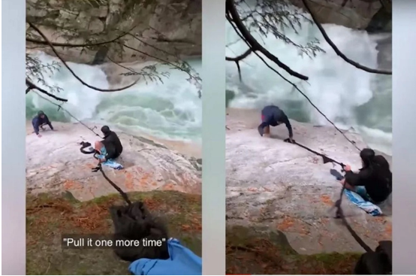  https://www.upworthy.com/sikh-hikers-use-turbans-to-rescue-stranded-man
11.11.21  Remembrance Day | Meet in the hall first Mrs Powell to explain why this is a special day. Visit to the Cenotaph in our Church grounds. Mrs Kendrick to lead the service of Remembrance. Last post music. Chn to plant Poppy seeds in recycled tyres made in the shape of a poppy in our outdoor reflection area as a sign of respect to the soldiers.  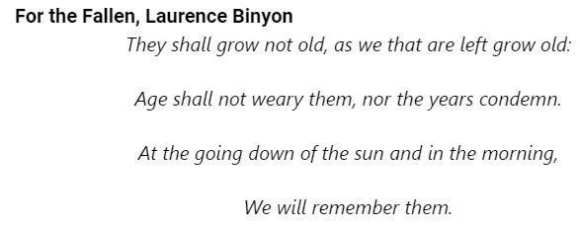  How did the soldiers show Love for their country, friends and families? | 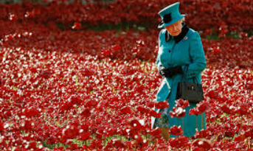  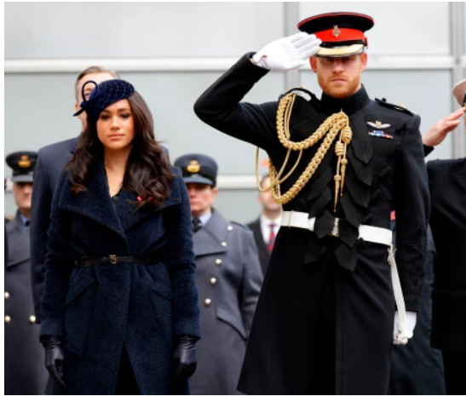
16.11.21 | A story of Love from the Bible - Moses and the Burning Bush  Watch the video clip and read from the Lion Story Tellers Bible (OTB)  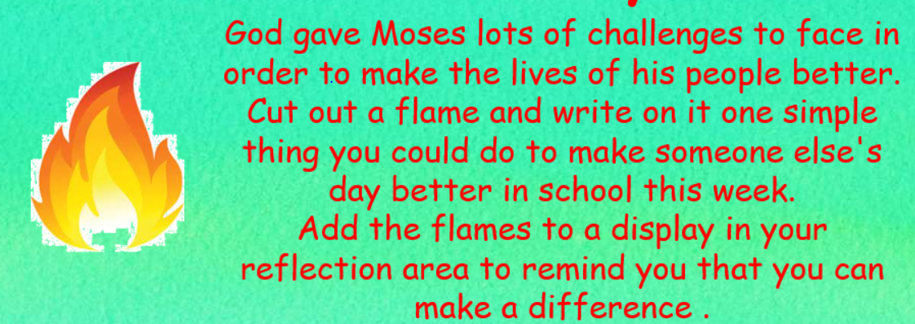  How does this story show God’s love for us? | Moses and the Burning Bush  https://www.youtube.com/watch?v=8kNTUX0mWP8  NR to create a burning bush in the hall for chn to add flame reflections onto.  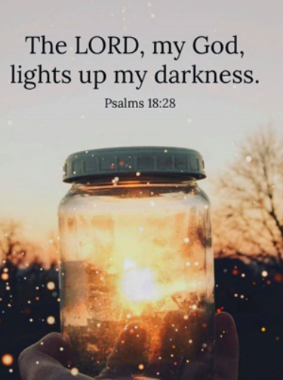
23.11.21 | Love can not be measured. Explore measuring equipment, chn to measure items in the hall. Could we measure the length of the playground with this ruler? Why/why not?  Prayer  Thank you, God, for all those who love and care for us.  Thank you that your love reaches to the highest heaven, and to the deepest ocean.  Thank you that there is nowhere I can hide or run to, but your love is already there.  Please help us to be people who give love, as well as receiving it.  Amen.  Song/music  Display the collection of ‘big’ words.  Ask the children to try to fit these words into a sentence, such as, ‘The planet Jupiter is enormous’ or ‘When I grow up to be a footballer, I’ll score a huge number of goals’.  Explain that Christians and people of other faiths believe that there is one thing that you can’t measure: love. You can’t put a price on the love of other people. You can’t measure it with a ruler or a set of weighing scales or any other measuring device – even a tape measure as big as the solar system!  Christians believe that God’s love for each of us is limitless.  Think of:  the longest journey you’ve ever made . . .  Pause to allow time for thought.  - the longest time you’ve stayed up . . .  - the biggest meal you’ve ever eaten . . .  - the most money you’ve ever had . . .  - the biggest crowd you’ve ever seen . . .  - the largest thing you know about . . .  Love is bigger than them all.  Pause to allow time for thought.  1 John 4:16-18 “And so we know and rely on the love God has for us. God is love. Whoever lives in love lives in God, and God in them.” | https://www.assemblies.org.uk/pri/3092/enormous-love
30.11.21 | The Christmas Story. God shows his love for the world by giving us his only son.
07.12.21 | Christmas Performances
13.11.21  14.12.21 | Whole school Christingle service  Whole School Carol Concert in church

