Children are at the heart of everything we do and Christ is the light that guides us.
John 8:12
Weekly Message
Thank you so much for your incredible pumpkins - we have some very creative families! It was lovely to see how much we all enjoyed our pumpkin art gallery! Our PTA are amazing, thank you! You will notice Christmas comes early to Lostock this year and we have a very busy term; as always, we will keep the newsletter updated with everything you need to know!

Something lovely!
Each week we will give you an idea to support your child’s wellbeing on the newsletter. Mrs Evans is going to start us off!
Please have a look at the links below to some New Horizons Guided Mindfulness and Sleep Meditation for children. I used these regularly during lockdown both in school and at home with my 3 children.
https://www.youtube.com/watch?v=FUb6Pf1KiHw
https://www.youtube.com/watch?v=DWOHcGF1Tmc
https://www.youtube.com/watch?v=gwytGLzMu7s
https://www.youtube.com/watch?v=GNKA2k44aTw
https://www.youtube.com/watch?v=3fXr8nR8g9E
https://www.youtube.com/watch?v=kQsp9SchSoE
https://www.youtube.com/watch?v=WToh_dpg7mE
https://www.youtube.com/watch?v=Uv08oxaUr70

Children in Need – Friday 17th November
As always, we will be supporting this wonderful cause with a non-uniform day, donations can be given on the day or sent to the link below! Thank you!
https://donate.bbcchildreninneed.co.uk/

Phonics Meeting for Parents – Reception and Year 1
On Tuesday 14th November, we will be having a Reception and Year 1 parent meeting regarding how to support your child in early reading at home. We will be sharing example lessons, resources and giving support on the correct pronunciation of sounds. There will be a meeting at 2:45pm and 4:30pm; these sessions are for parents only. Please email admin@lostockgralam.cheshire.sch.uk by Friday 10th November to let us know whether you will be attending so we have an idea of numbers. Thank you for your support with this.

Friday 15th December – we will be finishing at 1pm and there will be no Fun Foxes. A party lunch of burger and chips will be available from the school kitchen.

Remembrance Day
We are continuing to sell poppies on the playground before and after school. Thank you for supporting this special charity.

To celebrate Remembrance Day this year, we’d like to make a poppy out of red and green reused plastic milk bottle lids. Please send any that you have into your child’s class teacher and together, we’ll make a school poppy to commemorate this special national event.

Please click on the PDF for further information about how to enter:

Very Green Grocery Northwich
(formally the Cheshire Food Hub)
Click here to follow on Facebook – it really is worth it as they offer an incredible service!

Online Safety
To help keep your children as safe as possible online, please click here to access an interactive guide. It gives you practical instructions on how to set parental controls on the most common devices children use.

Diary Dates
This will be added to each week!
6th November | Years 5 & 6 worship in Church led by Vicar Andrew – parents welcome to join
13th November | Years 3 & 4 worship in Church led by Vicar Andrew – parents welcome to join
15th November | Robins trip to Beeston Castle
17th November | Non-uniform day to raise money for BBC Children in Need
20th November | Years 1 & 2 worship in Church led by Vicar Andrew – parents welcome to join
21st November | Skylarks trip to Lion Salt Works
22nd November | Swallows trip to Titanic Museum
28th November | KS1 Christmas play – 9:30am and 2pm
29th November | KS1 Christmas Play – 2pm
1st December | Christmas jumper day for St Luke’s and Elf run
6th December | KS2 play – 1:30pm and 5pm
7th December | KS2 play – 5pm
8th December | Christingle
12th December | PTA non uniform day for a donation for Xmas Fair, chocolate KS1 and bottles KS2.
13th December | Panto & PTA Christmas Fair
14th December | Christmas Carol concert & Christmas Lunch
15th December | Party lunch and school finishes at 1 pm – No Fun Foxes
10th January | Toucans trip to the Imperial War Museum
17th January 2024 | Goldfinches trip to Chester Grosvenor Museum
12th March 2024 | Swallows Trip to Fox Howl Centre, Delamere
8th May 2024 | Skylarks Trip to Tatton Park
3-5th June 2024 | Toucans Residential Petty Pool Centre

Worship
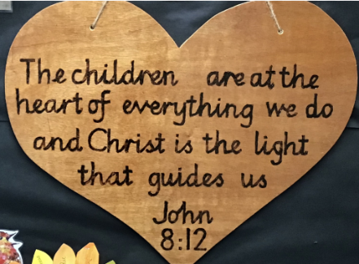
Owls class enjoyed their first church worship with Vicar Andrew this week. It was lovely to welcome so many families into church to join in this special worship with us. Thank you for your kind comments, the children and staff really enjoyed sharing our beautiful church with you.
Year Six Ethos members led a role play where the characters needed to use courage in order to over come an unfamiliar experience. We discussed how a rope is strong as the threads are woven together and how the rope can be a physical reminder of the tools we have inside us, places we can go and things we can hold in order to feel God’s courage all around us, making us as strong as the rope in tricky situations.

“Even though I am not right there with you, I am with you in spirit.” (1 Corinthians 5)
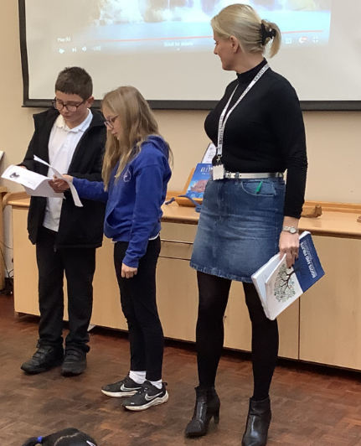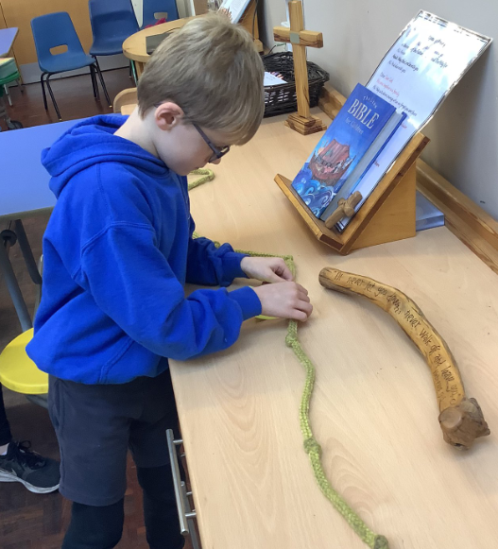
We have also began exploring the significance of Remembrance Day in preparations for our worships next week.

Praise Children
Owls (Reception) | Alfie | With resilience and respect, Alfie has come to school every day this week with a fantastic learning attitude. Well done superstar!
Starlings (Y1) | Callum | Callum always has the biggest smile and has a wonderful love of reading. I enjoy reading about all the wonderful stories you have enjoyed at home. well done Callum!
Swallows (Y2) | Braydon | For kindness, patience and always showing respect to others. I am also really impressed with your Maths this week!
Robins (Y3) | Marnie | For showing courage to complete more work in Maths by herself! Loving the ‘have a ‘go’ attitude! Well done, Marnie.
Goldfinches (Y4) | Layla W | For letting your light shine by showing courage in expressing your thoughts and views in class. Your confidence is glowing!
Skylarks (Y5) | Jacob C | For his wisdom and beautiful presentation in his fact file about the Lion Salt Works. Thank you for showing such respect for your work.
Toucans (Y6) | Gracie | For always bringing joy into our classrooms with your patience, hard work and gorgeous smile.

‘Top Table’ children for wonderful manners at lunchtime |  |  | Before & After school clubs – Autumn Term  Name Day/Time Key Stage  Dodgeball Monday 8-9am Years 1-6  Girls Football Monday 3.15-4.15pm KS2  Hockey/Basketball Wednesday 8-9am Years 1-6  Football Wednesday 3.15-4.15pm Years 1,2,3  Athletics/Benchball Friday 8-9am Years 1-6  Football Friday 3.15-4.15pm Years 4,5,6
Owls (Reception) | Lana and Edie
Starlings (Y1) | Emilio and Chester
Swallows (Y2) | Alba and Harry
Robins (Y3) | Annabelle and Olivia
Goldfinches (Y4) | India and Owen
Skylarks (Y5) | Molly and Naomi
Toucans (Y6) | Amy and Alexa
Happy Birthday!
To Evelyn and Henry in Swallows and Kenzie in Robins

Lunch Menu – Week 3
Monday | Tuesday | Wednesday | Thursday | Friday
Homemade sausage roll served with mashed potato & baked beans | Tomato & mascarpone cheese pasta served with garlic & herb bread and seasonal vegetables | Cottage Pie served with seasonal vegetables | Chicken korma served with Rice, Naan Bread & Seasonal Vegetables | Breaded Mozzarella sticks with chips beans or peas
Jacket Potato with a Selection of Fillings Served with a Side Salad | Jacket Potato with a Selection of Fillings Served with a Side Salad | Jacket Potato with a Selection of Fillings Served with a Side Salad | Jacket Potato with a Selection of Fillings Served with a Side Salad | Jacket Potato with a Selection of Fillings Served with a Side Salad
Deli Choice of Breads with a filling choice of ham, cheese or tuna Served with a Side Salad | Deli Choice of Breads with a filling choice of cheese, ham or tuna Served with a Side Salad | Deli Choice of Breads with a filling choice of ham, cheese or tuna Served with a Side Salad | Deli Choice of Breads with a filling choice of ham, cheese or tuna Served with a Side Salad | Deli Choice of Breads with a filling choice of cheese or tuna Served with a Side Salad
Fruit and Ice-cream | Chocolate Crispy Cake | Apple & Grape Pot | Fruit Jelly | Vanilla biscuit

TERM DATES September 2023/August 2024
 | Date of Closing | Date of Re-Opening
Christmas 2023/2024 | Friday 15th December school finishes at 1 pm – No Fun Foxes | Tuesday 2nd January
Spring Half-Term 2024 | Friday 16th February | Monday 26th February
Spring Break 2024 | Wednesday 27th March | Monday 15th April
May Day Weekend 2024 | Friday 3rd May | Tuesday 7th May
Summer Half-Term 2024 | Friday 24th May | Monday 3rd June
Summer break 2024 | Friday 19th July school finishes at 1 pm – No Fun Foxes | Monday 2nd September

INSET DAYS (Teacher Training) – 5 in total for 2023/24
Thursday 28th March 2024
Monday 22nd July 2024
Tuesday 23rd July 2024
Wednesday 24 July 2024

HOLIDAYS IN TERM TIME
Pupils are discouraged from taking holidays in term time unless there are exceptional circumstances. It is very rare that any holiday would be authorised. Good attendance is key to pupils making good progress and taking time out to go on holiday can significantly hamper progress. Where a holiday is unauthorised the LA is informed. A Fixed Penalty Notice will then be issued in accordance with section 444 of the Education Act 1996. The current rates payable by parents are £60 where the amount is paid within 21 days and £120 where the amount is paid within 28 days. The charge is per parent/carer per child. If the Fixed Penalty Notice remains unpaid this could lead to prosecution in the Magistrate’s Court.
For the DfE statutory guidance on school attendance please click on the following link:
https://www.gov.uk/school-attendance-absence

Attendance
Attendance is crucial for all children in order that they will achieve and is monitored closely by school. We are always happy to help any families who are struggling for any reason. Emily Leather our family support worker is in school Monday, Tuesday and Friday and is always keen to help.

“Central to raising standards in education and ensuring all pupils can fulfil their potential is an assumption so widely understood that it is insufficiently stated – pupils need to attend school regularly to benefit from their education. Missing out on lessons leaves children vulnerable to falling behind. Children with poor attendance tend to achieve less in both primary and secondary school.” School Attendance DfE May 2022

If your child is ever unwell, please do let us know the reason for the absence by 8:45am on 01606 668270 (a message can be left on the school answer phone).

